1. Bites: ChatGPT4 response (App Flow_ caldwell.ben.bites_1.mhtml )

There is an inconsistency in the behavior of the application when clicking the "Send Email Recipe" button, resulting in the app crashing. This is unexpected as typical operations, especially those like sending an email which should be standard functionality, should not cause the application to crash. This indicates a flaw in either the button’s functionality or error handling within the app that needs to be addressed.

Bugs Triggered Flow

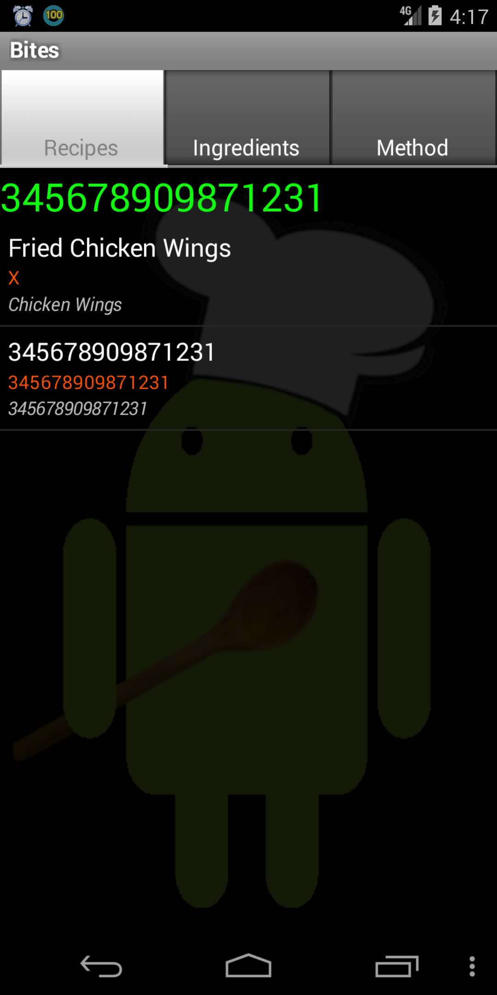 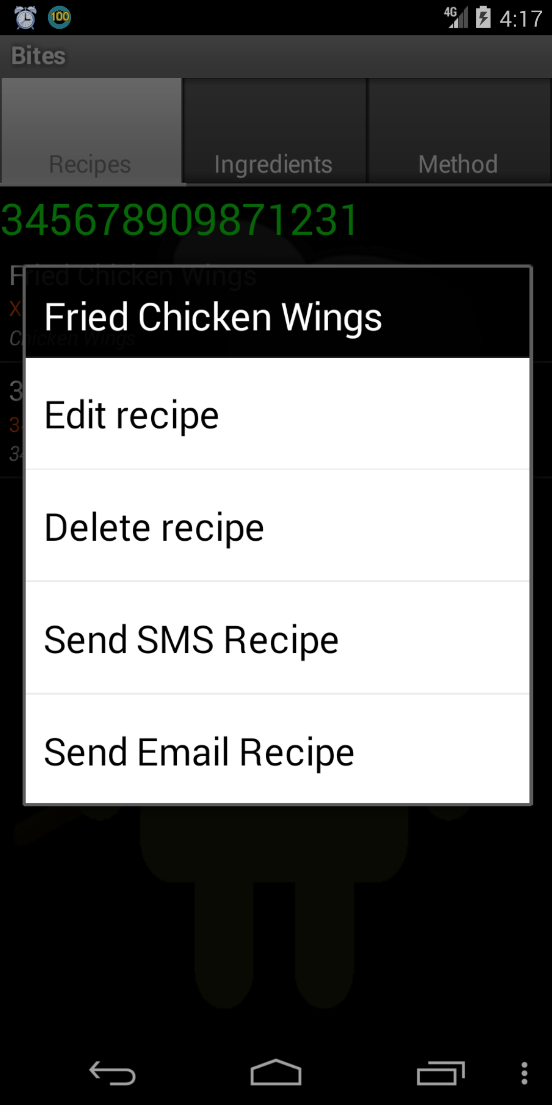 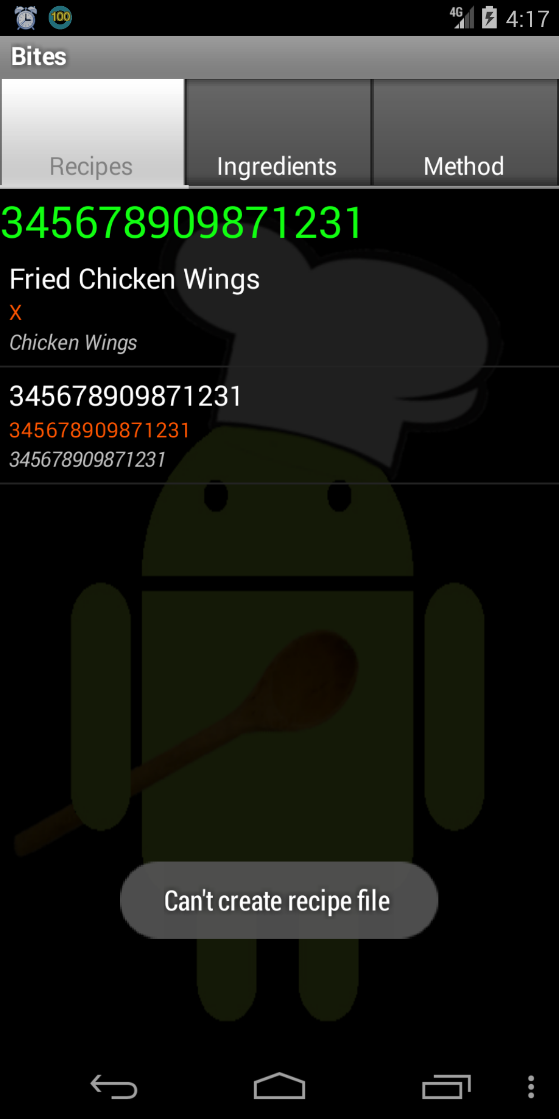

Create several “Recipes”,and long click on anyone Click “Send Email Recipe” Bugs triggered

Normal Flow:

  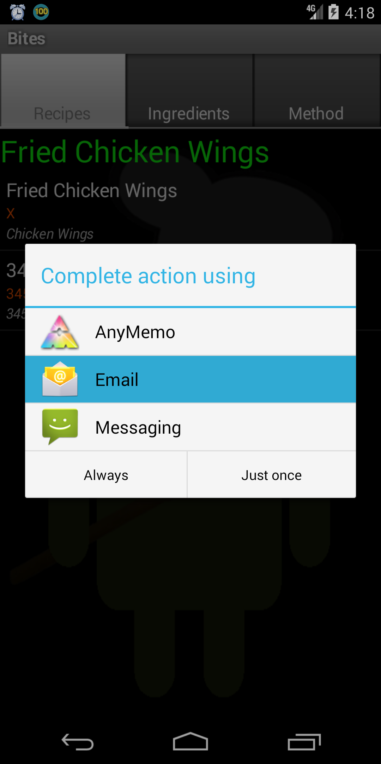

Create several “Recipes”, Click “Send Email Recipe” Go to outside Apps

and long click on anyone

1. Anymemo ChatGPT4 response (anymemo-stable-8.3_oracle_0(37).mhtml )

The output indicates that after clicking on "Look up in a dictionary", the application attempts to launch an external dictionary app which is not installed, resulting in an error message. This error suggests a lack of a fallback or error handling mechanism when the expected dictionary app is not available on the device.

Bug trigged Flow:

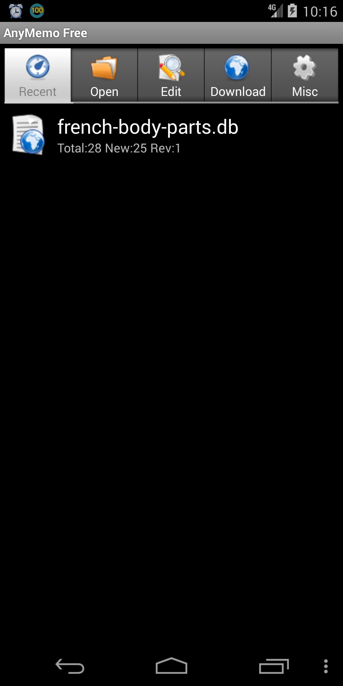 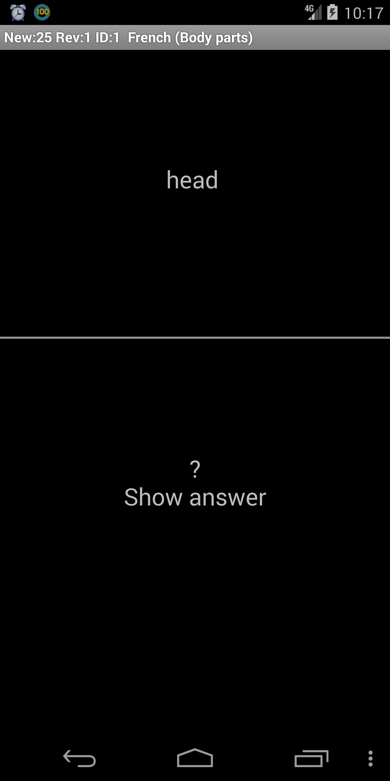 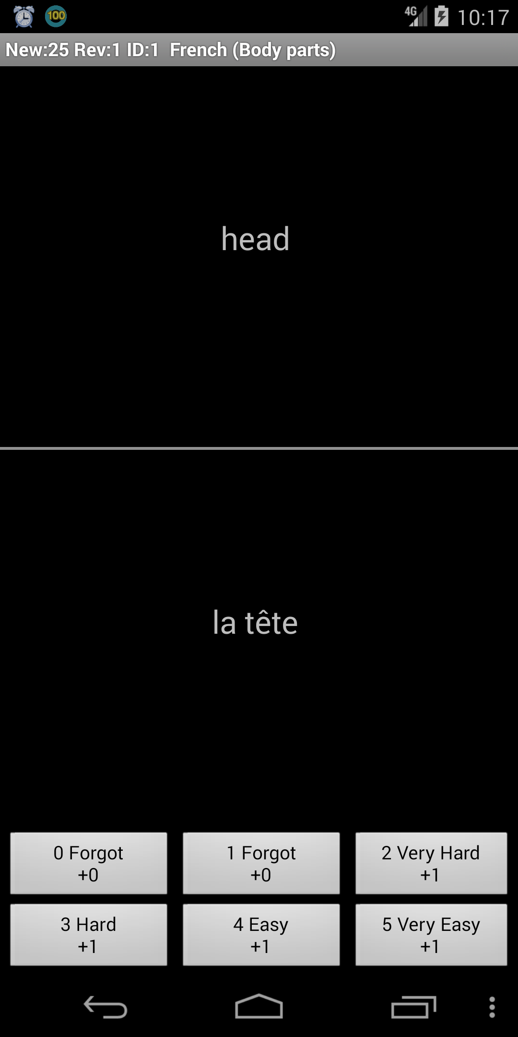

Click “french-body-parts.db” click “show answer” long click “la tete”

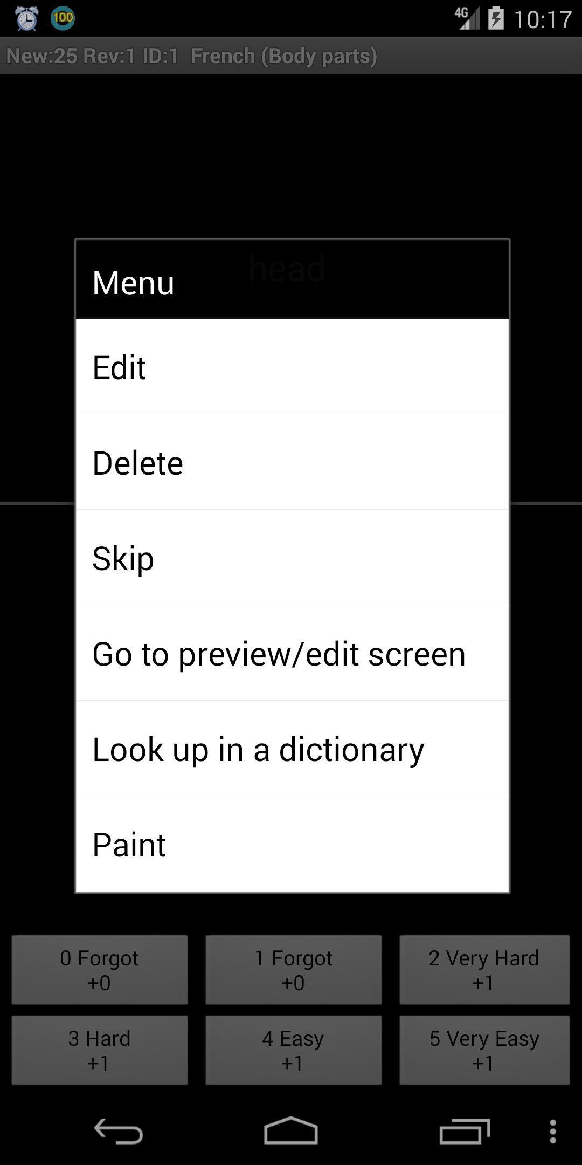 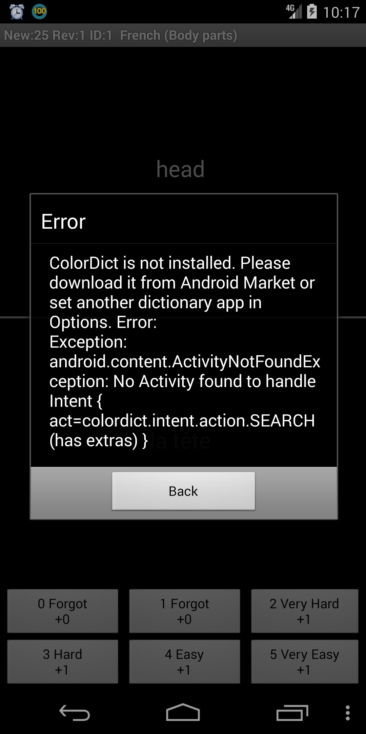

Click “Look up in a dictionary” Error message triggered

1. Filexplorer: ChatGPT4 response (App Flow_ fileexplorer_oracle_0.mhtml )

Yes, there is a logic error.

The reason is that clicking on various filesystem entries such as 'mnt', 'cache', 'storage', 'system', 'sdcard', 'ueventd.ranchu.rc', 'etc', 'config', 'sys', 'd', 'ueventd.rc', 'acct', 'vendor', 'ueventd.goldfish.rc', 'scroll', 'fstab.goldfish', 'init.trace.rc', 'fstab.ranchu', 'default.prop', 'init.rc', 'dev', 'data', 'init.environ.rc', 'file_contexts', 'init', 'root', 'init.usb.rc', 'init.ranchu.rc', 'init.goldfish.rc', and 'root' did not result in any change to the page structure or navigation, which is unexpected behavior when interacting with file system directories or files in a file explorer application. The output structure remained the same after these actions when it should have displayed the contents of the clicked directory or file.

Bug trigged Flow:

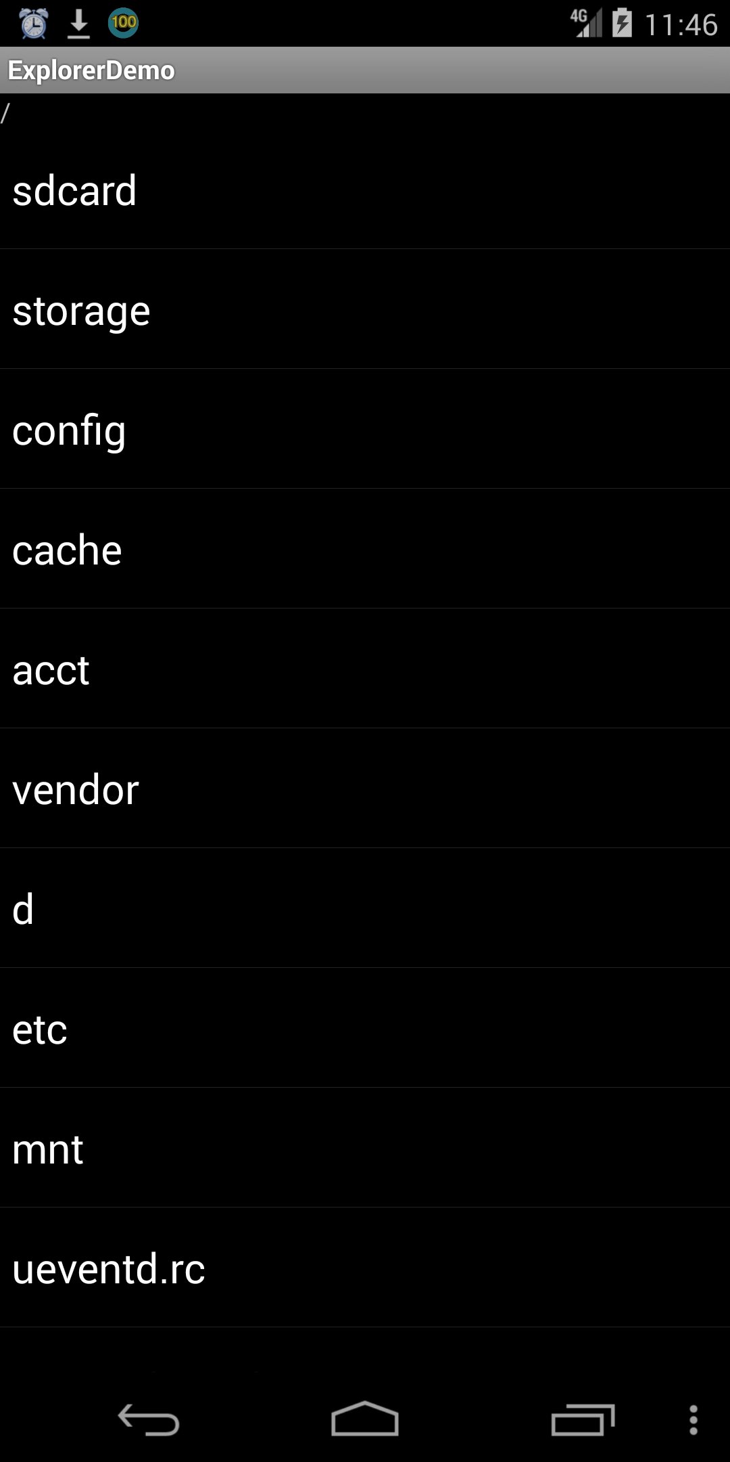 

After clicking any button, the view remains the same, which means all the buttons cannot function properly.

1. Mirrored: ChatGPT4 response (App Flow_ de.homac.Mirrored_9_src_oracle_1.mhtml)

Yes, there is a logic error in the app flow.

The inconsistency occurs with the "OK" button's behavior and the final output shown. After certain actions that redirect to an empty page and prompt a "back" navigation, the app incorrectly shows the "Sport (Offline)" or "International" text instead of returning to the state expected by clicking the "OK" button, which typically resets to the initial state with "No articles available."

Bug trigged Flow:

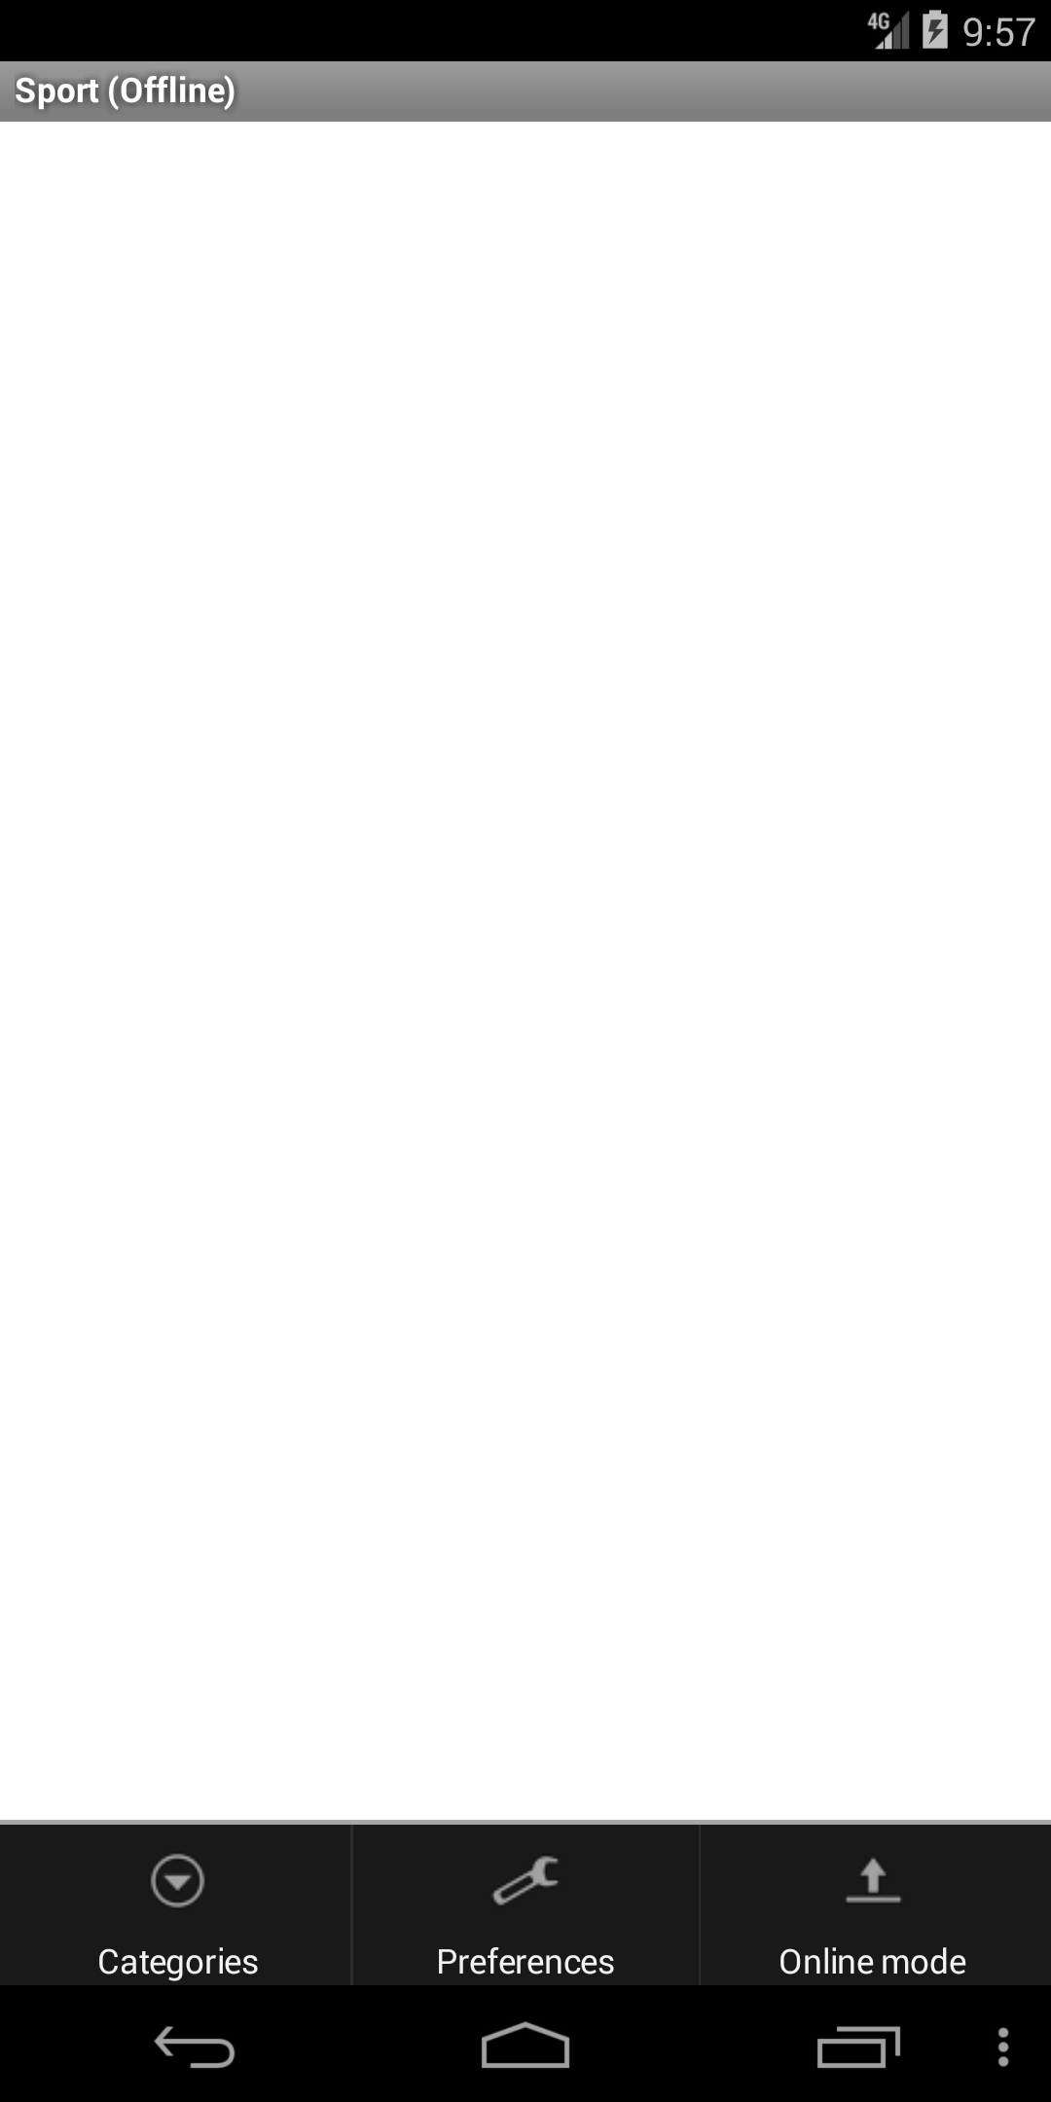 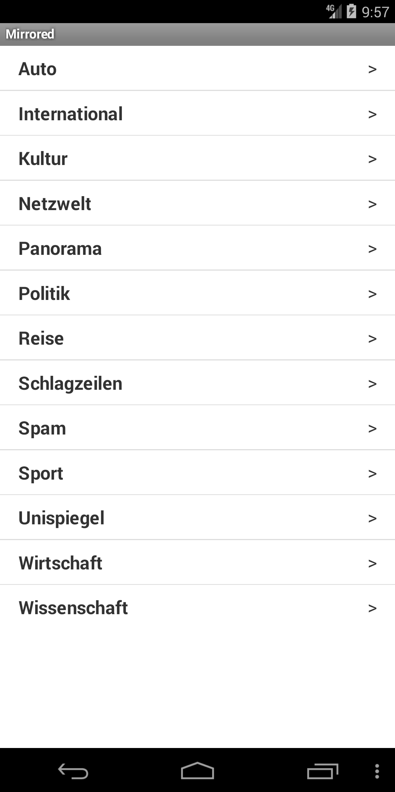 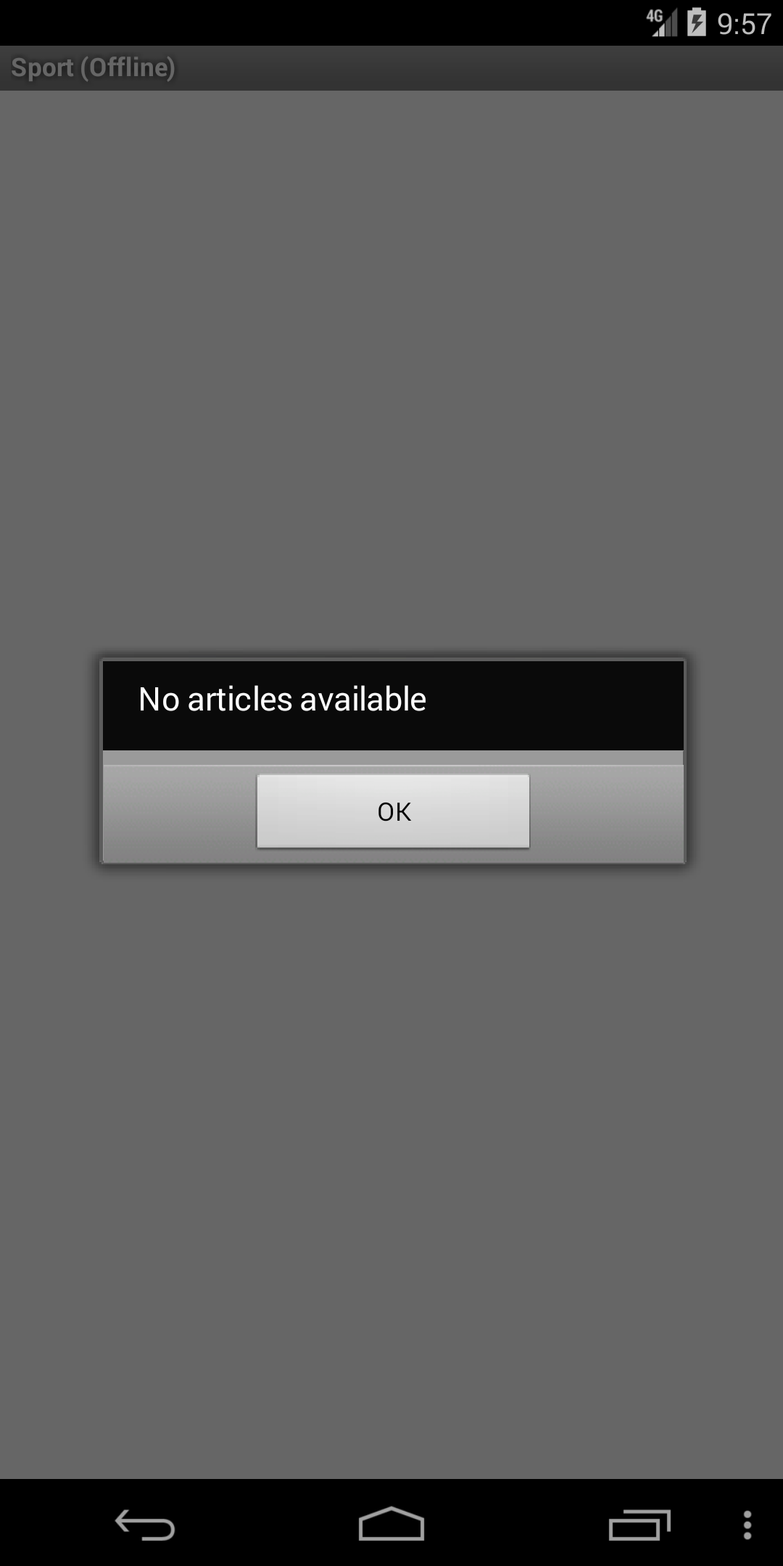

Click “menu” and “Categories”. Click any category like “Sports”. Shows empty page and no article available.

Given the internet is working, it cannot show anything.

1. Tippytipper: ChatGPT4 response (App: tippy_1.1.3_oracle_0.mhtml)

Yes, there is a logical error. The output after the "Click Round Up" action incorrectly shows an inflated tip percentage of 9900.0% instead of rounding up the tip value in a reasonable manner. This results in a tip amount of $0.99 for a subtotal of $0.01, which is incorrect behavior for a rounding operation intended to adjust the tip to the nearest whole number.

Bug trigged Flow:

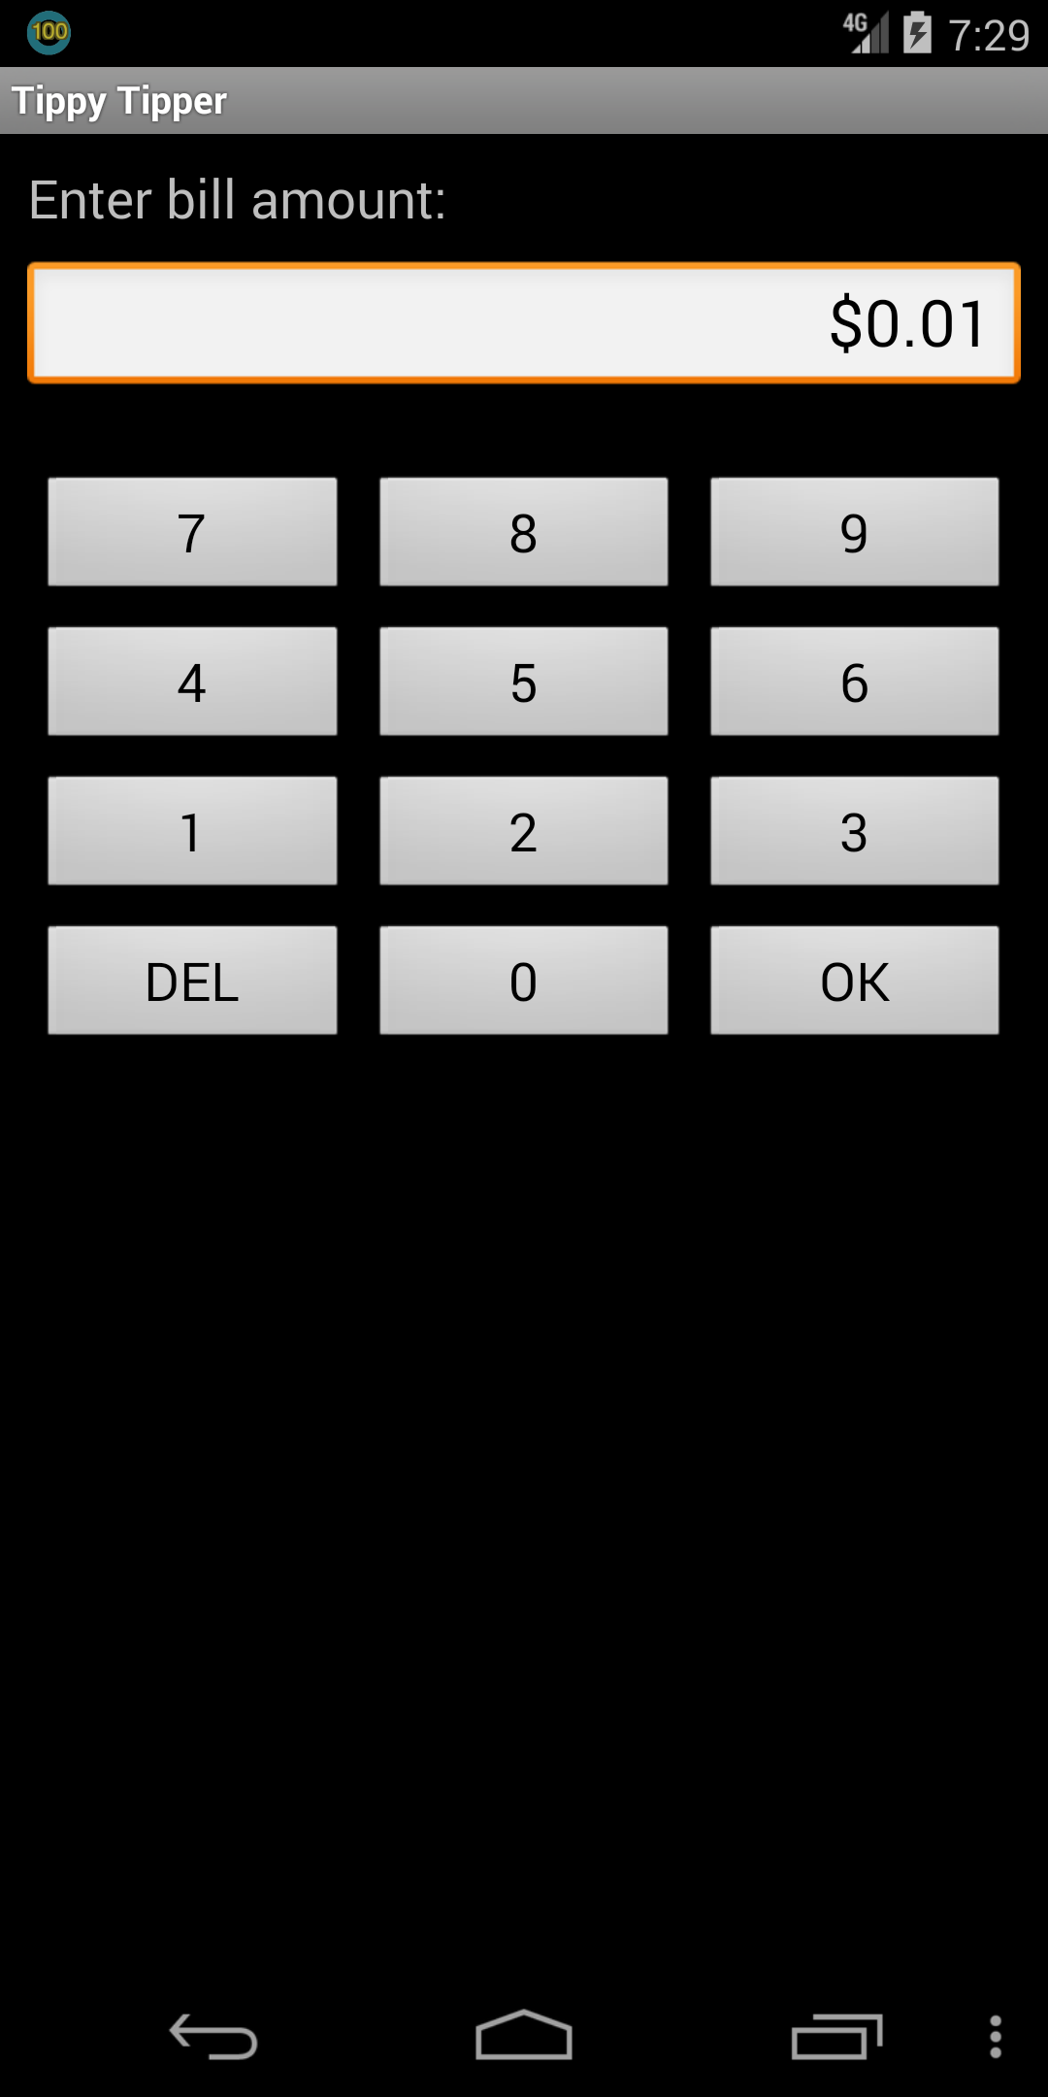 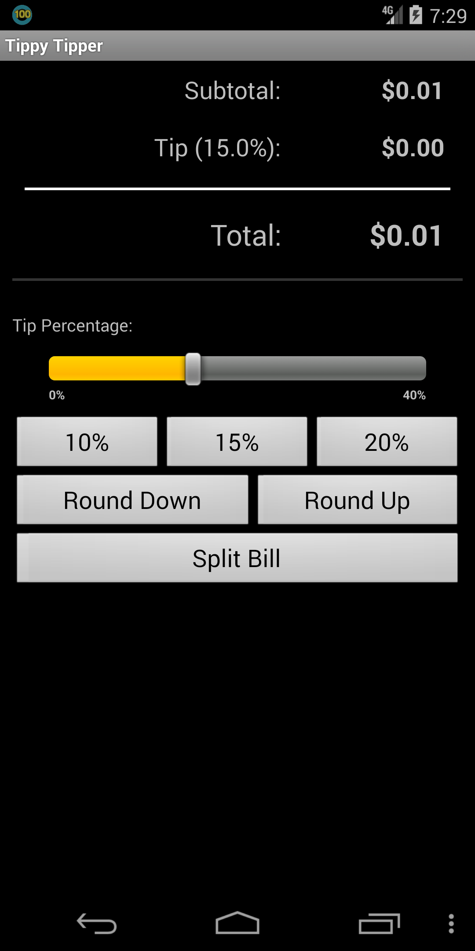 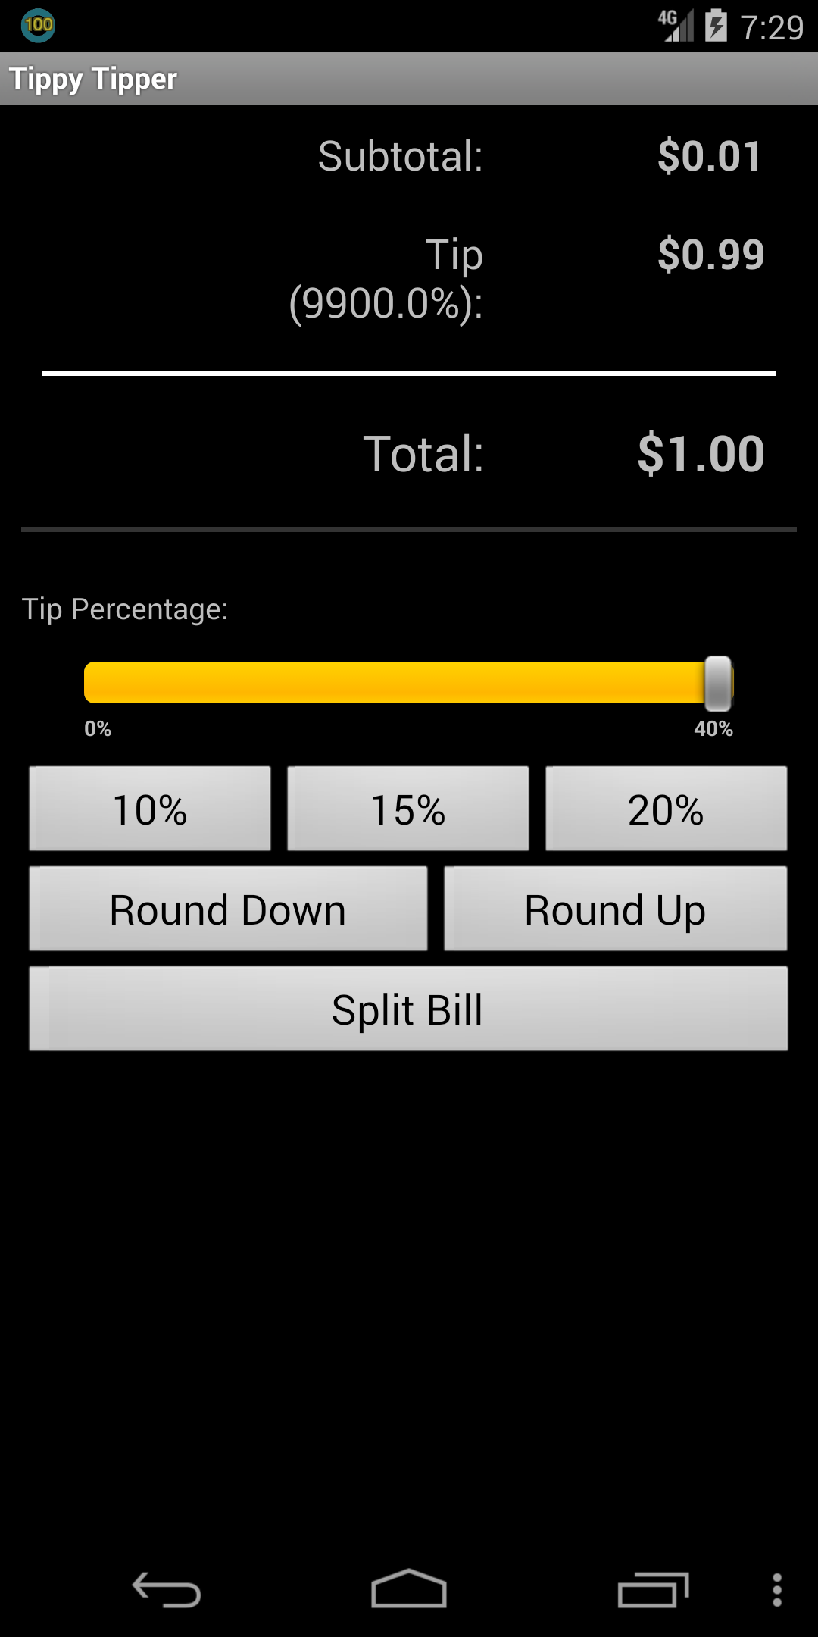

Click "1” and then “OK” click “Round Up” Tip amount is 9900.0%

When the bill amount is low, the “round up” will cause an abnormally high tip rate, which is significantly greater than its limit of 40%.

1. Swiftp_free: ChatGPT3.5 response (App_ be.ppareit.swiftp_free_21_src_oracle_0.mhtml )

Yes, there is a logical error. Reason: Clicking on "Running;Start FTP server;" should start the FTP server, but instead, it shows the message "Failed to start the FTP server, no wifi?". This behavior indicates a logical inconsistency.

Bug trigged Flow:

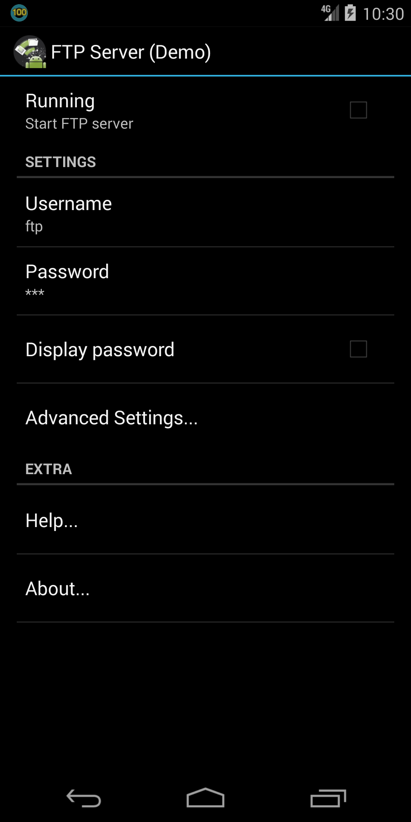 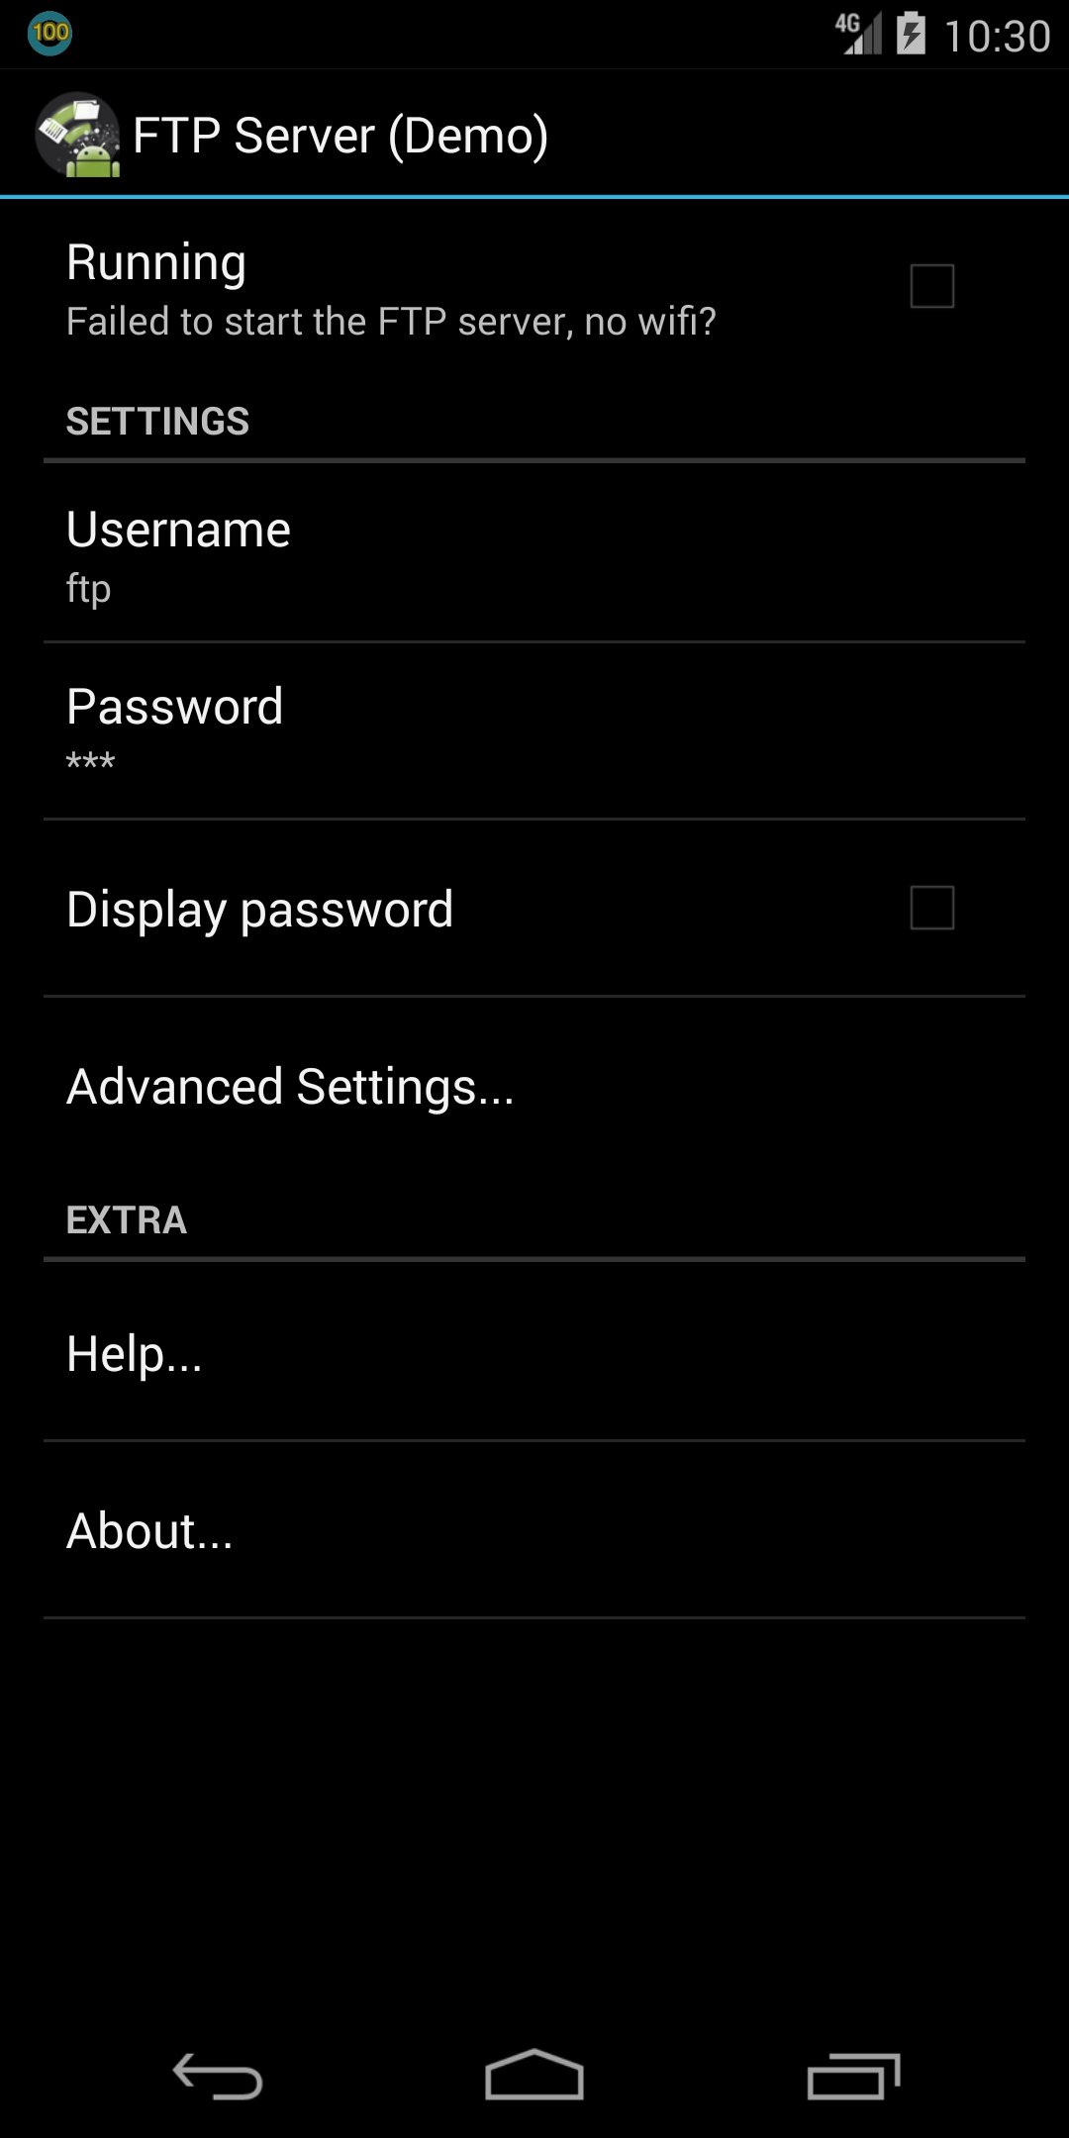 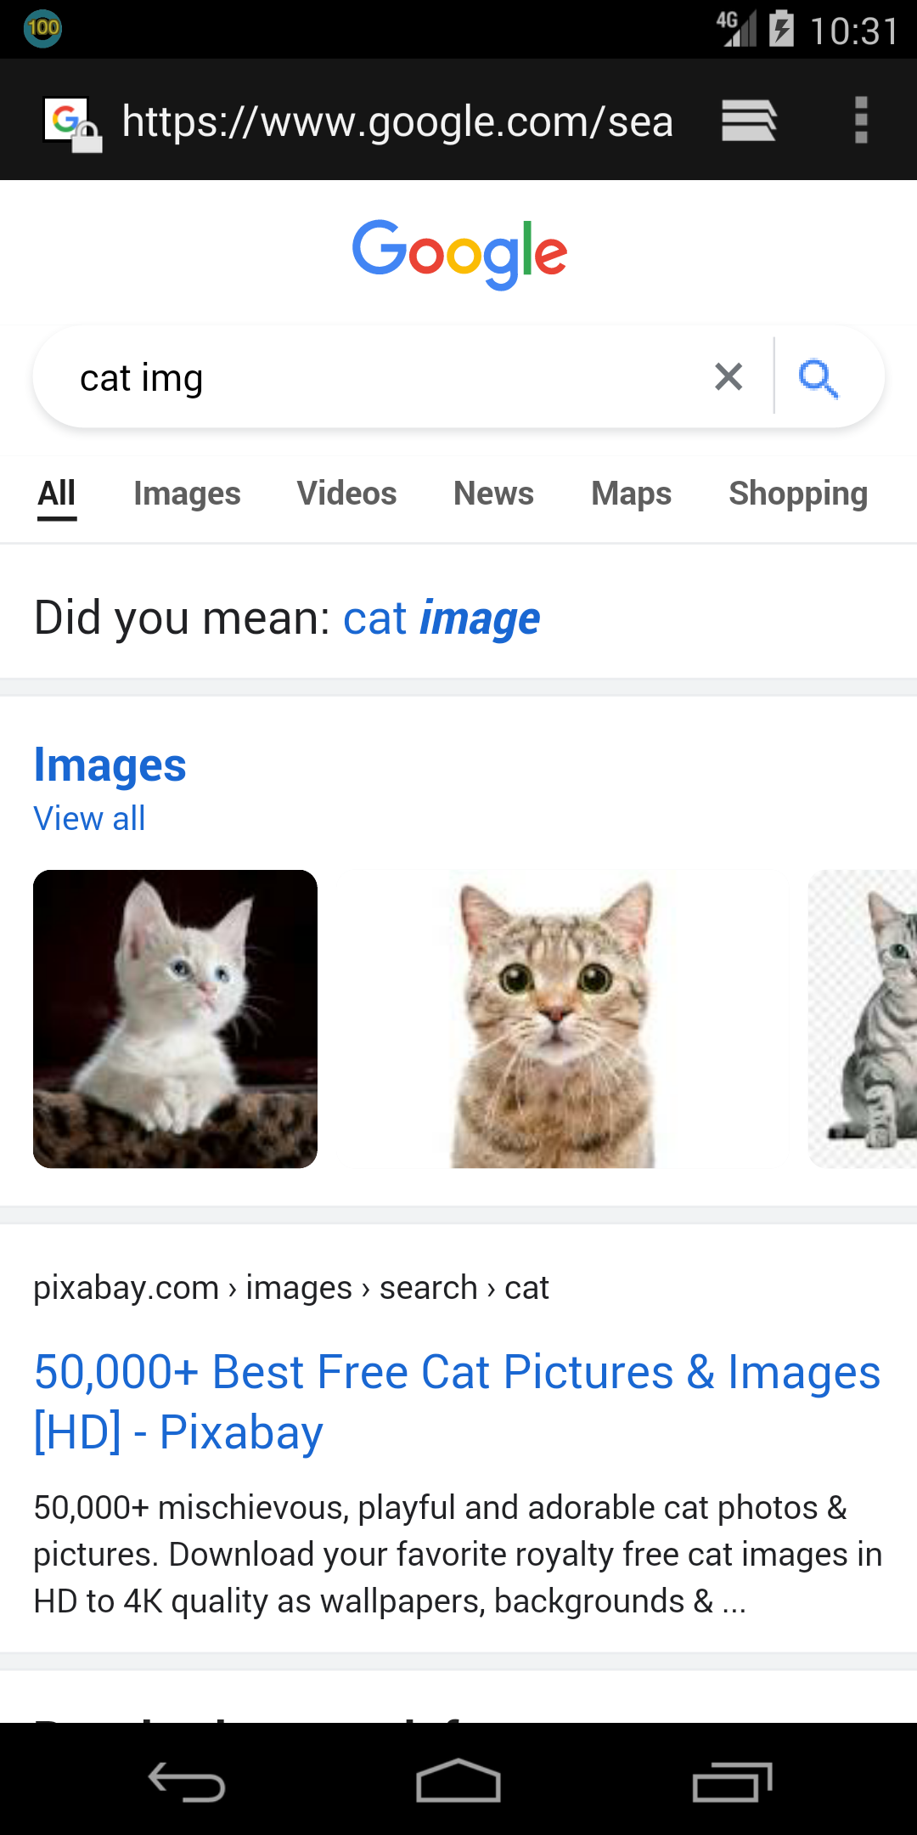

Click “Running” It shows “Running;Failed to start the FTP server, no wifi?”

The internet is working (see the google page in browser), but app cannot work properly

1. Wikipedia: ChatGPT4 response (App_ org.wikipedia_17_src_oracle_0.mhtml)

After clicking "Save page" multiple times and then navigating to "Saved pages", the output structure does not reflect the addition of any saved pages. The absence of visible saved page details or identifiers suggests that the "Save page" function may not be altering the application state as expected, which is inconsistent with the intended functionality of saving and subsequently viewing saved pages.

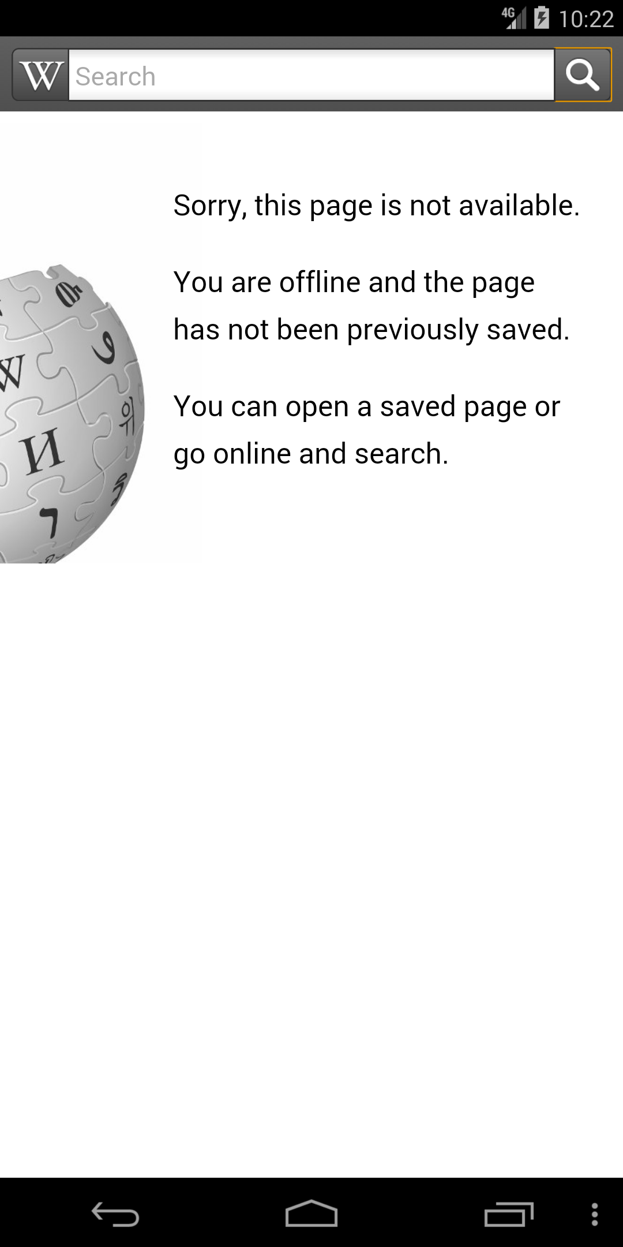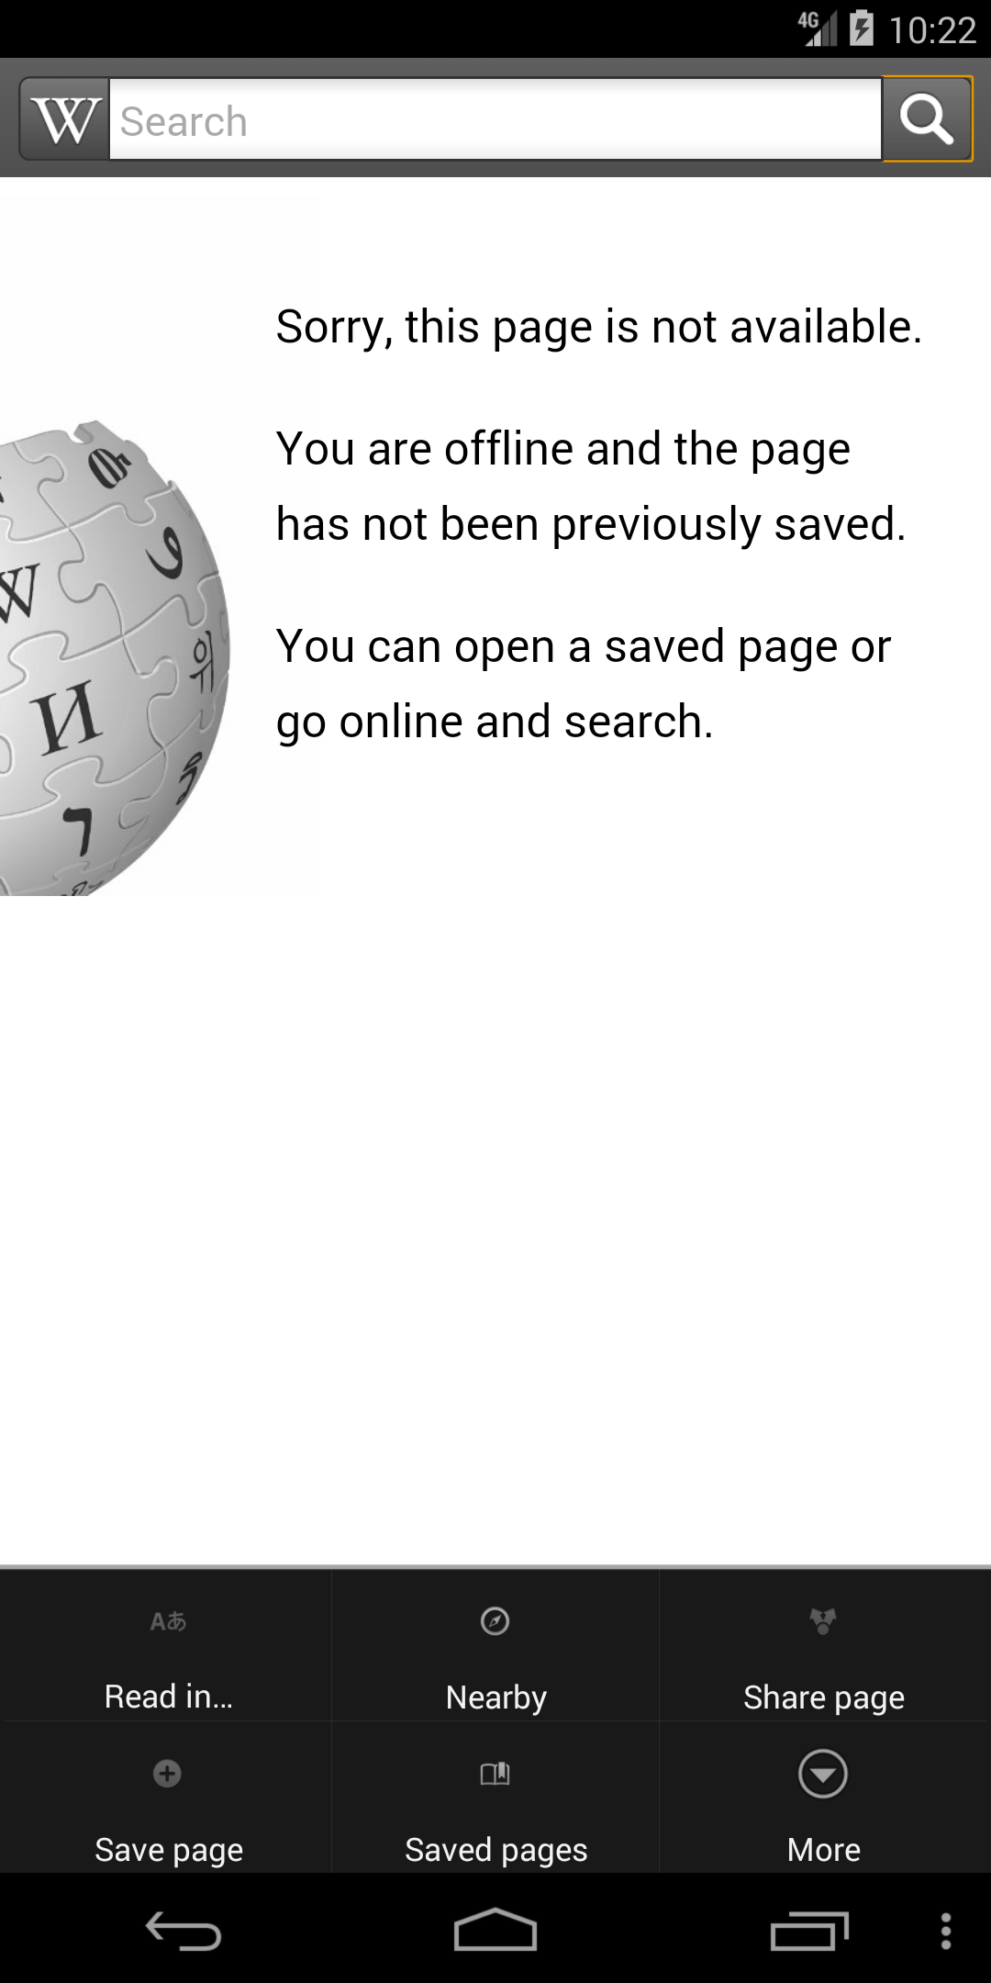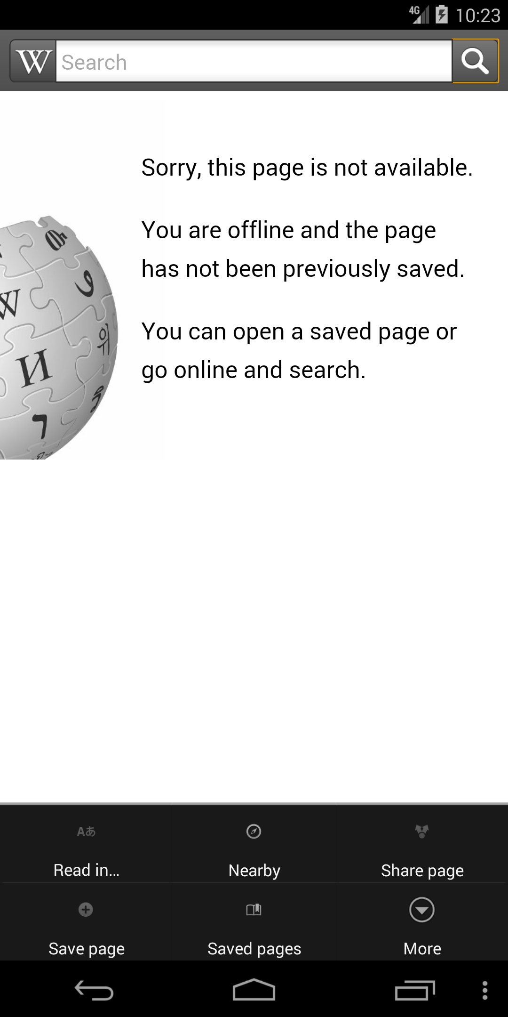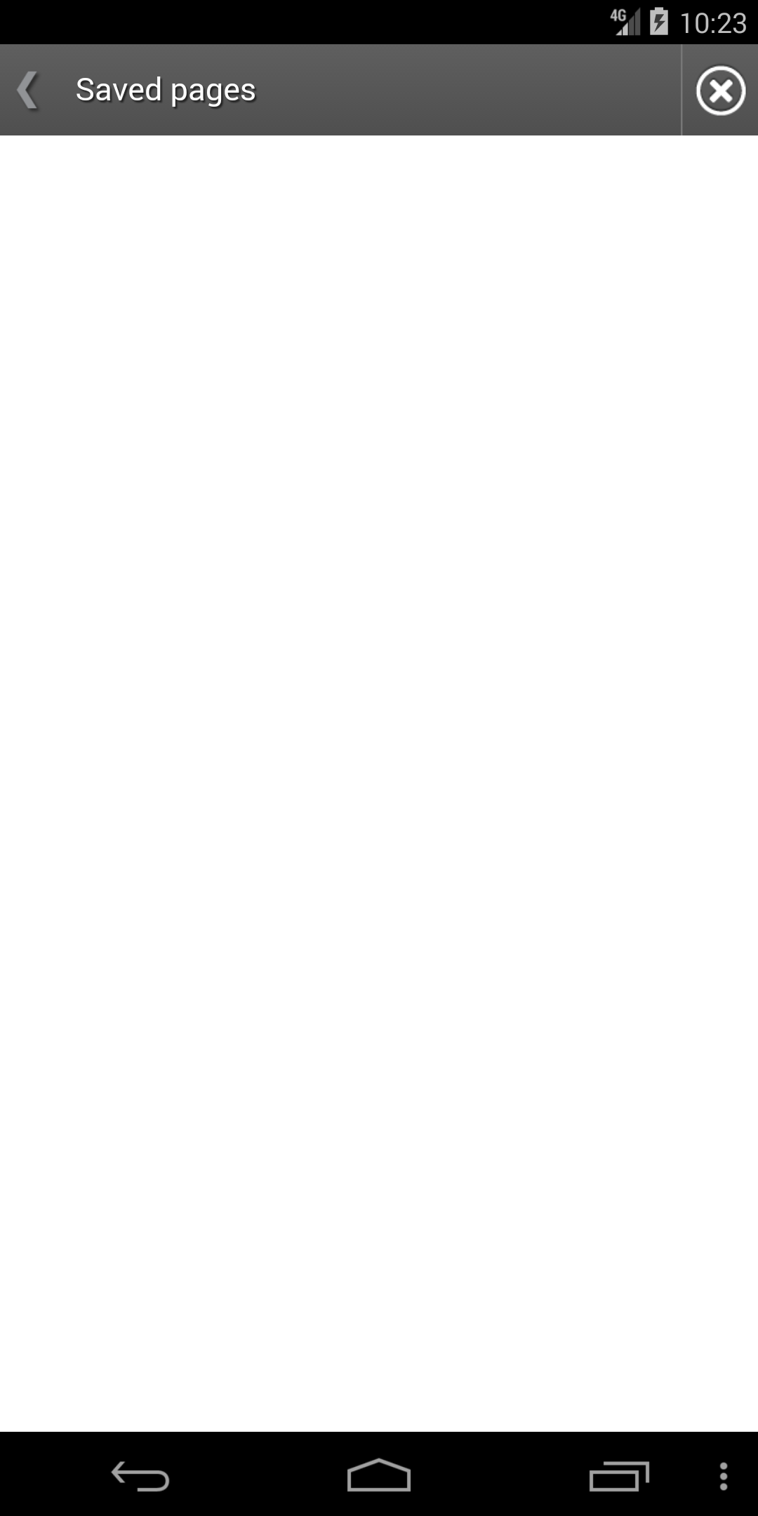 Click ”menu” button Click ”Save page” Click ”Saved page” Nothing shows here.

It means the “Save page” button does

not function properly. Bug triggered!

1. Translate: ChatGPT4 response (App_ Translate_oracle_0.mhtml )

Yes, there is a logical error. The error occurs when "Click Catalan" action is repeated. After the first click on "Catalan", the output structure displays additional language options like 'Chinese', 'Czech', 'Dutch', and maintains 'English' and 'Catalan'. However, when "Catalan" is clicked again immediately after, the output reverts to showing fewer options ('English', 'Catalan', 'Translate'), and displays an 'Error:Translation failed' message, which suggests an issue with the application state not being maintained correctly or a failure in handling repeated clicks on the same language option consistently.

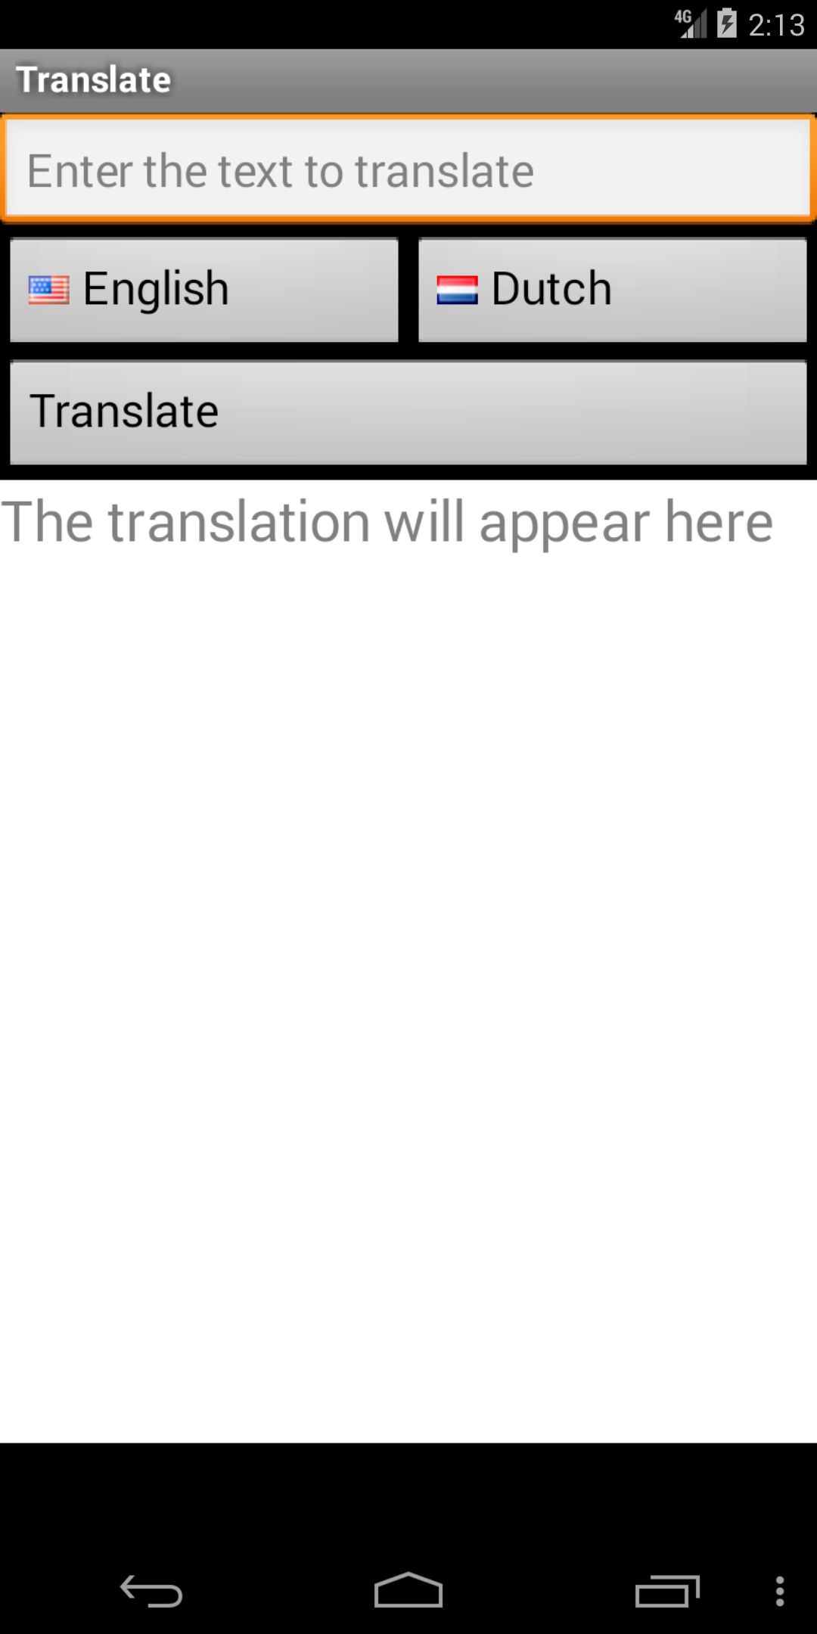 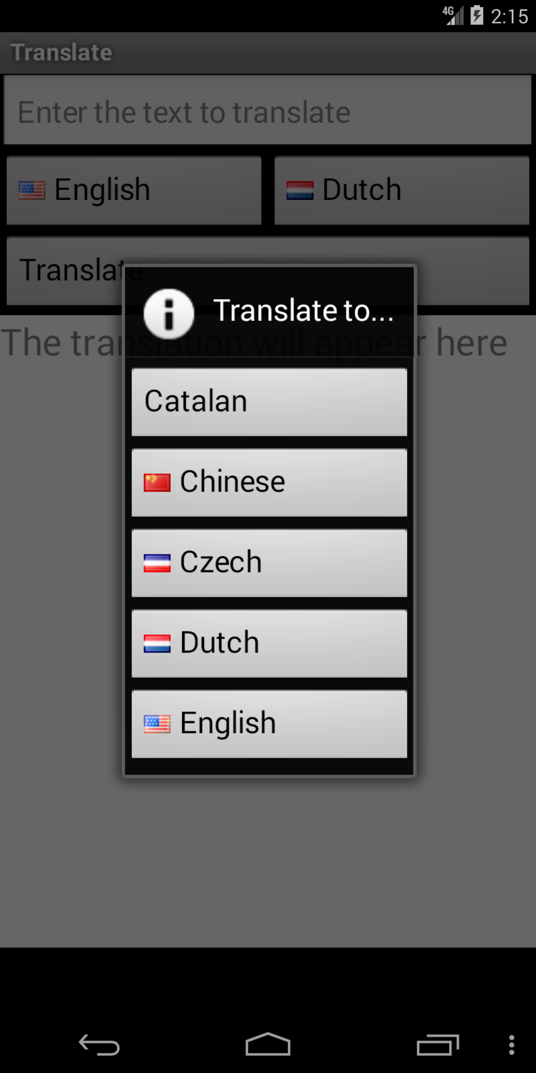 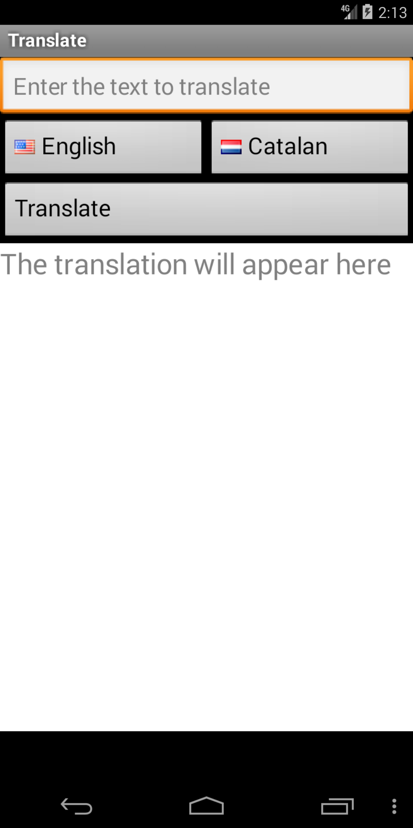

Open app and click “Dutch” Click “Catalan” Click “menu”

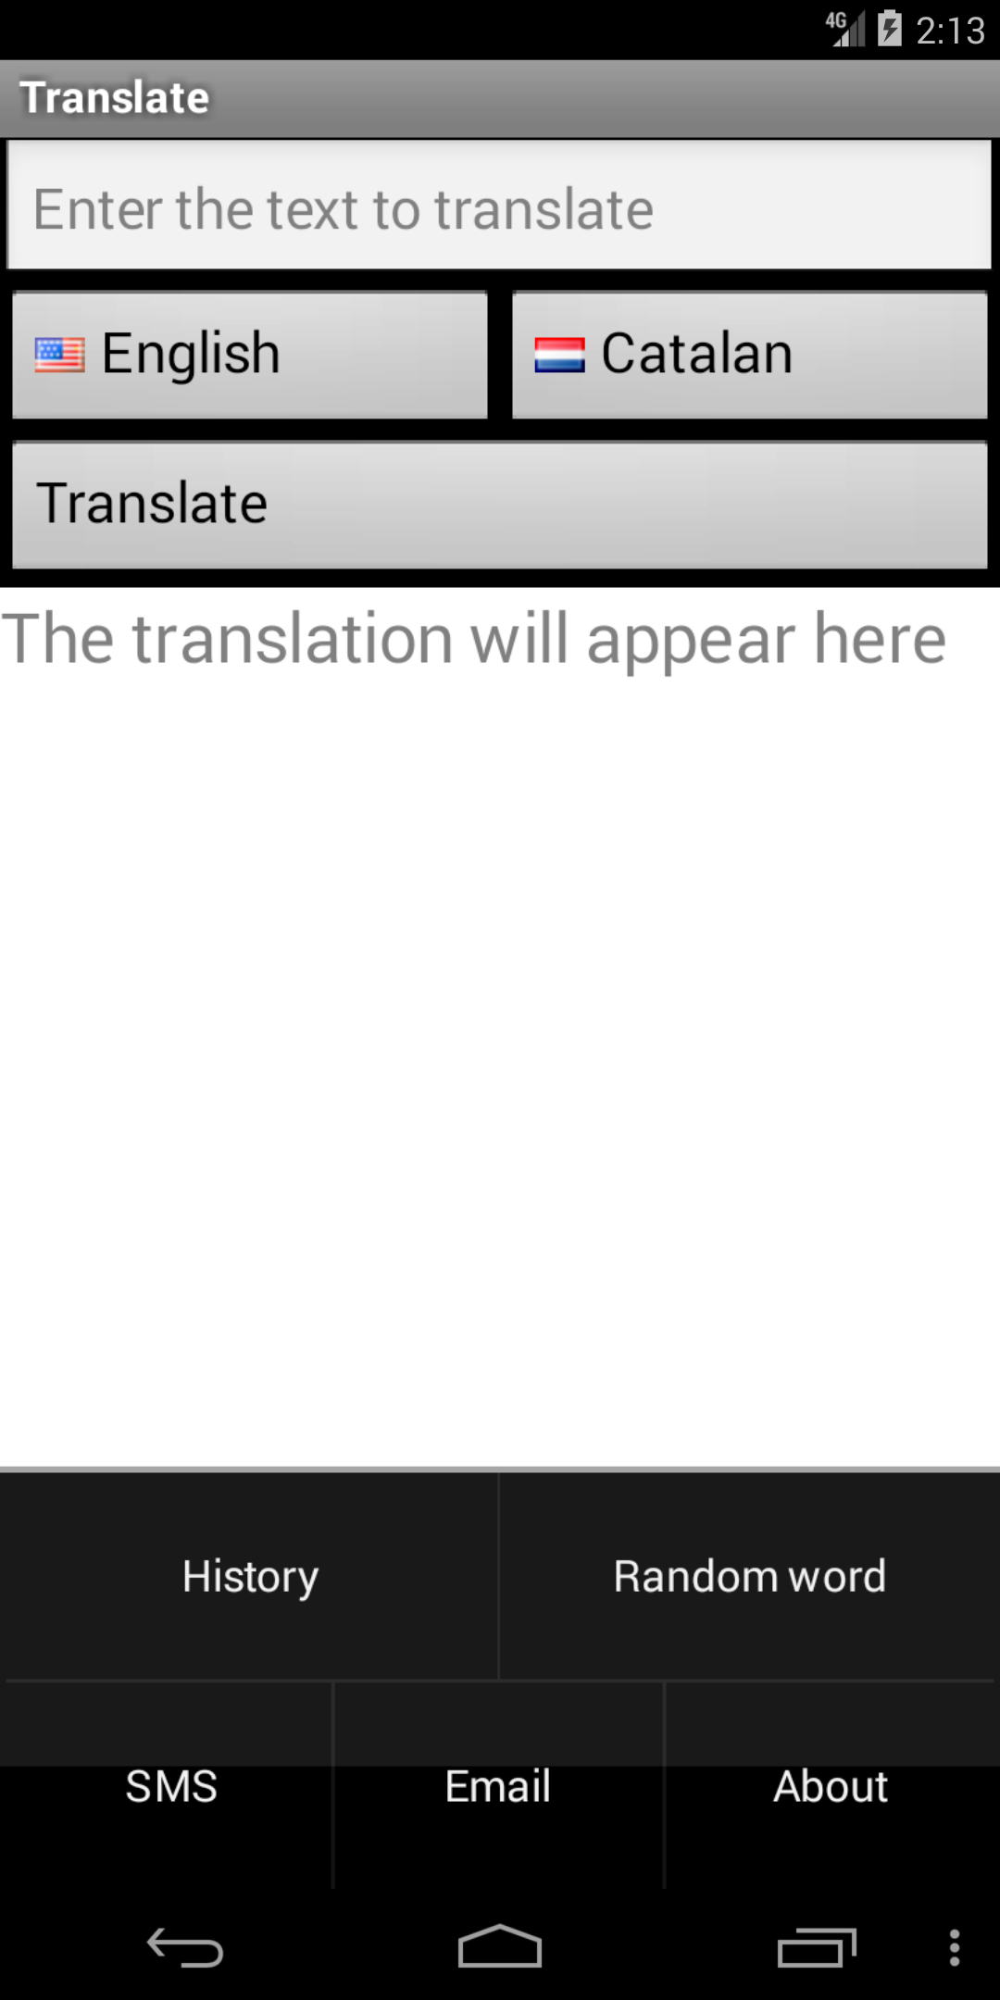 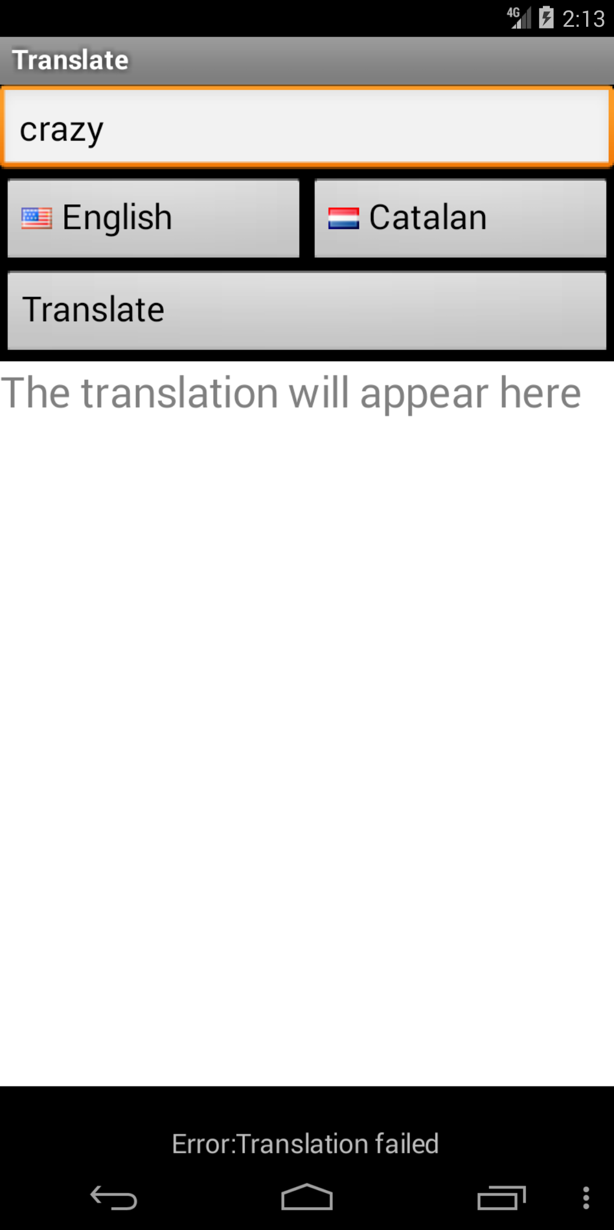

Click “Random word” “Error: Translation failed” shows. Bug Triggered!

1. A2DP Volume: ChatGPT4 response (a2dp.Vol_93_src(92).mhtml )

The screenshot provided appears to be from a mobile browser showing a security warning about a site's security certificate. This warning is not related to the app actions described in the sequence provided, which are focused on managing data and Bluetooth device settings within an app.

The sequence details the navigation through an app's menu, specifically around data management and Bluetooth settings for car and home docks. The final action mentioned is a long click on 'Bluetooth Devices;Home Dock;'. However, the screenshot is showing a security warning from a web browser, which is not an expected result of the described action in the app.

It is important to note that a browser security warning is a system-level notification and not a UI error within the app itself. Therefore, this discrepancy indicates a potential issue with the app's function or flow, as it is not supposed to lead to a browser or display a security certificate error when managing Bluetooth device settings.

Final decision: Yes, there is a discrepancy as the screenshot does not correspond to the expected output of the app's navigation sequence.

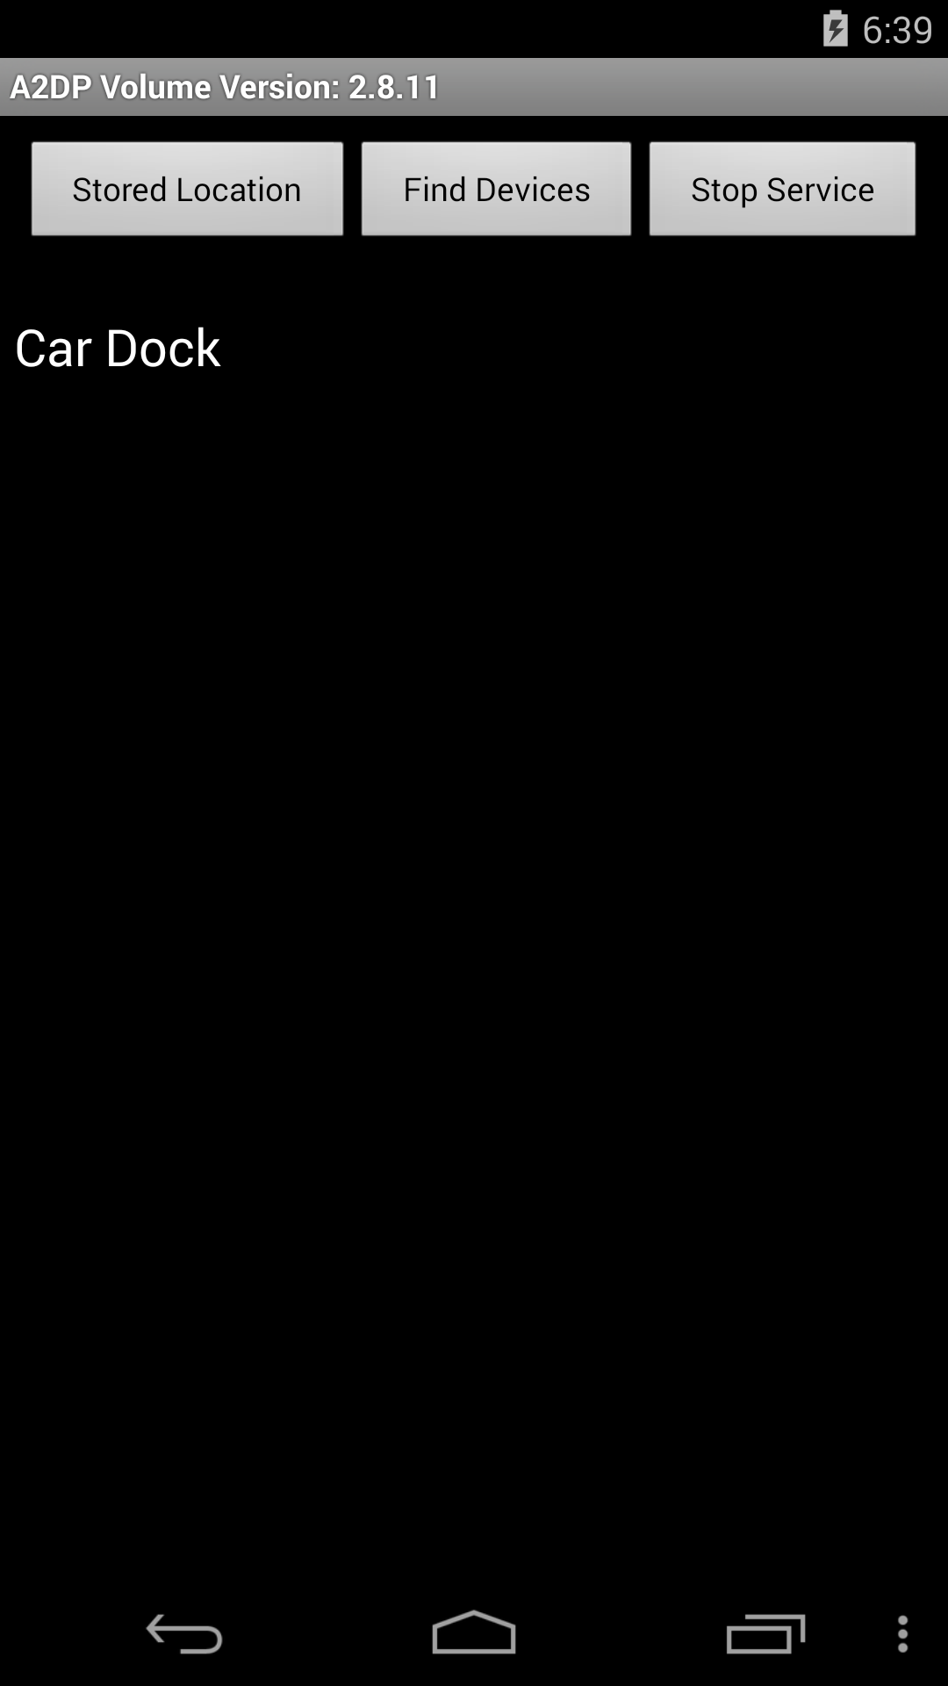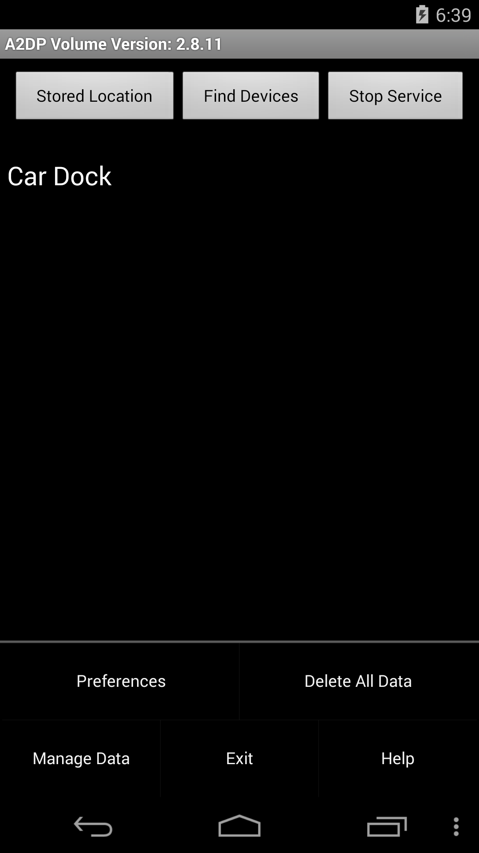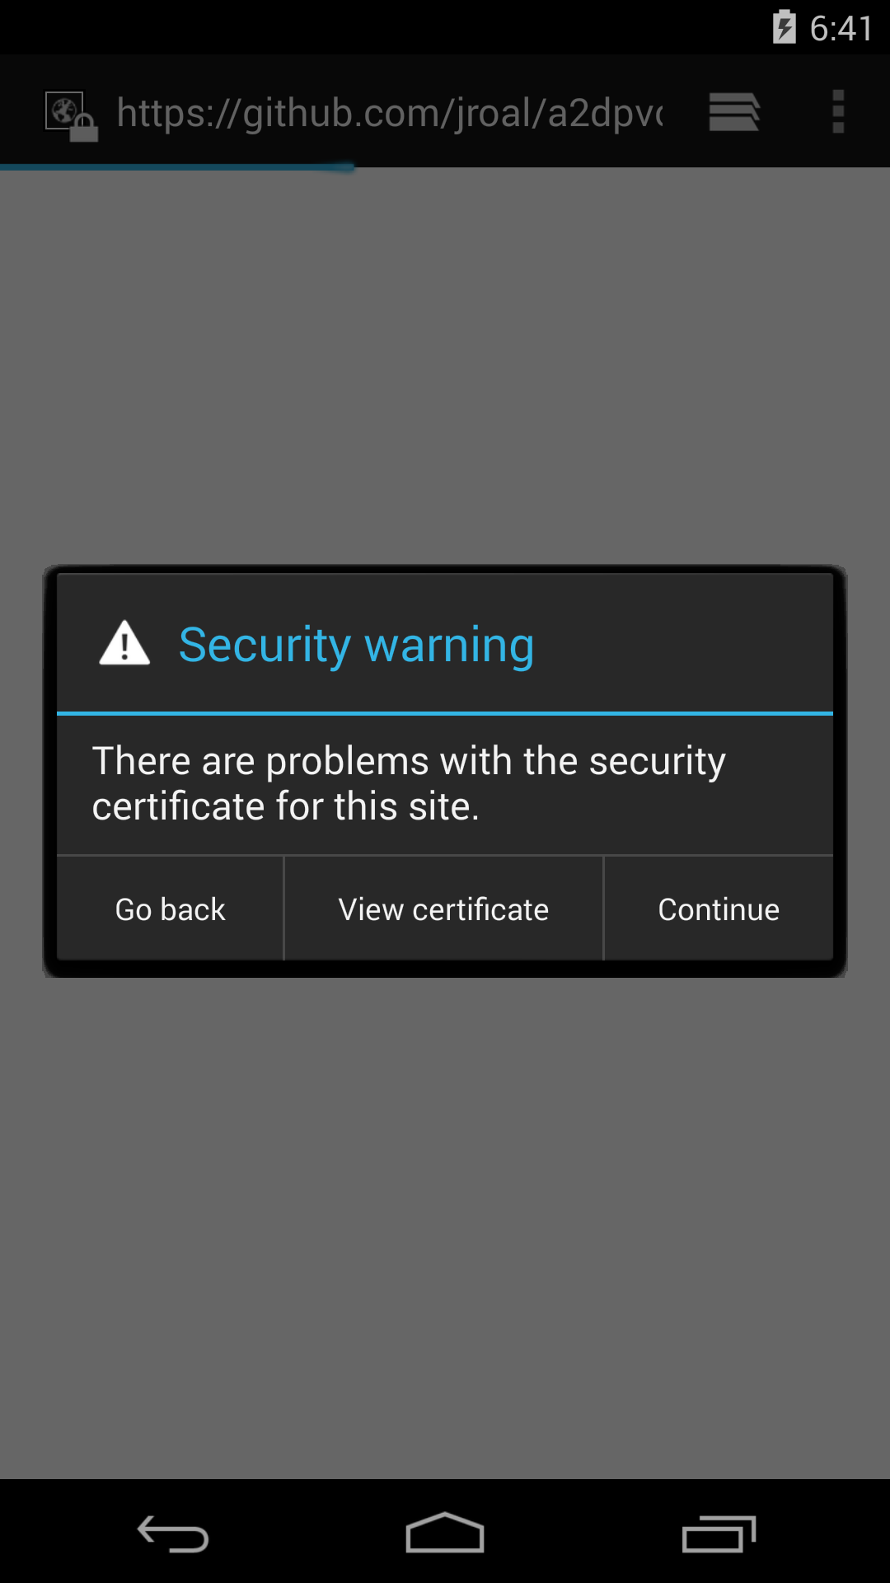

Click “menu” Click “Help” Jump to site which cause endlessly Security warning

1. aagtl: ChatGPT4 response (com.zoffcc.applications.aagtl_31_src_oracle_0(20).mhtml)

Yes, there is a UI error in the screenshot. The error message "Failed getting top 100 track :(" does not correspond to any text described in the provided app sequence actions. Also, there are graphical elements (red lines, blue and yellow dots) that are not described in the text of any page, and thus may be indicative of a UI error or an unfinished interface. The app sequence also does not describe an error message or these graphical elements as part of the expected UI.

Final decision: UI error detected.

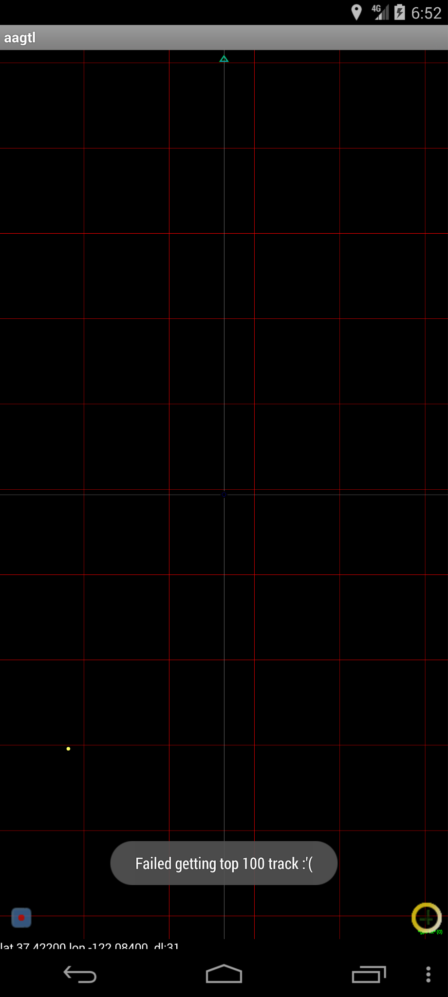

On restart the app, it reports “Fail getting top 100 track :’C”

1. Adsdroid: ChatGPT4 response (hu.vsza.adsdroid_2_src_oracle_0(14).mhtml )

Yes, there is a UI error. The input text field contains "input text{.34567890987123}" which does not correspond to any action in the provided sequence, implying that it could be placeholder text or unintended input, and thus, it is inconsistent with the expected output. Additionally, the error message "Error fetching results." may indicate a functional issue, but it is not possible to determine if this is consistent with the expected behavior without further information about the application's intended error handling.

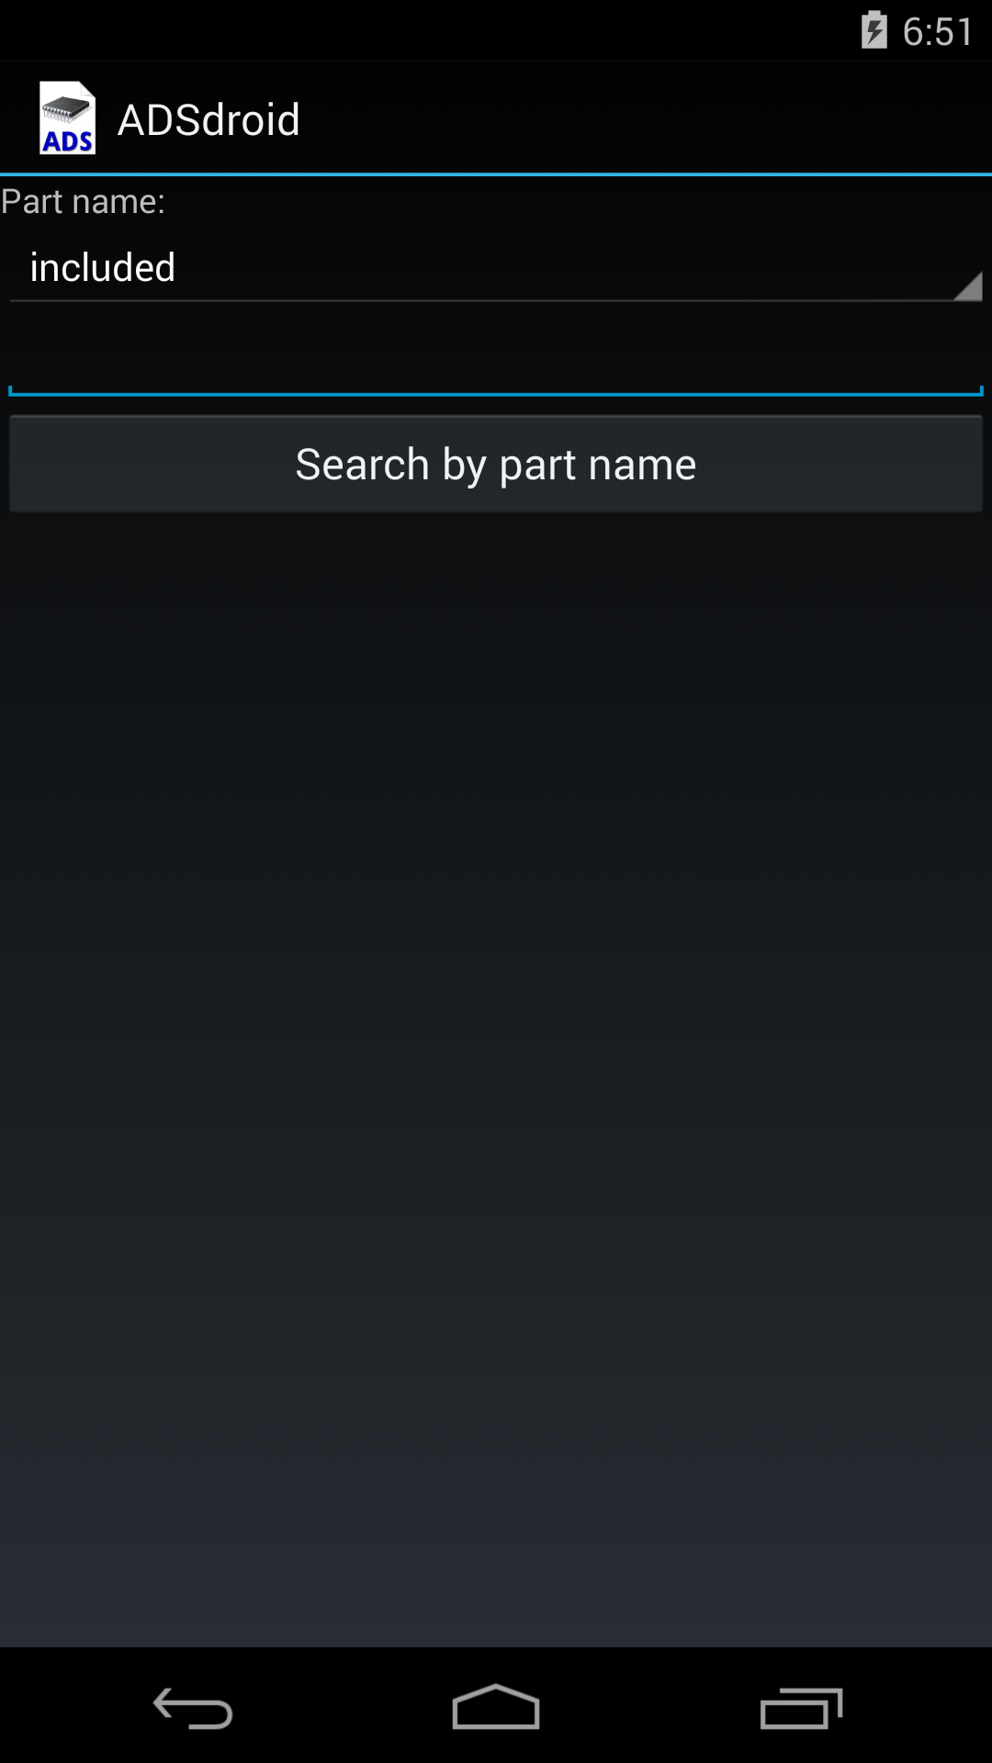 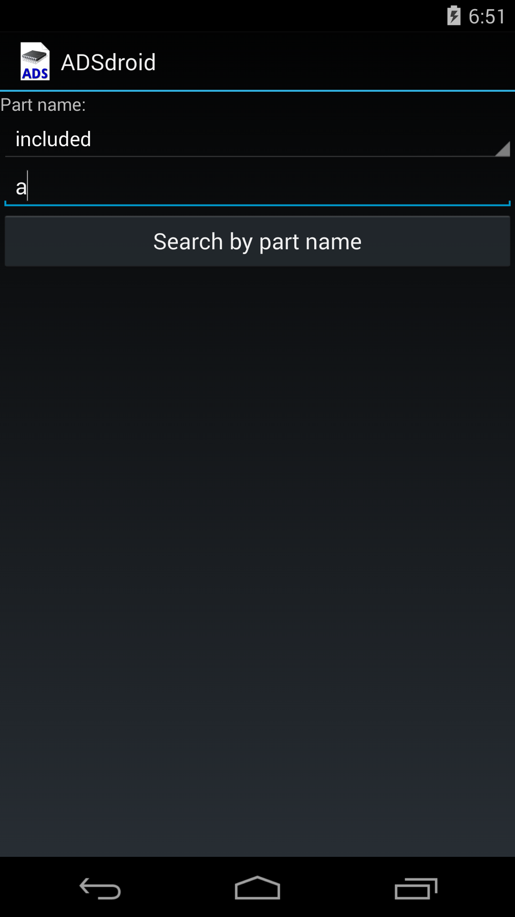 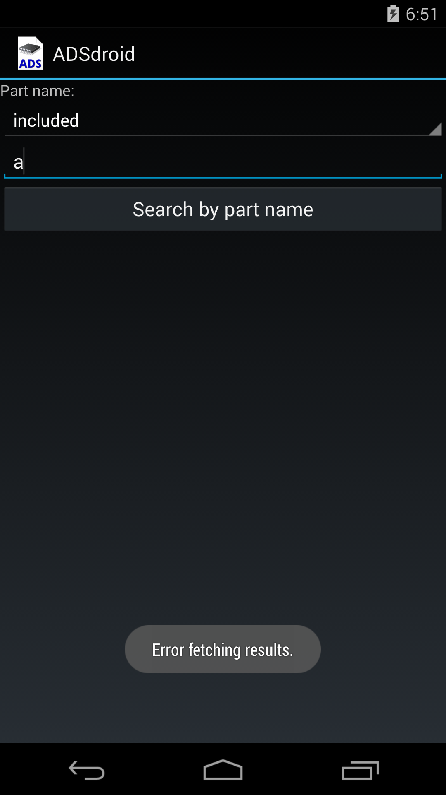

Input “a” in placeholder Click “Search by part name” Error message pop up.

1. AnyCut: ChatGPT4 response (AnyCut_oracle_2(84).mhtml )

Yes. The pop-up dialog shows an error message stating "Name cannot be empty," which indicates a mandatory field has not been filled out. However, according to the sequence provided, there has been no action that would lead to a name entry prompt or error message like this, suggesting a discrepancy.

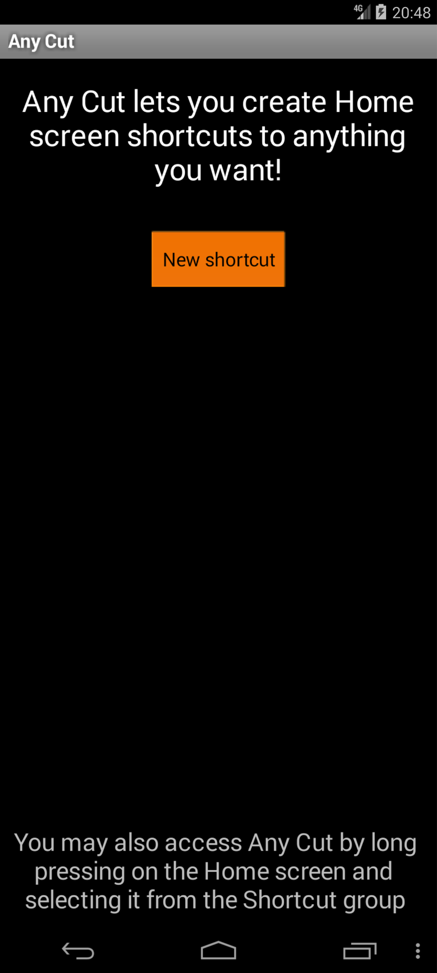 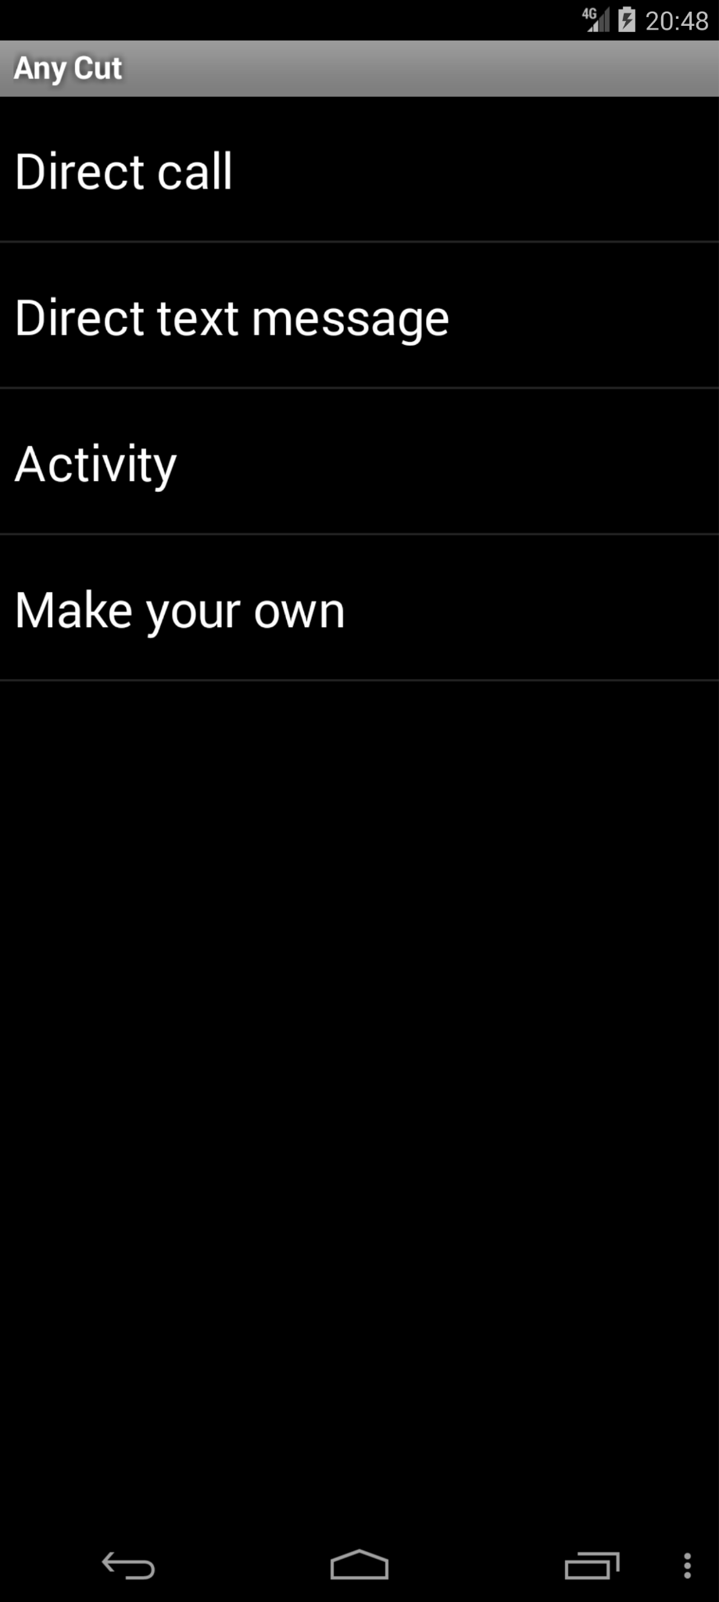 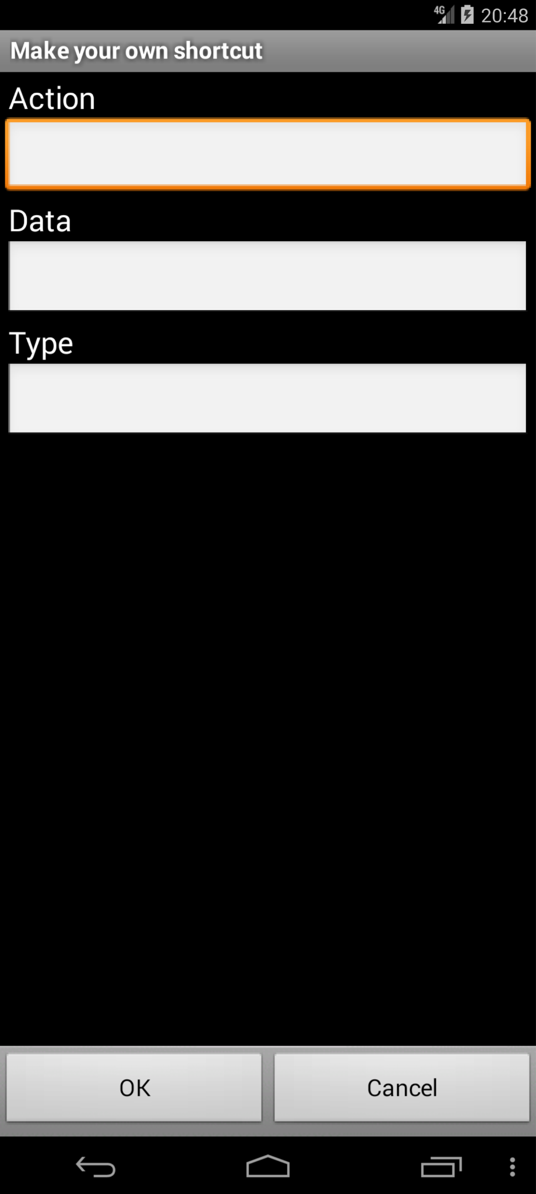 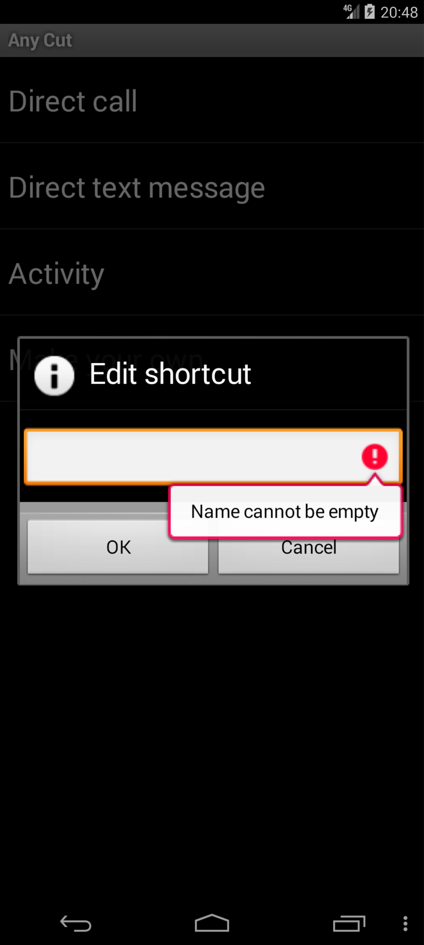

Click “New shortcut” Click “Make your own” Click “OK” Unexpected message triggered

before clicking anything.

1. Anymemo: ChatGPT4 response (anymemo-stable-8.3_oracle_0(103).mhtml)

Yes.

The error message displayed is inconsistent with the one described in the provided action sequence. The action sequence specifies a JSONException related to converting an HTML string to a JSONArray, while the screenshot shows additional text about checking the internet connection, which is not mentioned in the action sequence.

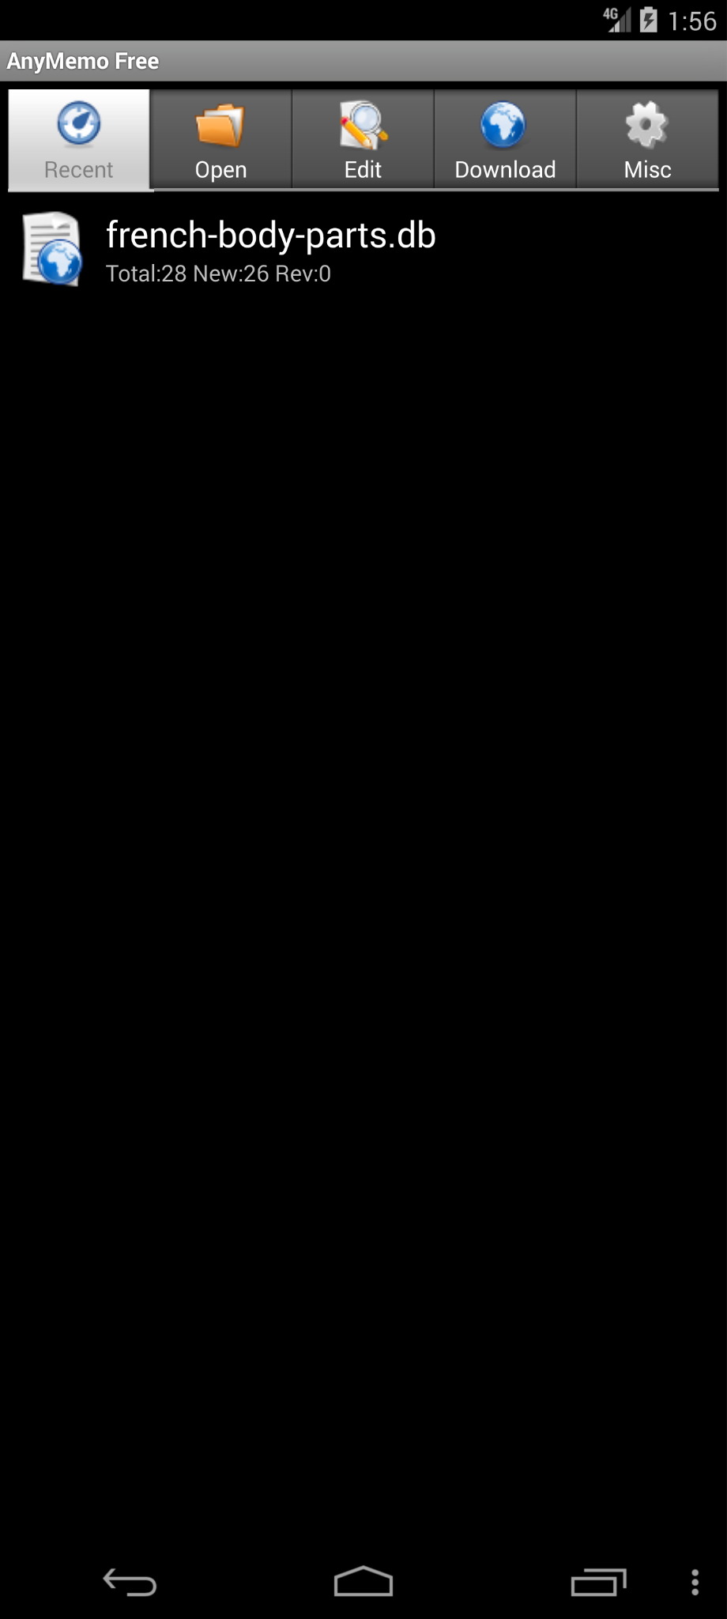 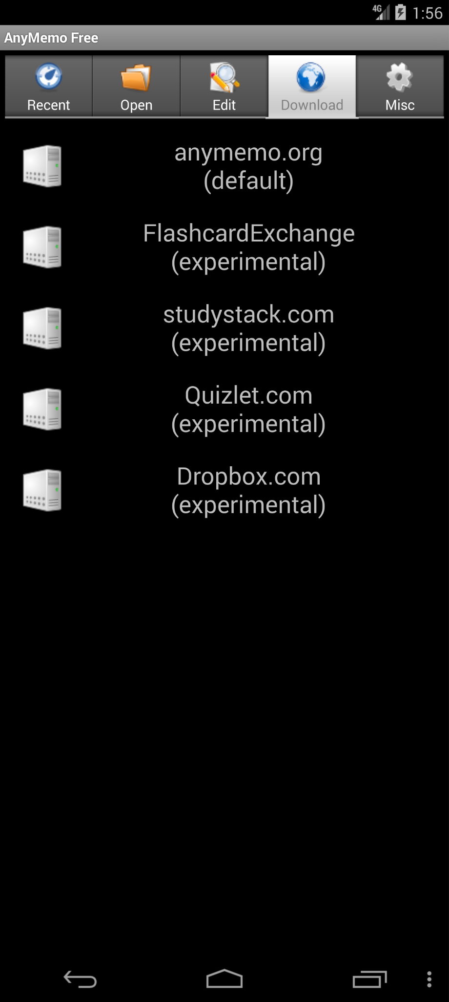 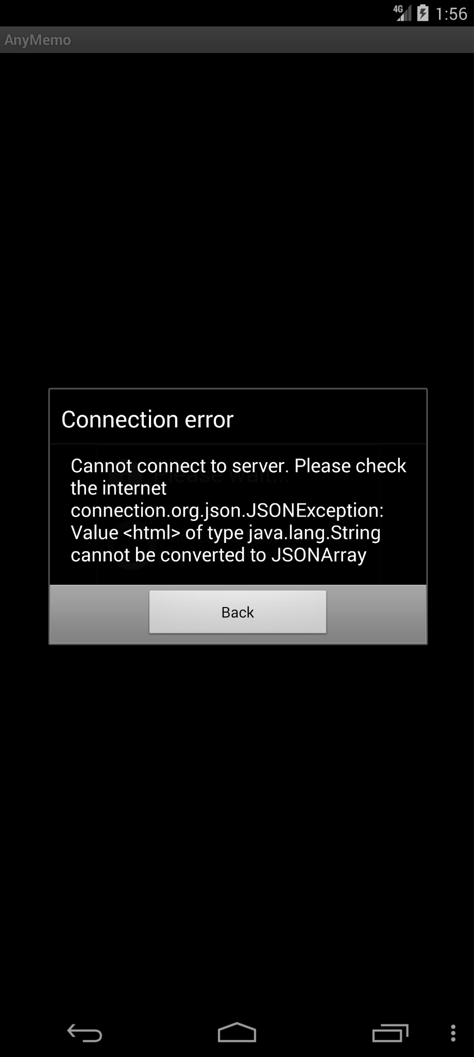

Click “Download” page Click “anymemo.org\n(default)” Error message pop up

Given the internet is working properly.

1. Anymemo: ChatGPT4 response (anymemo-stable-8.3_oracle_1(154).mhtml )

Yes.

The text on the button should read "Search by user;" according to the sequence provided, but the screenshot displays "Search by tag" on the pop-up dialogue, indicating a mismatch in the text.

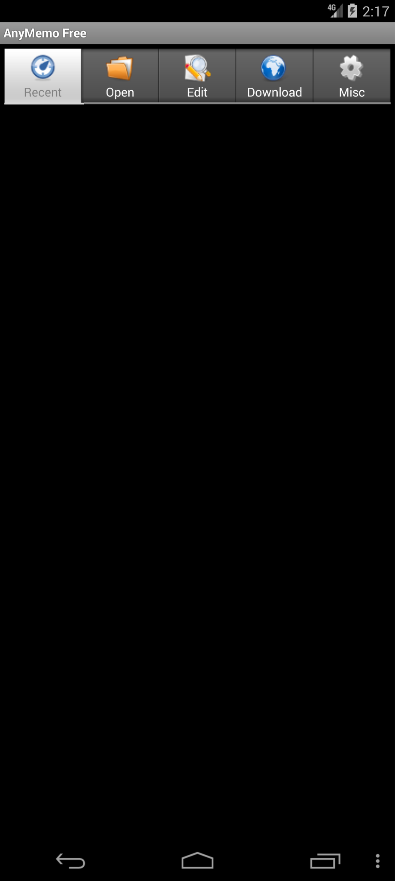 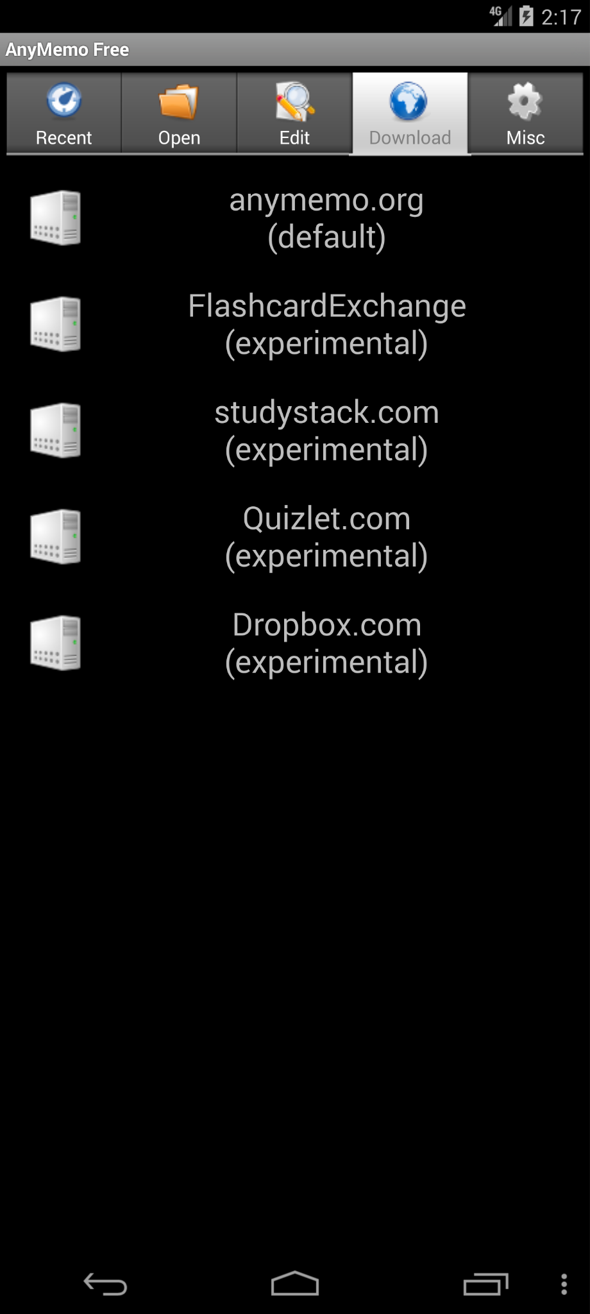 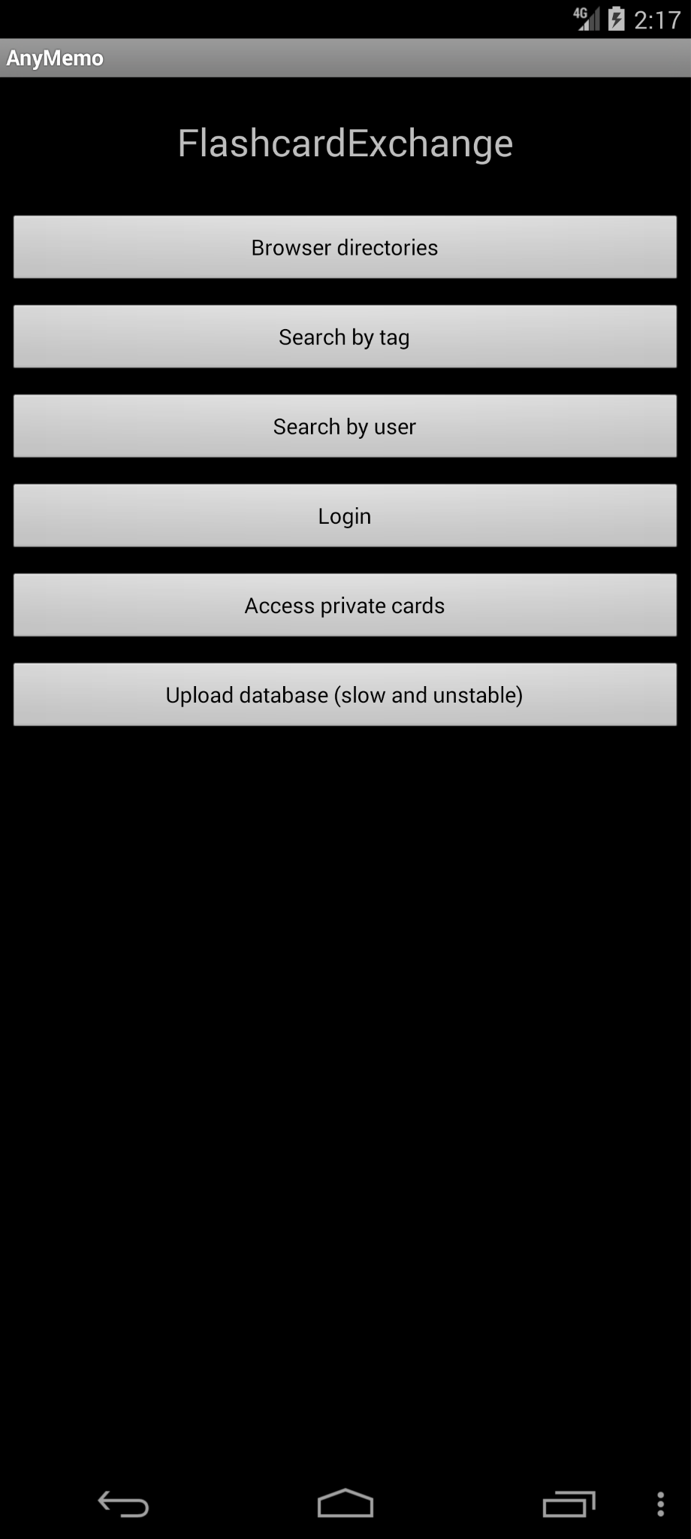 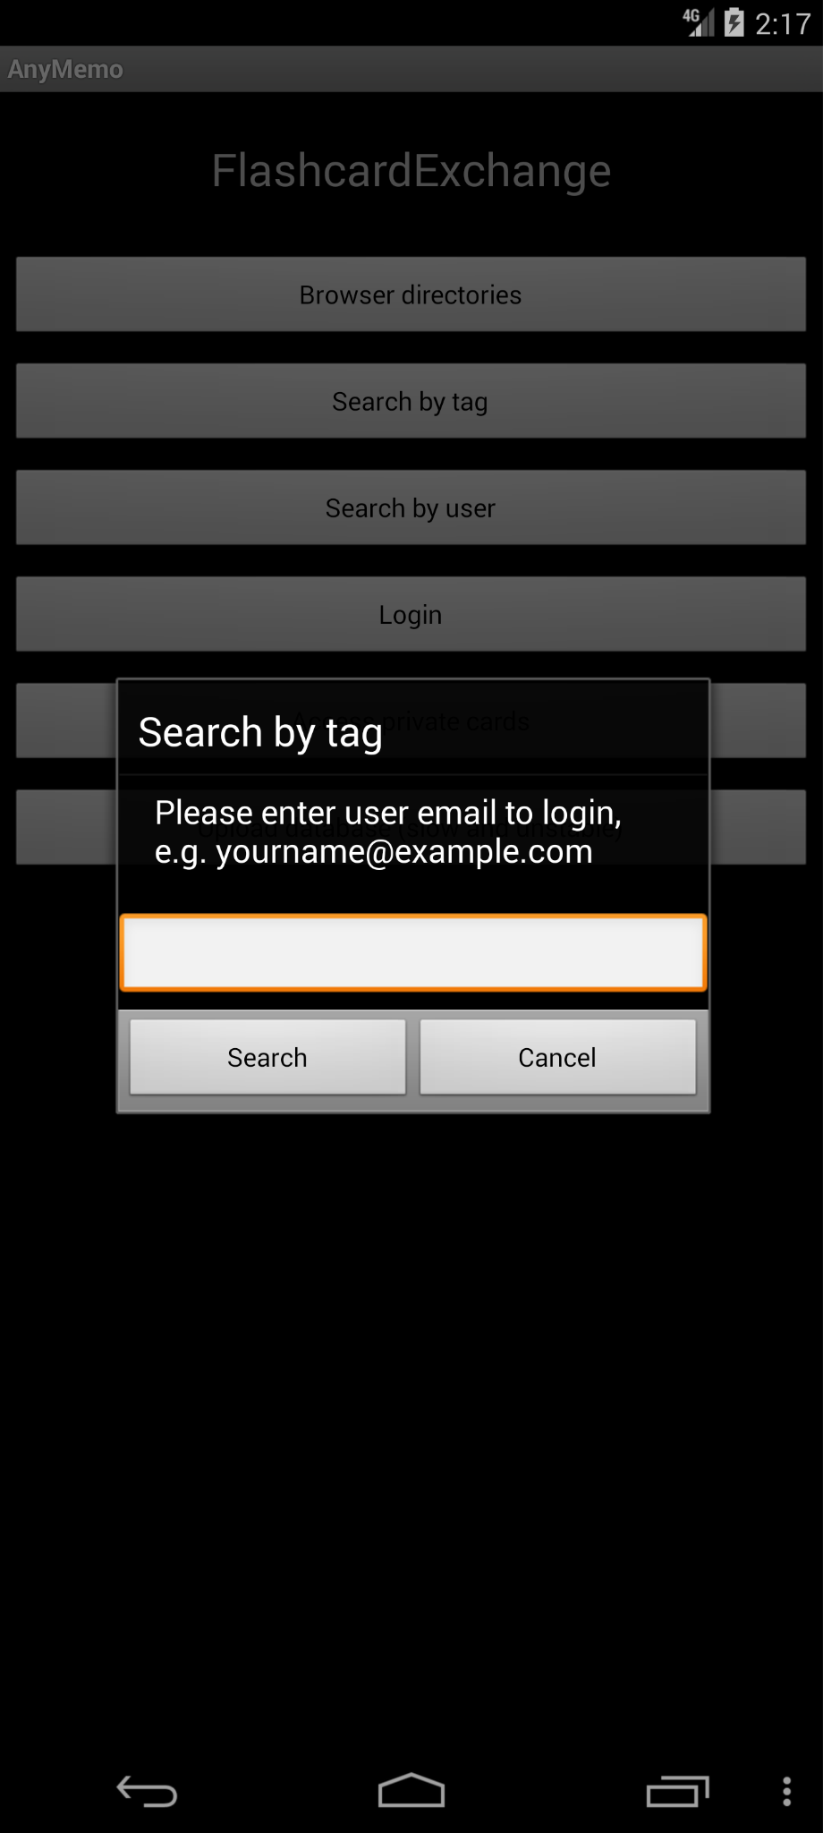

Click “Download” page Click “FlashcardExchange\n(experimental)” Click “Search by user” Pop up windows is wrongly titled

“Search by tag” rather than “Search by user”

1. Bites: ChatGPT4 response (caldwell.ben.bites_4_src_oracle_0(252).mhtml )

Based on the sequence provided and the screenshot, here is what I've found:

1. Redundant Elements:
   * The screenshot shows the text "test123" multiple times in different font sizes, which suggests that there might be redundant elements, as the sequence descriptions indicate that "test123" should likely only appear once as a button or text label.
2. Cut-off Text:
   * The text "test1" followed by "2" and then "3" on separate lines could indicate that a complete statement is truncated or improperly formatted, which is an error.
3. Missing Elements:
   * According to the action sequence, there should be tabs labeled "Bites," "Recipes," "Ingredients," and "Method." The screenshot does not clearly show these tabs, which could either be a navigation or display error.

Given the discrepancies with redundant text elements, potential cut-off text, and possibly missing tabs, it is likely that there are UI errors present in the screenshot.

Final decision: Yes, there are UI errors present.

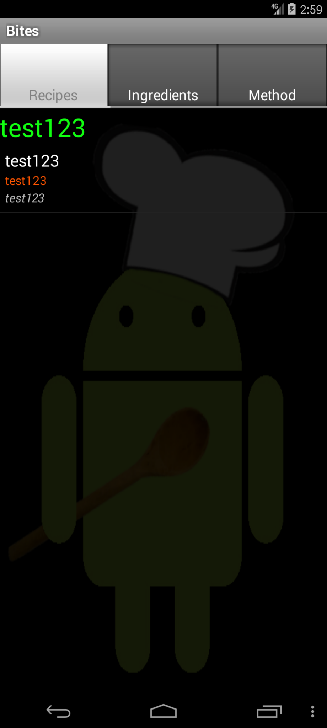 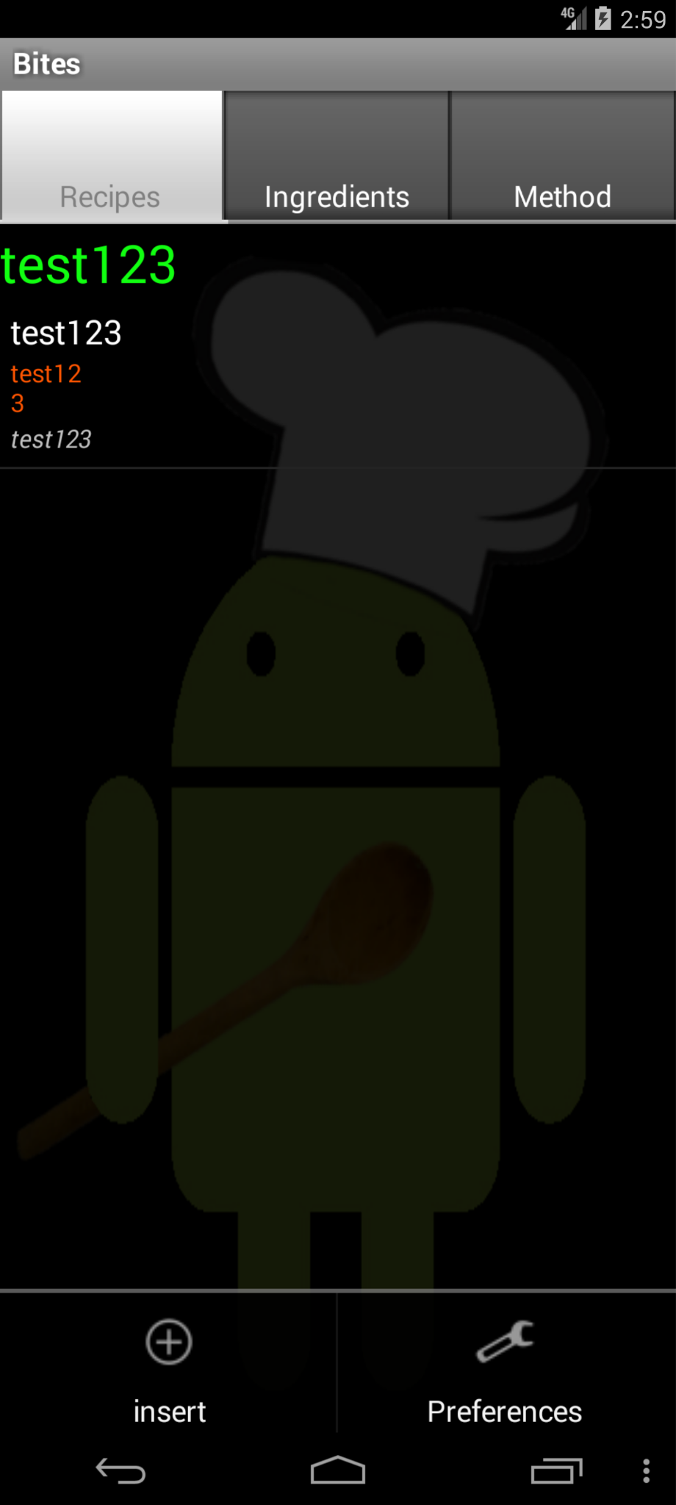 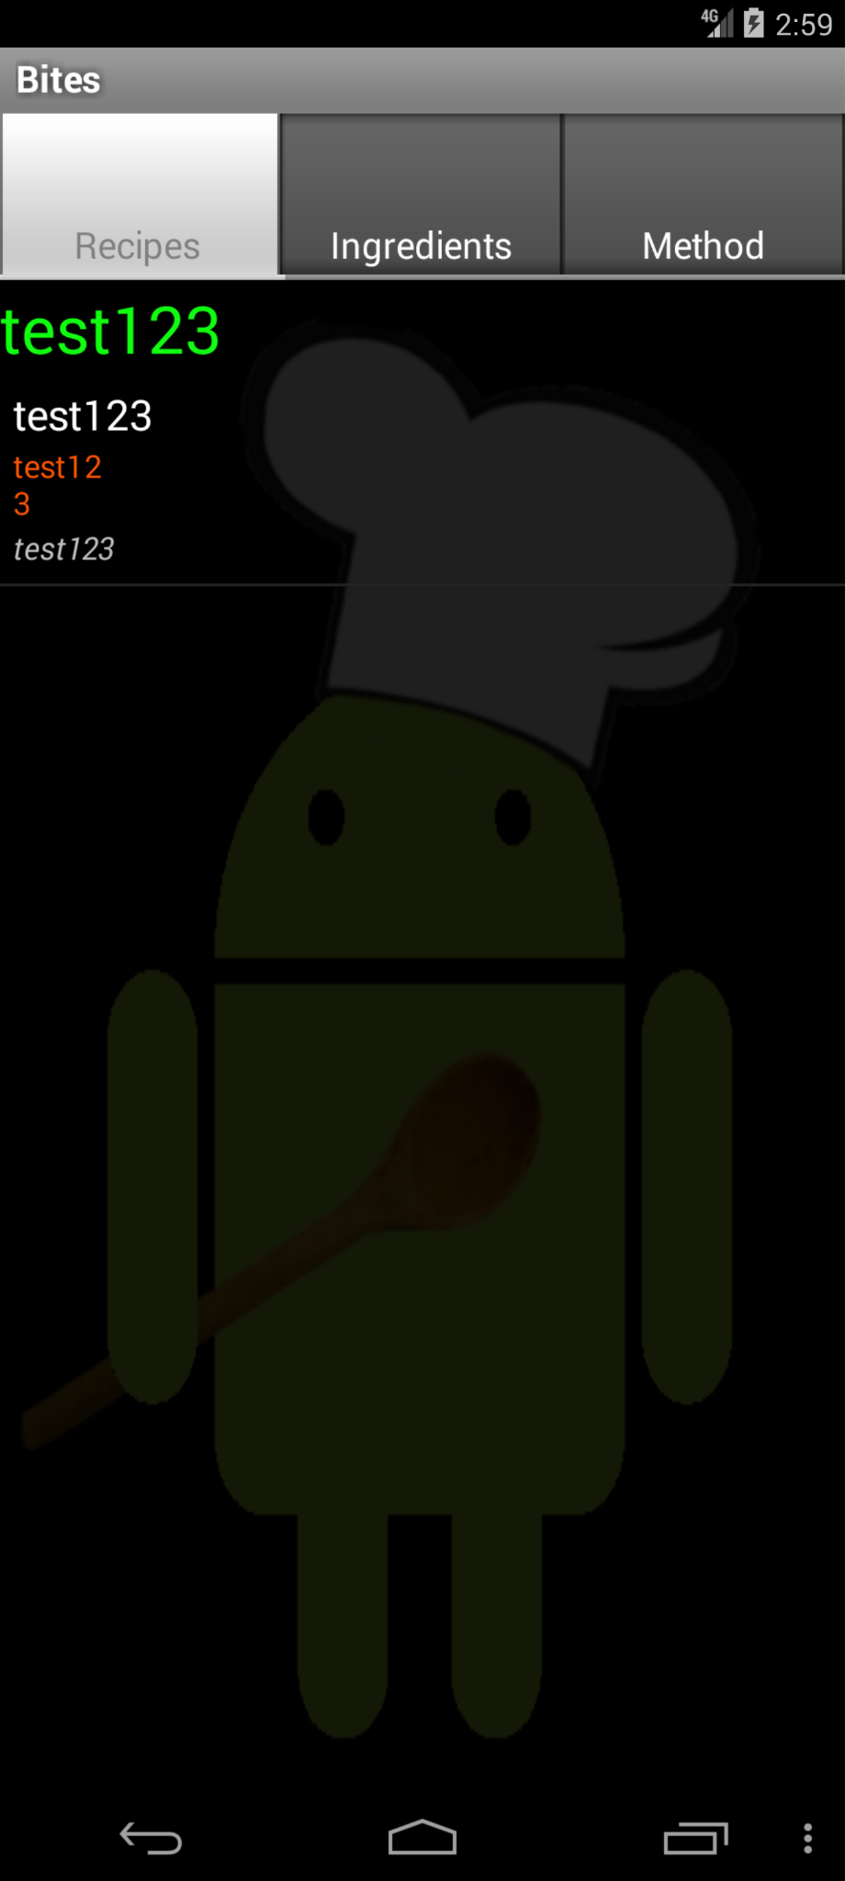

Click “menu” Click “back” In either page, “text123” is truncated into 2 lines.

16. Dalvik-explorer: ChatGPT4 response (dalvik-explorer(17).mhtml )

Yes, there is a UI error in the screenshot. The error message "Couldn't read '/dev/cpu0'" overlaps with the item "cpu_dma_latency," which makes both the error message and the item beneath it difficult to read. This overlapping of elements is a UI error as it affects the readability and overall user interface experience.

Final decision: UI error present.

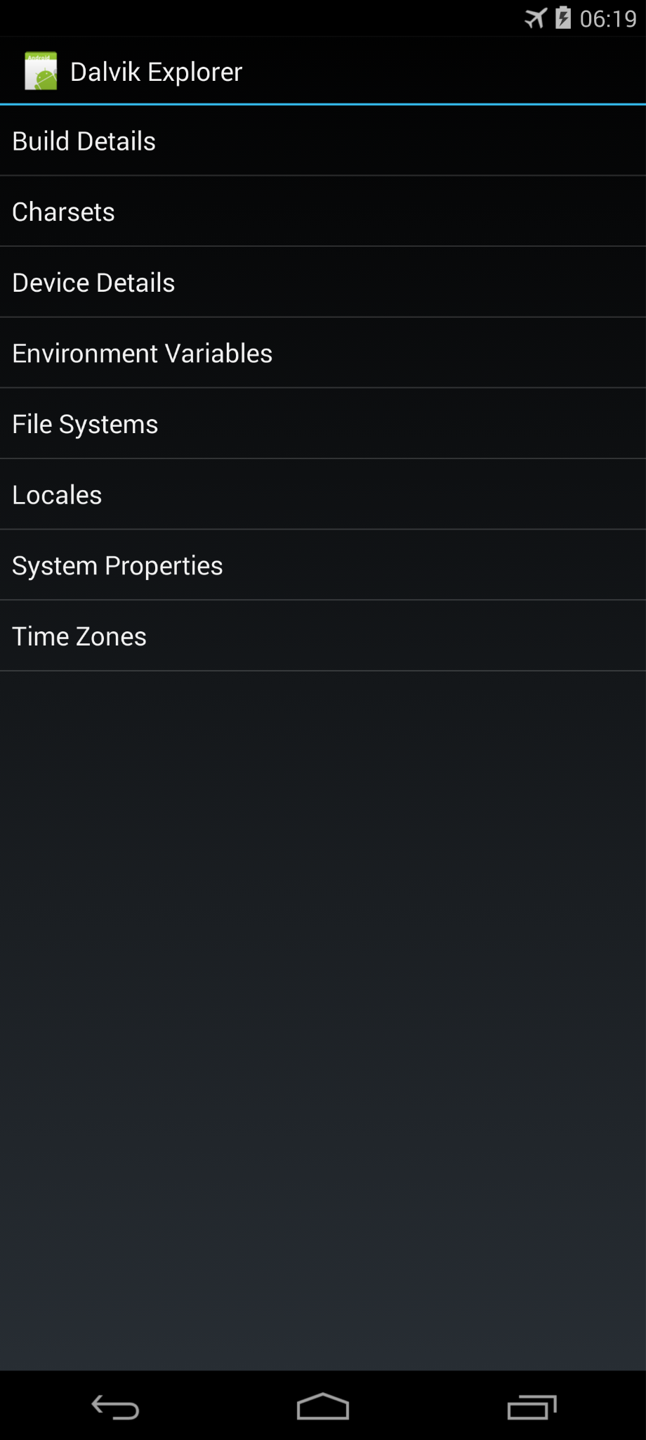 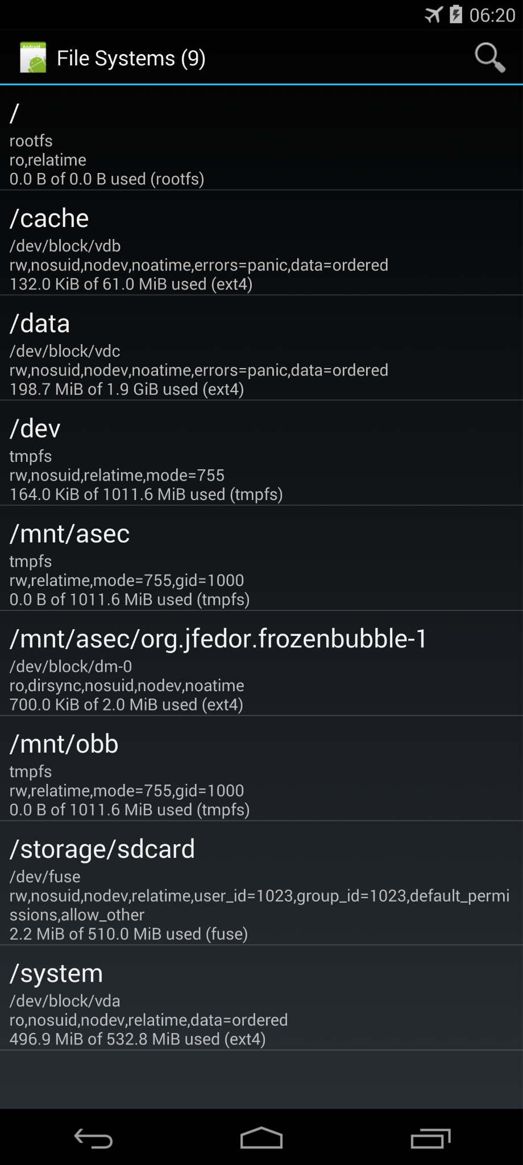 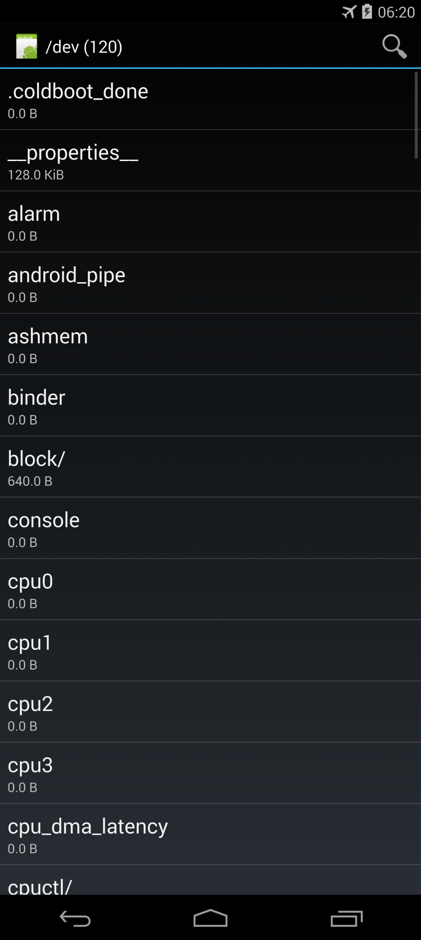 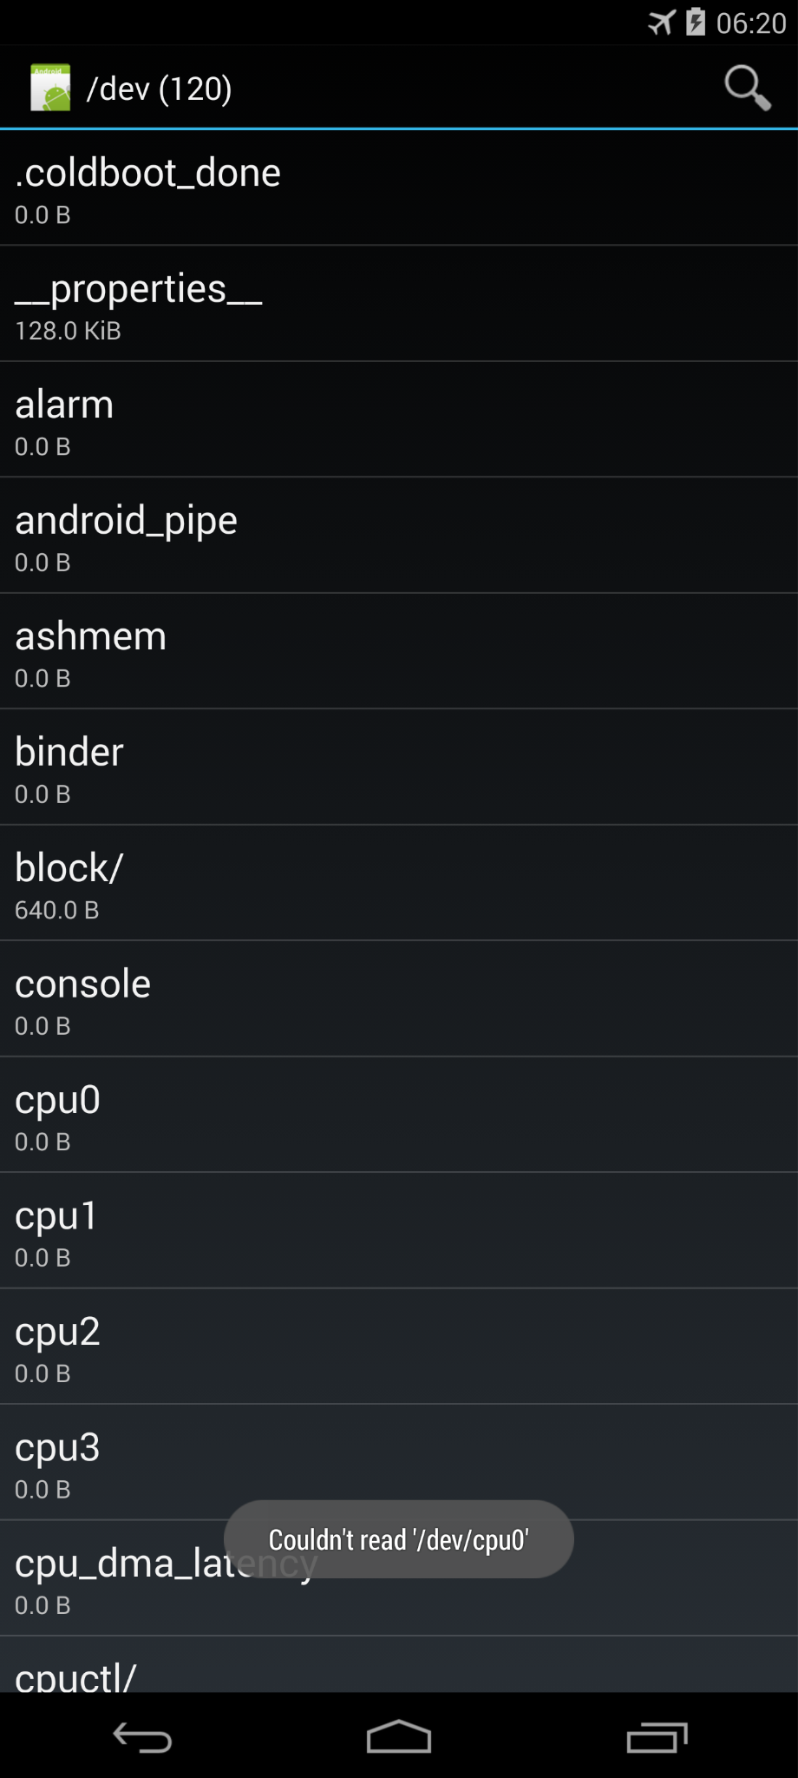

Click “File systems” Click “/dev” Click “cpu0” “cpu0” is clickable but cannot be read

17.Jamendo: ChatGPT4 response (com.teleca.jamendo_38_src_oracle_0(64).mhtml )

Based on the provided sequence and the screenshot, the final page should display options like "Browse Jamendo", "Search", "Radio", "Most listened", "My Library", "Playlists", "Albums", and "Download" as clickable buttons with respective content descriptions and other buttons like "Loading data..." corresponding to each section.

The screenshot provided shows the "Loading data..." message, which is consistent with the expected output. However, there is an error message at the bottom saying "OneLiner update failed". This error message is not mentioned in any of the provided sequences, indicating a potential discrepancy or an actual error in the app's UI.

Additionally, based on the actions leading up to this point, there were several instances where the action redirected to an empty page, and the user had to click back multiple times. However, there's no indication in the screenshot that such redirections occurred, as the screenshot shows the main page with options, which seems to be loaded correctly, except for the error message.

Therefore, yes, there is a UI error, as there is an unexpected error message "OneLiner update failed" that does not correspond to the expected output text from the given sequence.

Final decision: There is a UI error due to an unexpected error message.

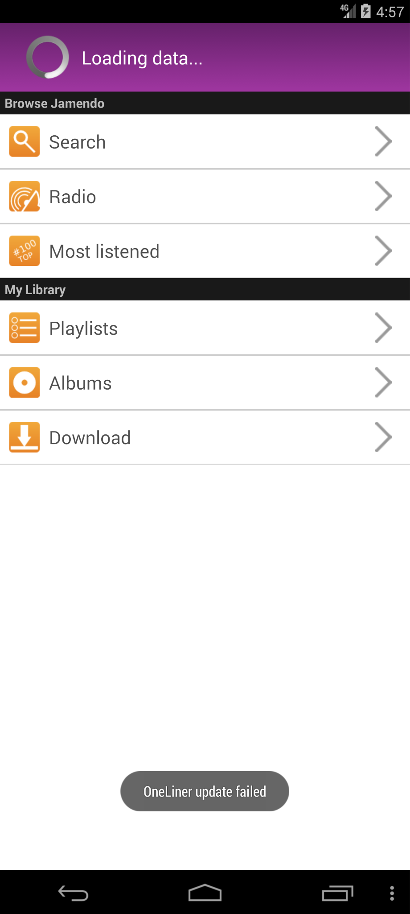

Error message on restart the app

18. KeePassDroid: ChatGPT4 response (passwordmanager_oracle_0(28).mhtml )

Yes, there is a UI error in the screenshot. The KeePass database filename field contains the literal string “input text'{.345678909871231,” which appears to be a user input error or a bug in how the text is displayed or handled. It does not correspond to a valid file path or filename and hence, the error message "Database format not recognized." is being shown. Additionally, the filename appears to be truncated, which could indicate that the full path is not being displayed properly.

Final decision: UI error detected due to incorrect and possibly truncated input in the filename field.

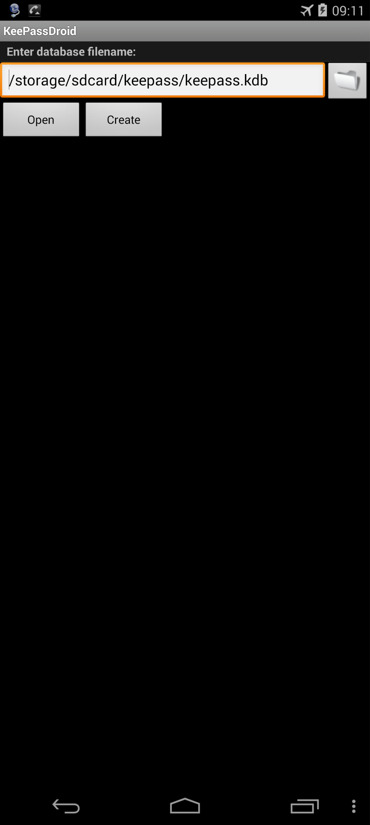 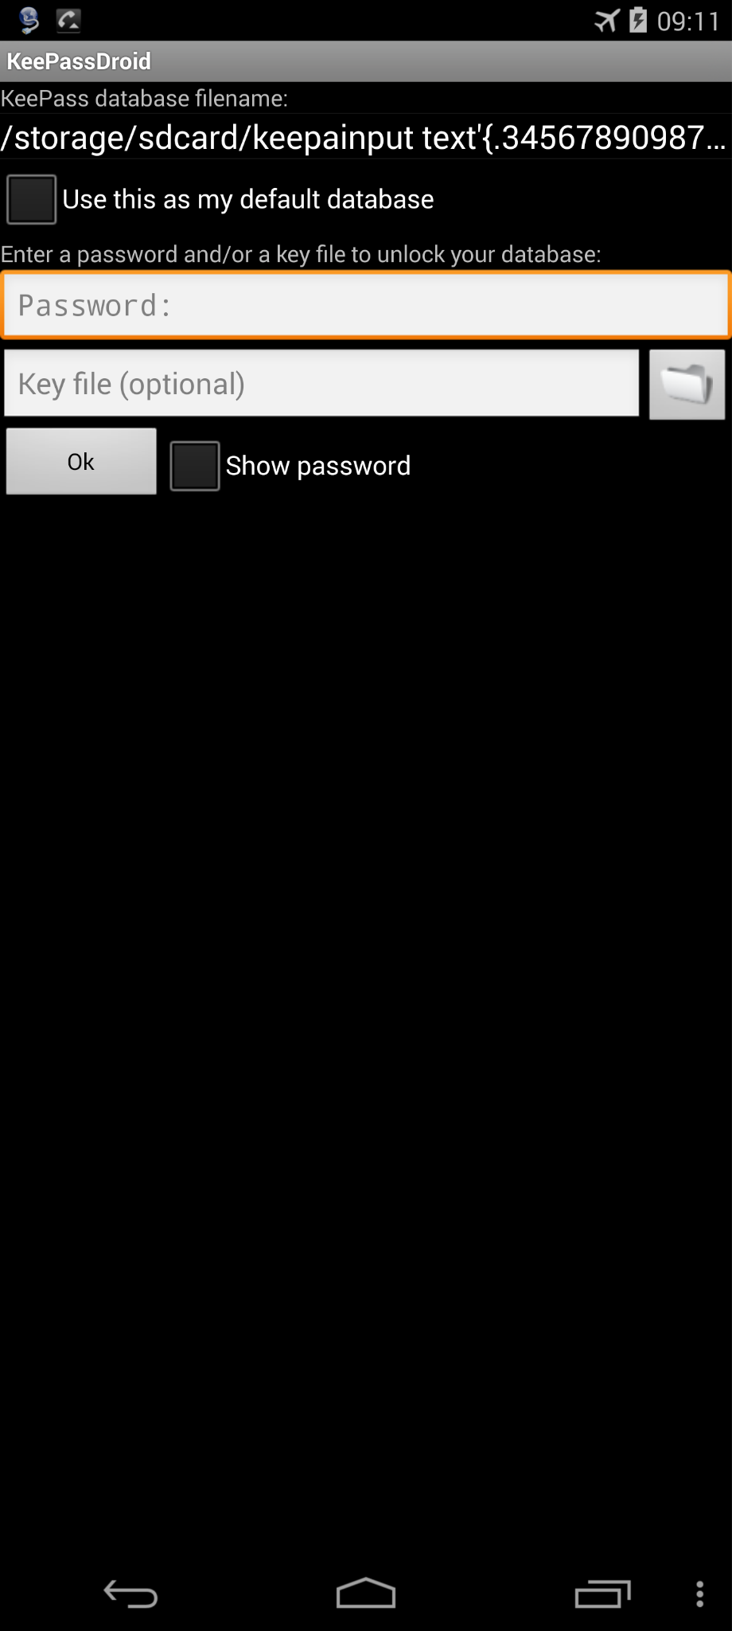 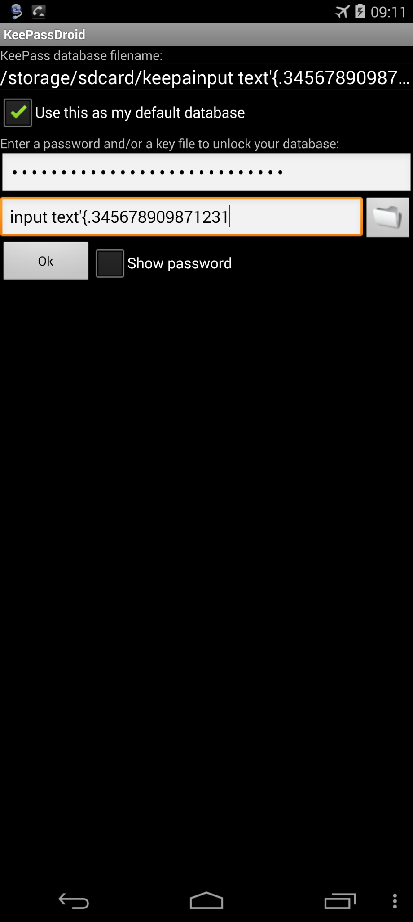 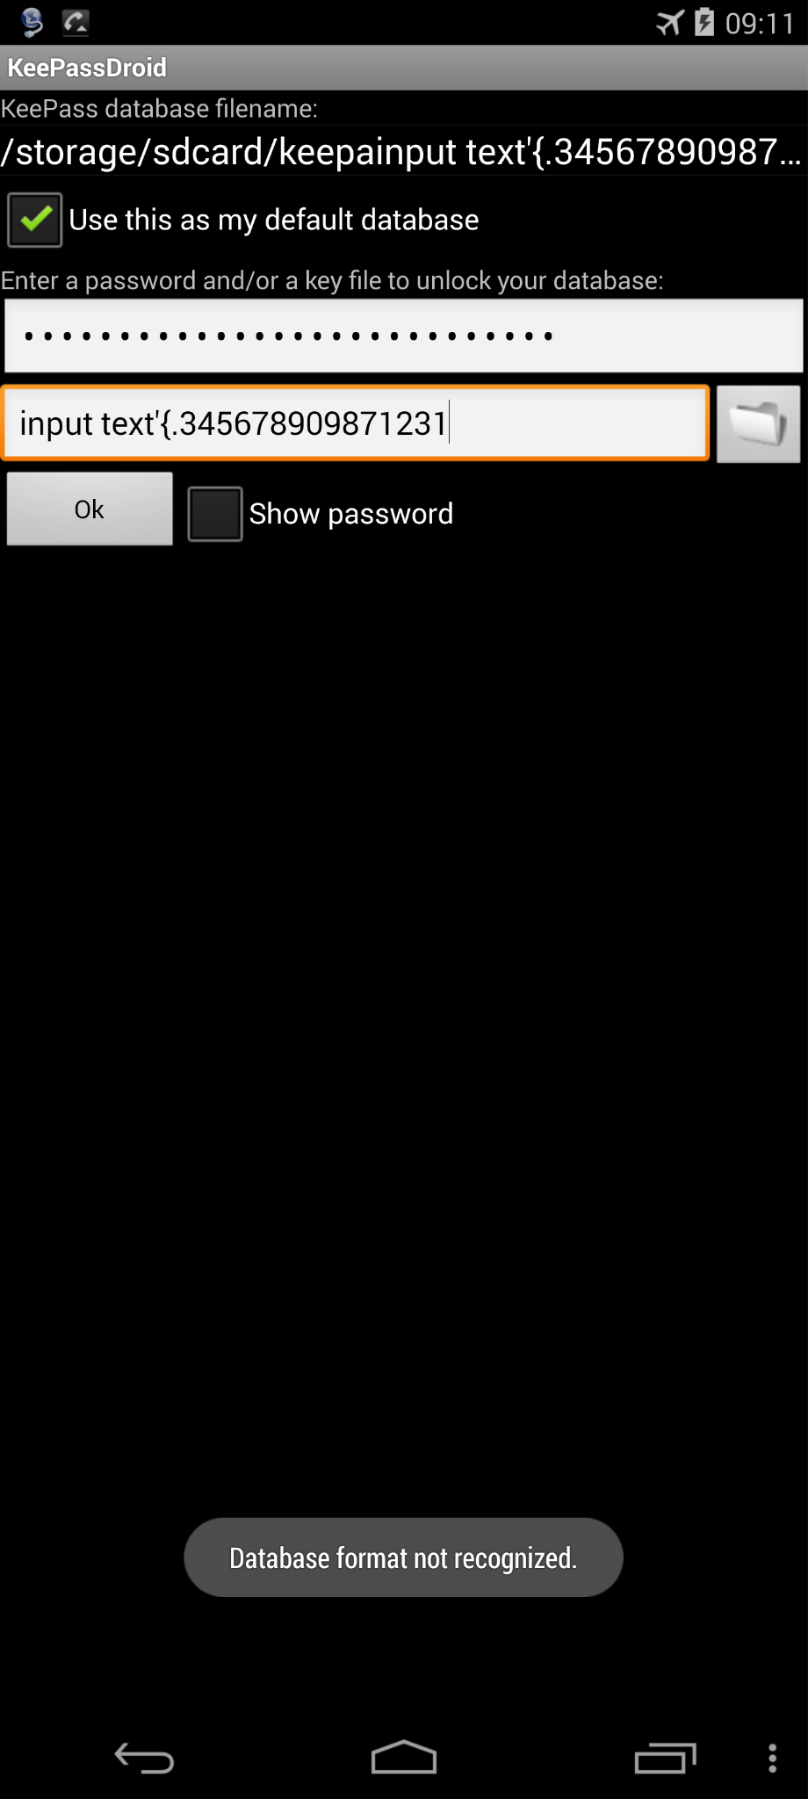

Click “open” Input random text in placeholder Click “OK” Error message pop up.

19. Manpages: ChatGPT4 response (com.chmod0.manpages_3_src_oracle_0(13).mhtml )

Based on the provided action sequence and the screenshot you provided, I can confirm that there is a UI error. The screenshot shows a 'Not Found' error message stating that the URL /android/manpages/htmlman1/chrt.1.html was not found on the server. This error message is inconsistent with the expected behavior as per the action sequence.

The action sequence ends with the user selecting 'Use online pages;' and then 'Click chrt (1);', which implies that the application should display the man page for 'chrt (1)'. Instead, the server response indicates that the page does not exist, which is a discrepancy and a UI error.

Final Decision: Yes, there is a UI error. The expected man page is not displayed, and a 'Not Found' error message is shown instead.

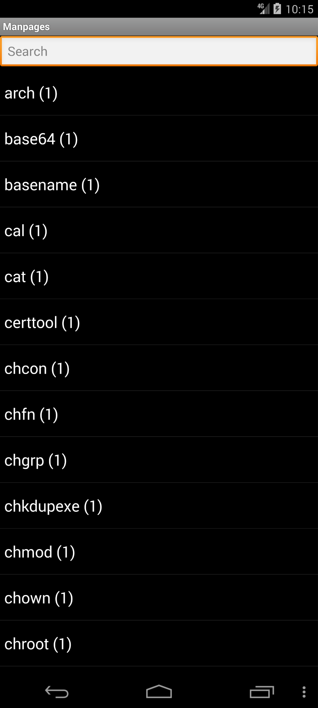 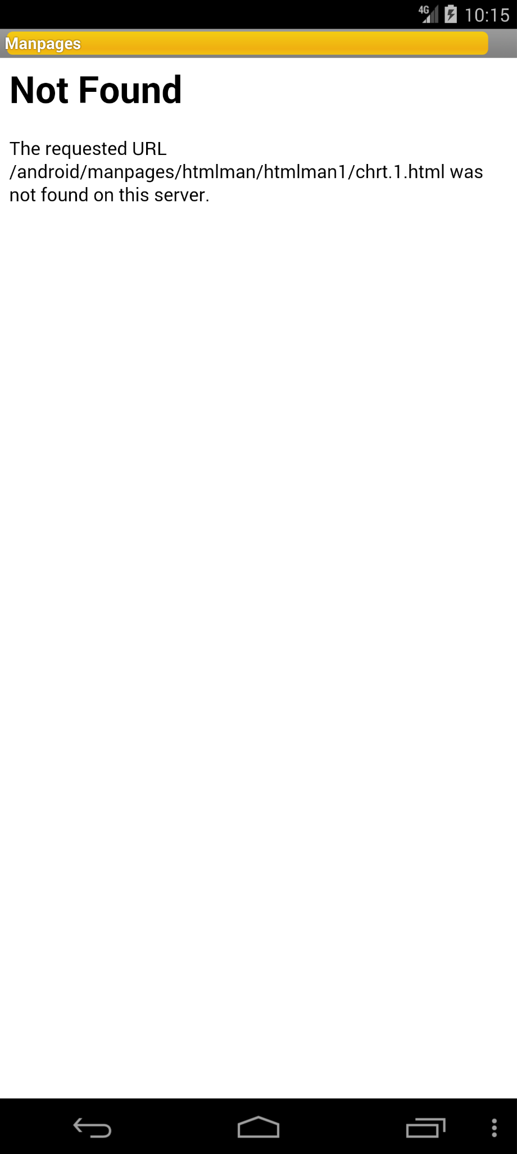

Click any button URL not found

20. Mileage: ChatGPT4 response (com.evancharlton.mileage_3110_src_oracle_0(188).mhtml)

Yes, there is a UI error. The text for the "Average cost per mi" states "$∞ / mi", which is an undefined or infinite value and does not correspond to a realistic or possible value for cost per mile. This could be a placeholder or an error in data calculation. Moreover, the values for "Worst fuel economy" and "Best fuel economy" seem to be incorrect; "Worst fuel economy" shows "10000.00 mpg" which is an unrealistically high value, and "Best fuel economy" shows "-10000.00 mpg" which is a negative value, not feasible for fuel economy metrics.

The "Fillup locations" also show values "-10000" for North and "10000" for South, which do not correspond to any standard geolocation or distance unit and seem to be placeholder or erroneous data. The "Minimum cost per mi" and "Maximum cost per mi" both show "$-1.00 / mi" which is also an unrealistic negative cost.

Final decision: UI error detected.

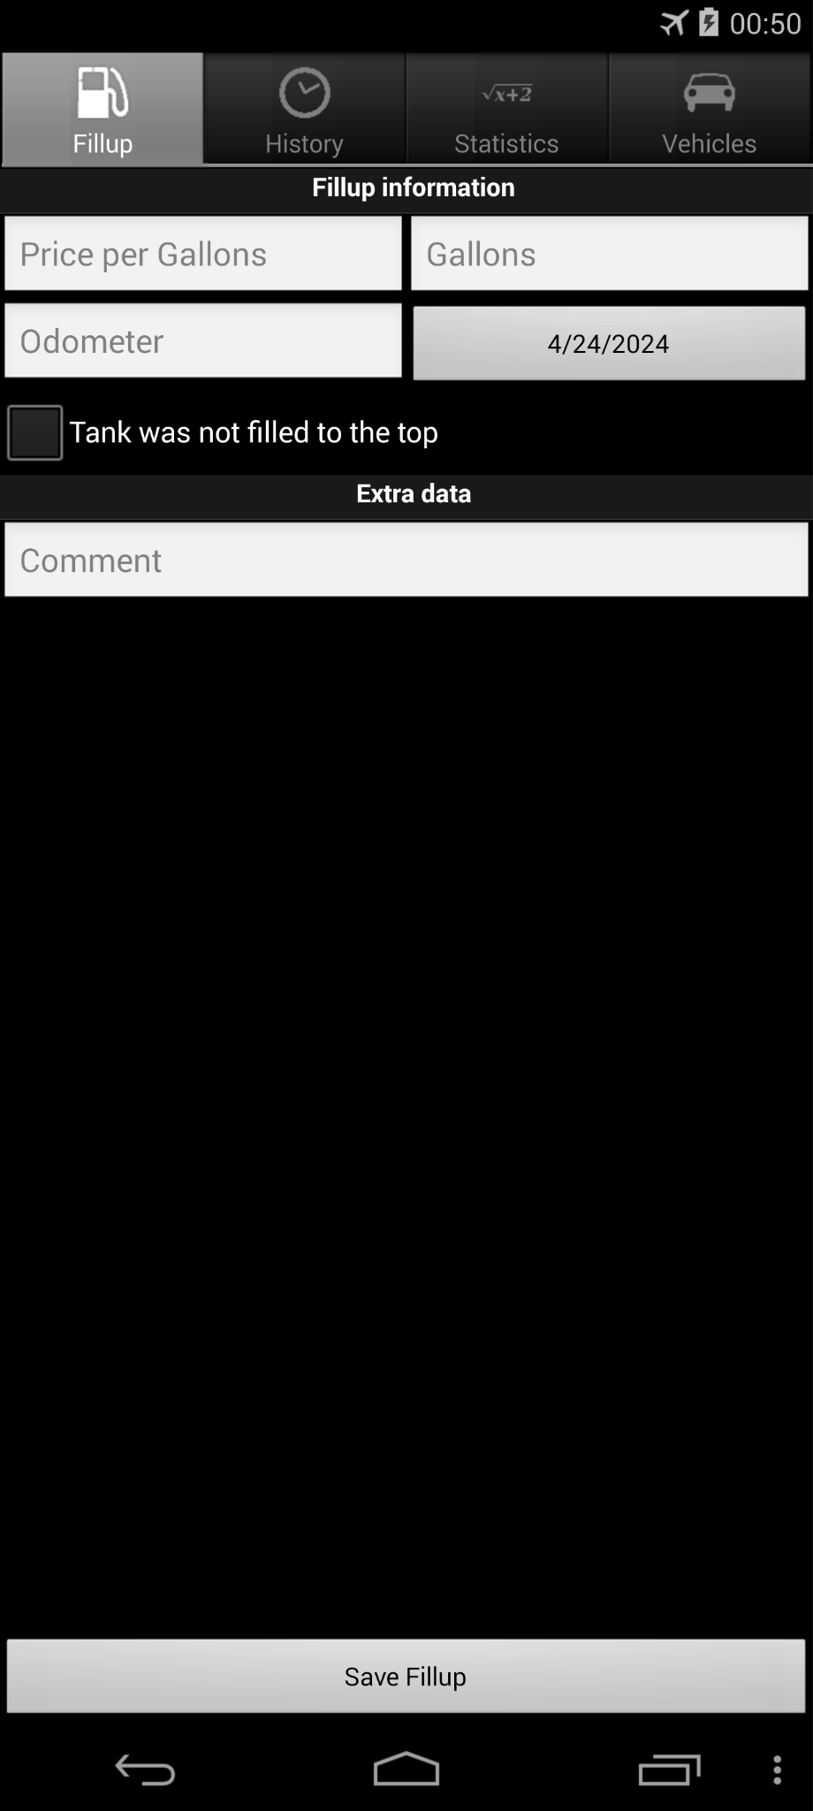 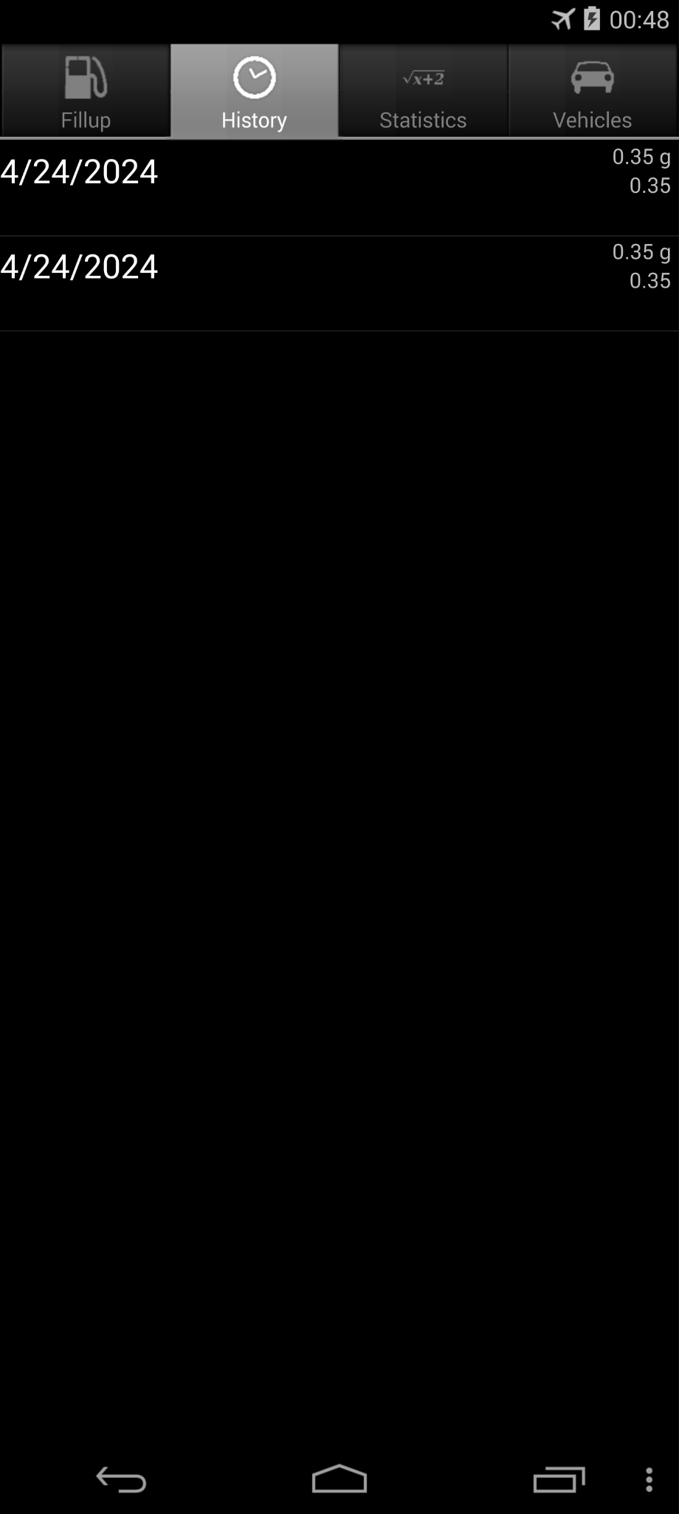 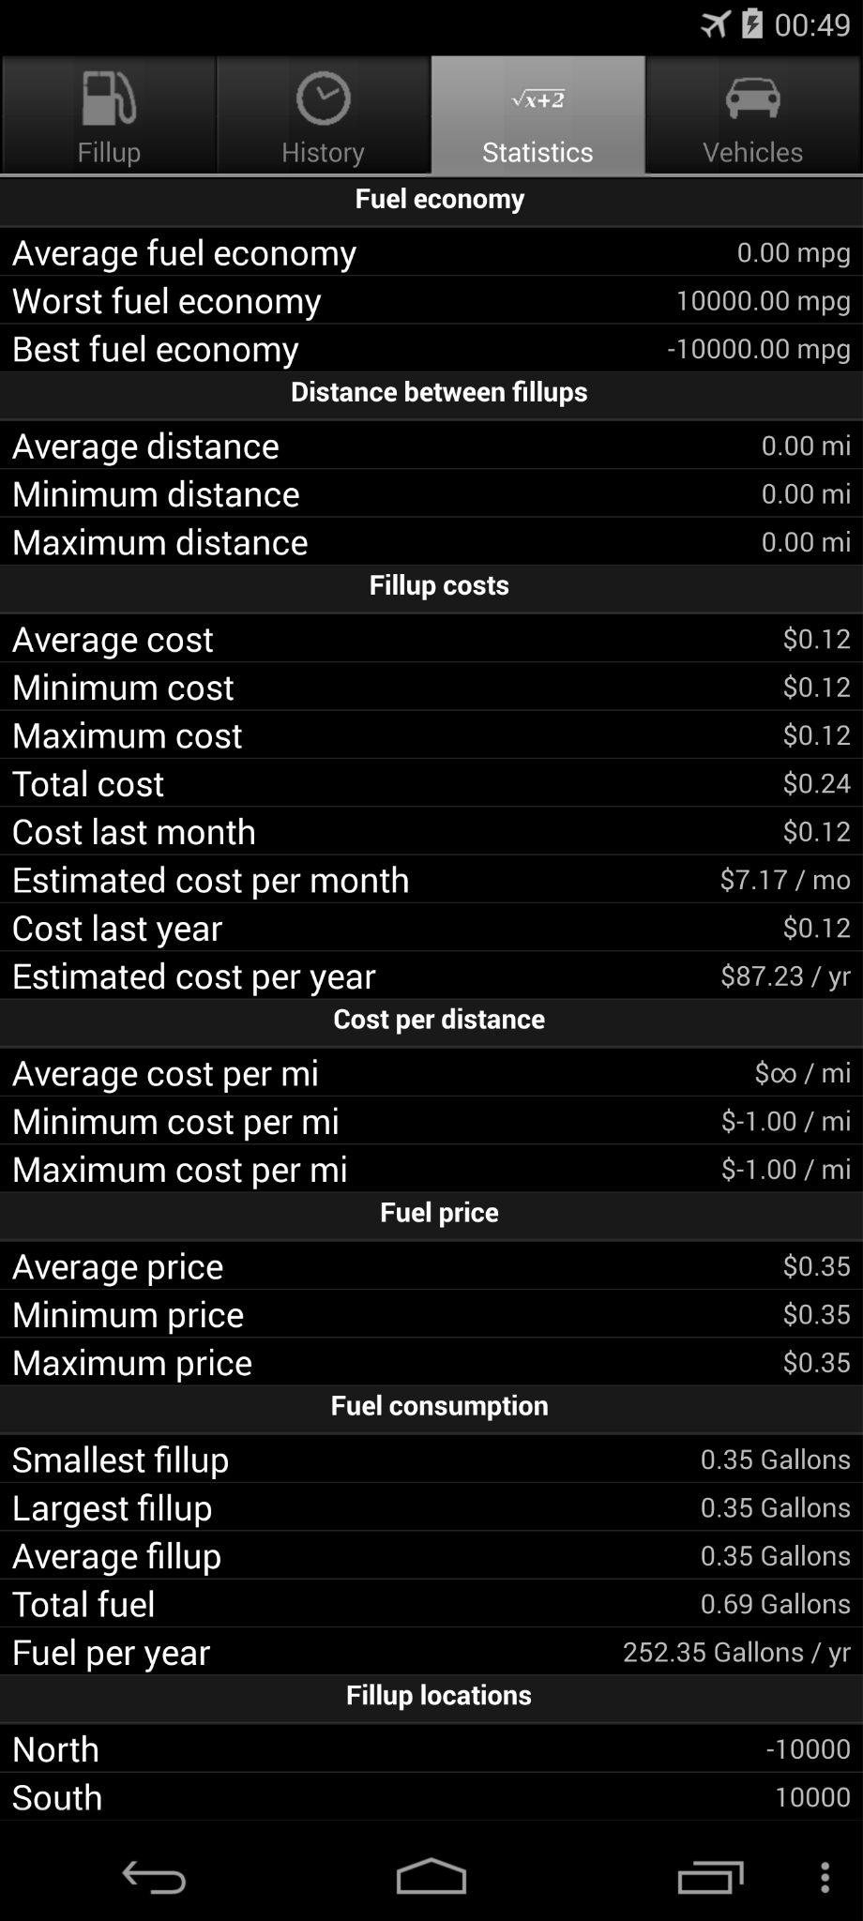

Input same information twice Click “history” and show that. CLick “Statistic”. There are some unrealistic parameters

Like -10000 worst fuel economy and “-1.00/mi” Minimum cost per mi

21. Mileage: ChatGPT4 response (com.evancharlton.mileage_3110_src_oracle_1(169).mhtml)

Yes, there is a UI error. The "About Mileage" page should contain a section titled "About Mileage" with text describing the app, credits for graphics, and other acknowledgements, according to the action sequence. However, the screenshot shows overlapping text on the left side where the menu should be, which indicates that the menu layer has not been correctly hidden or removed from the view. There are also readability issues due to this overlap, which is a UI error.

Final decision: UI error present due to overlapping text.

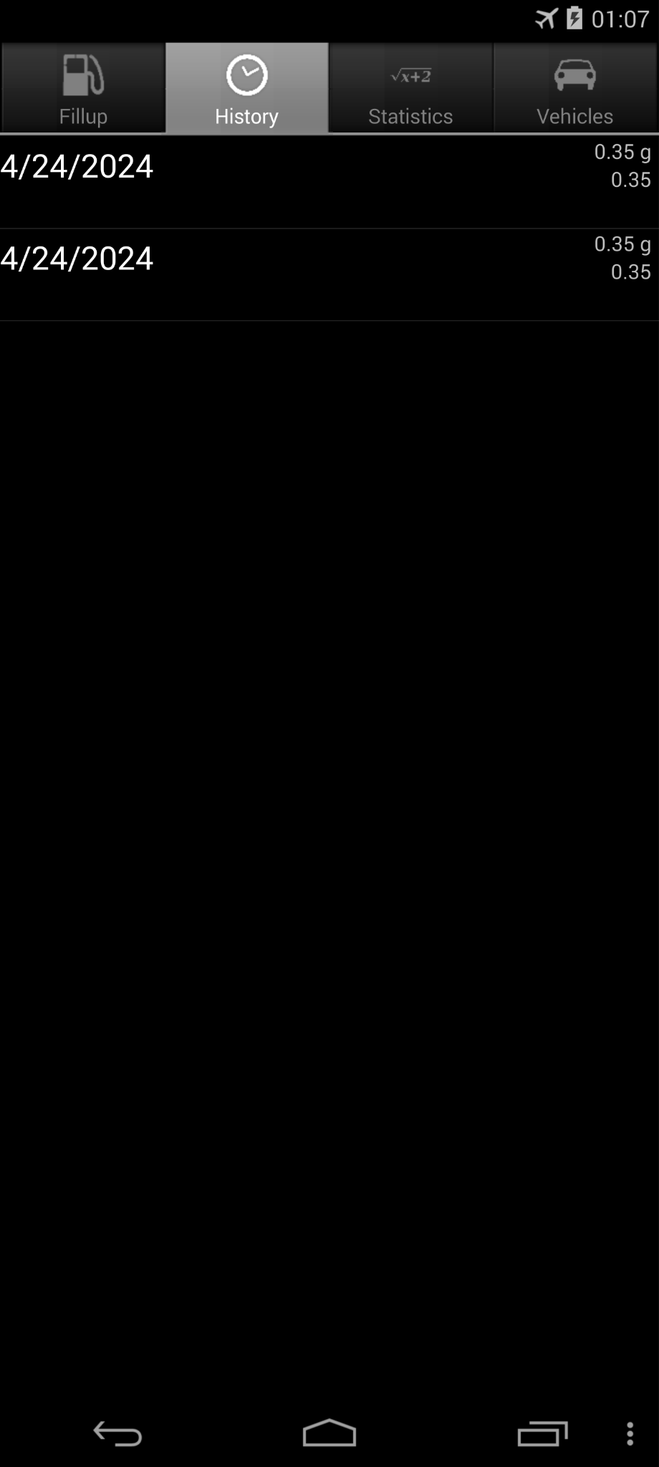 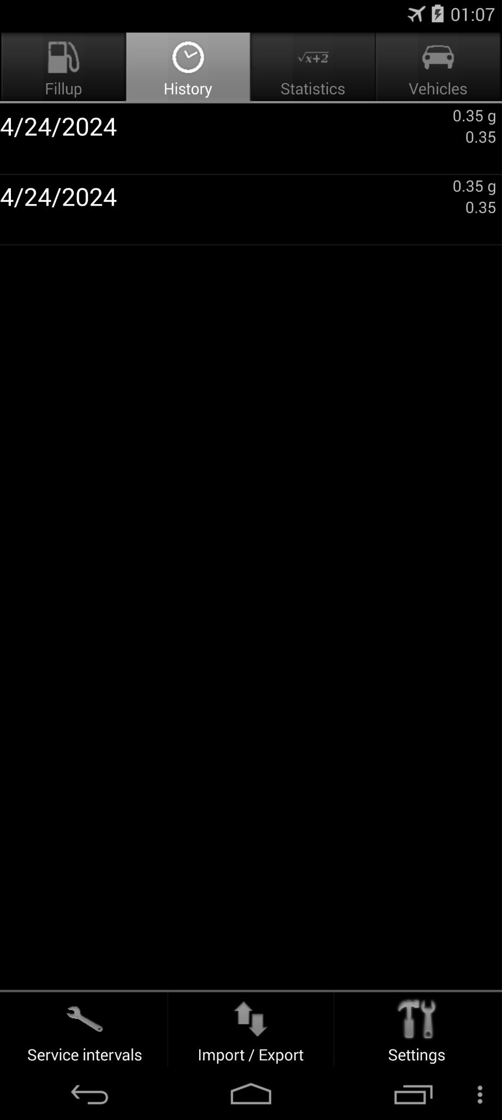 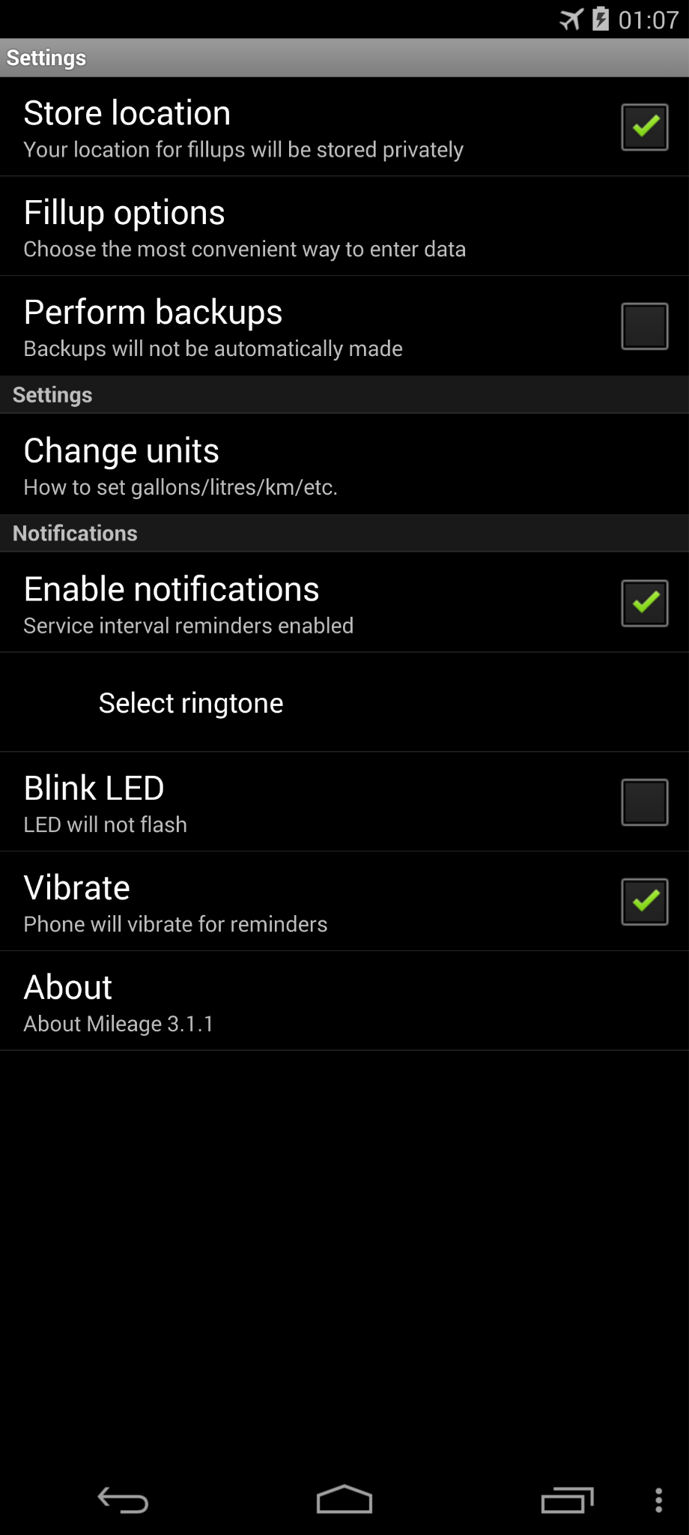 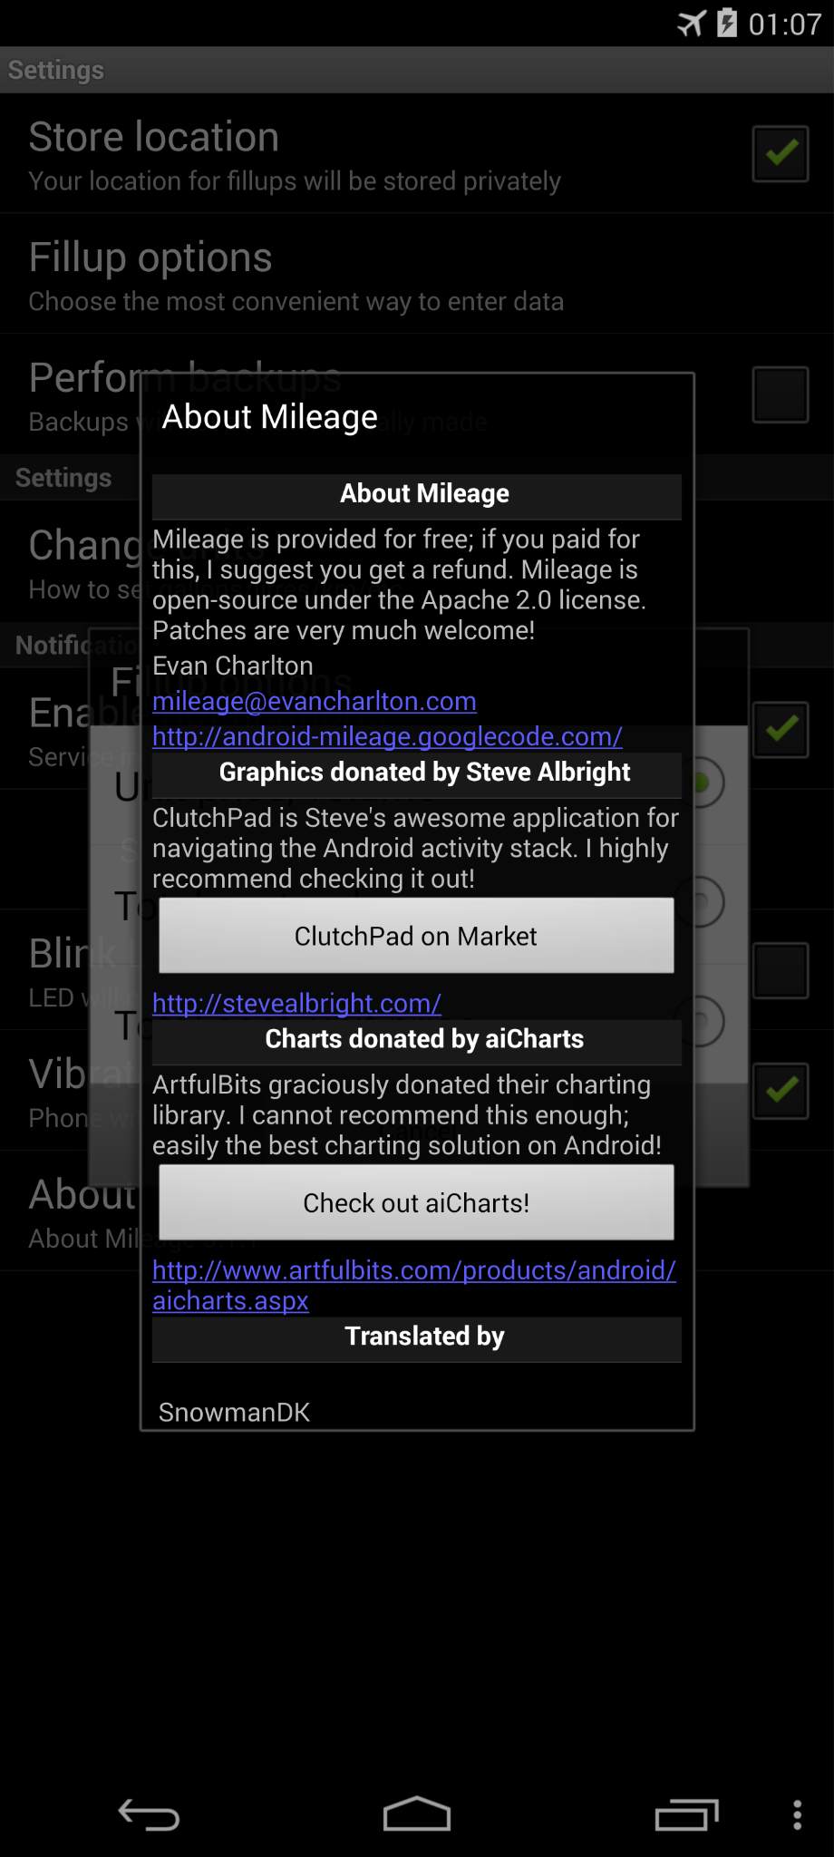

Click “menu” Click “Setting” Click “Select ringtone” 2 pop up windows overlay!

22. Mirrored: ChatGPT4 response (de.homac.Mirrored_9_src_oracle_0(56).mhtml )Yes, there is a UI error in the screenshot. The category names are broken up and appear on separate lines (e.g., "Netzwel" and "t" should be on the same line, as well as "Reis" and "e"). The category titles should be displayed on single lines as indicated in the output structure (e.g., 'text: Netzwelt', 'text: Reise'). Additionally, the word "Mirrored" at the top does not correspond to any text mentioned in the output structure provided.

Final Decision: UI error detected.

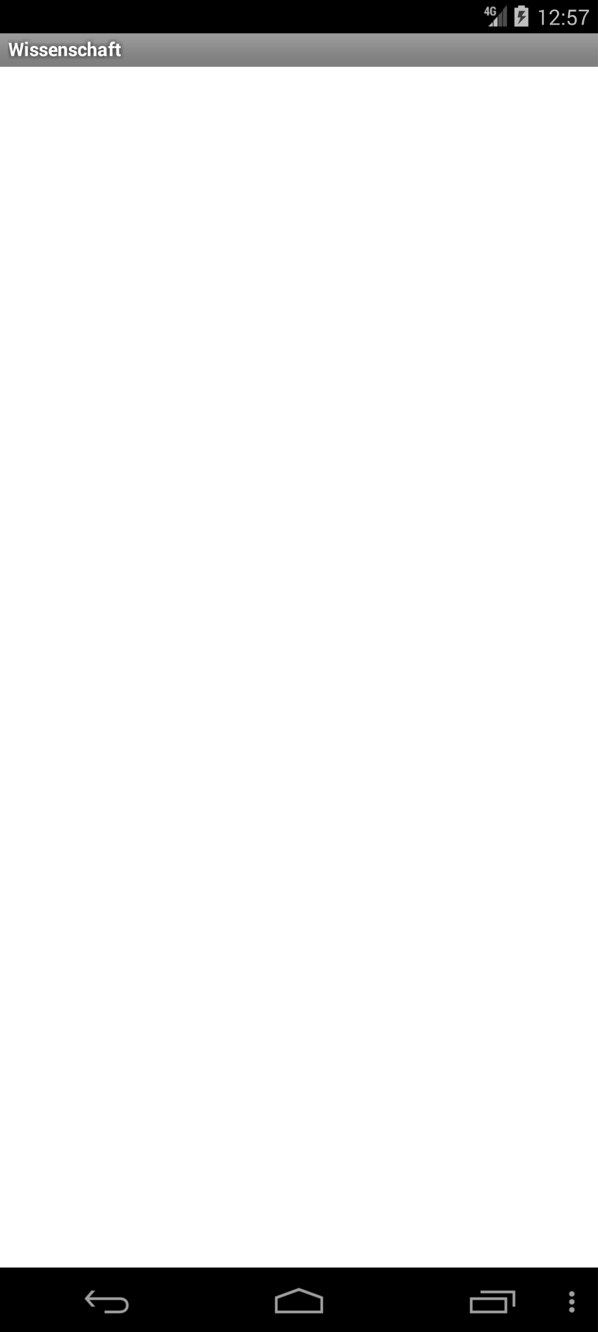 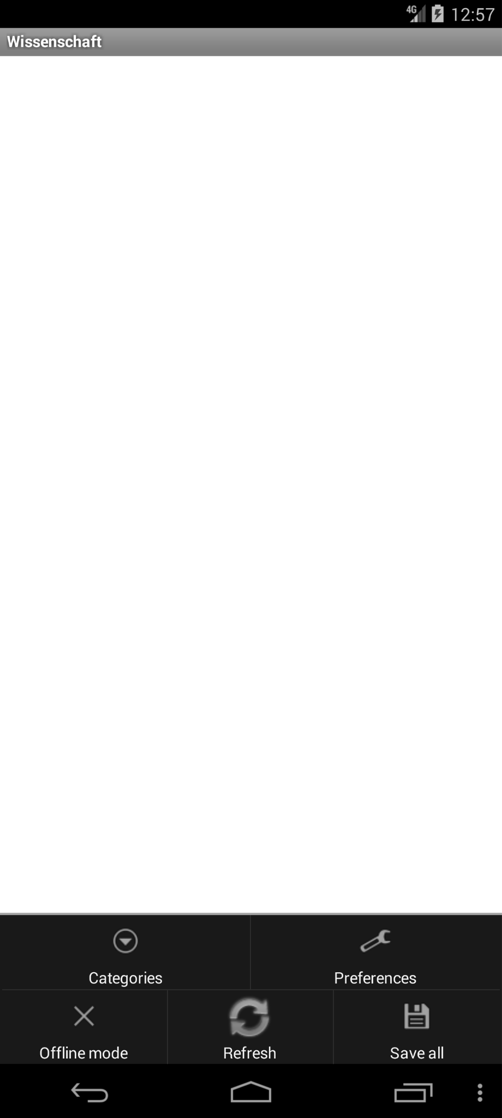 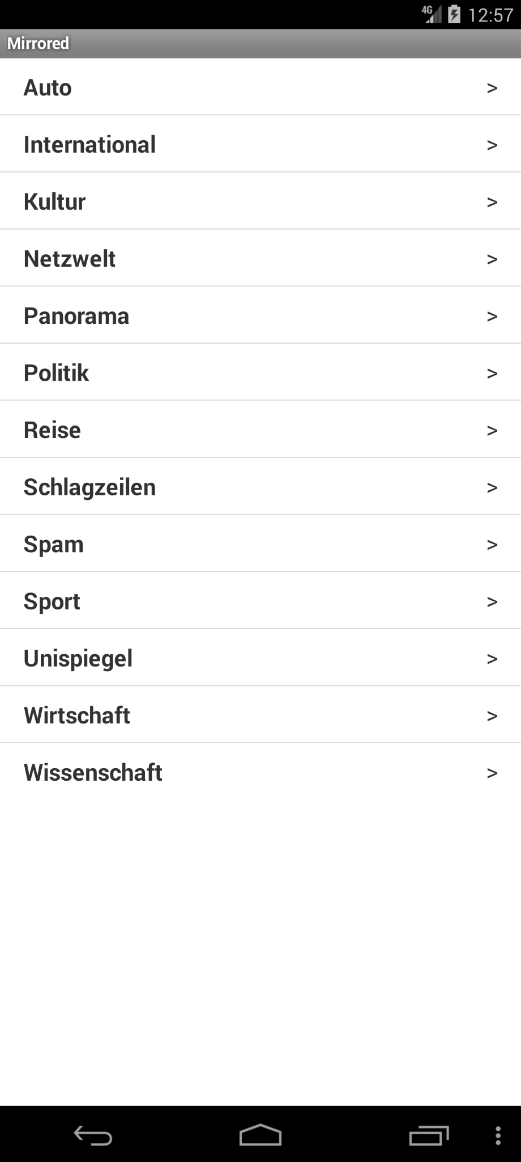 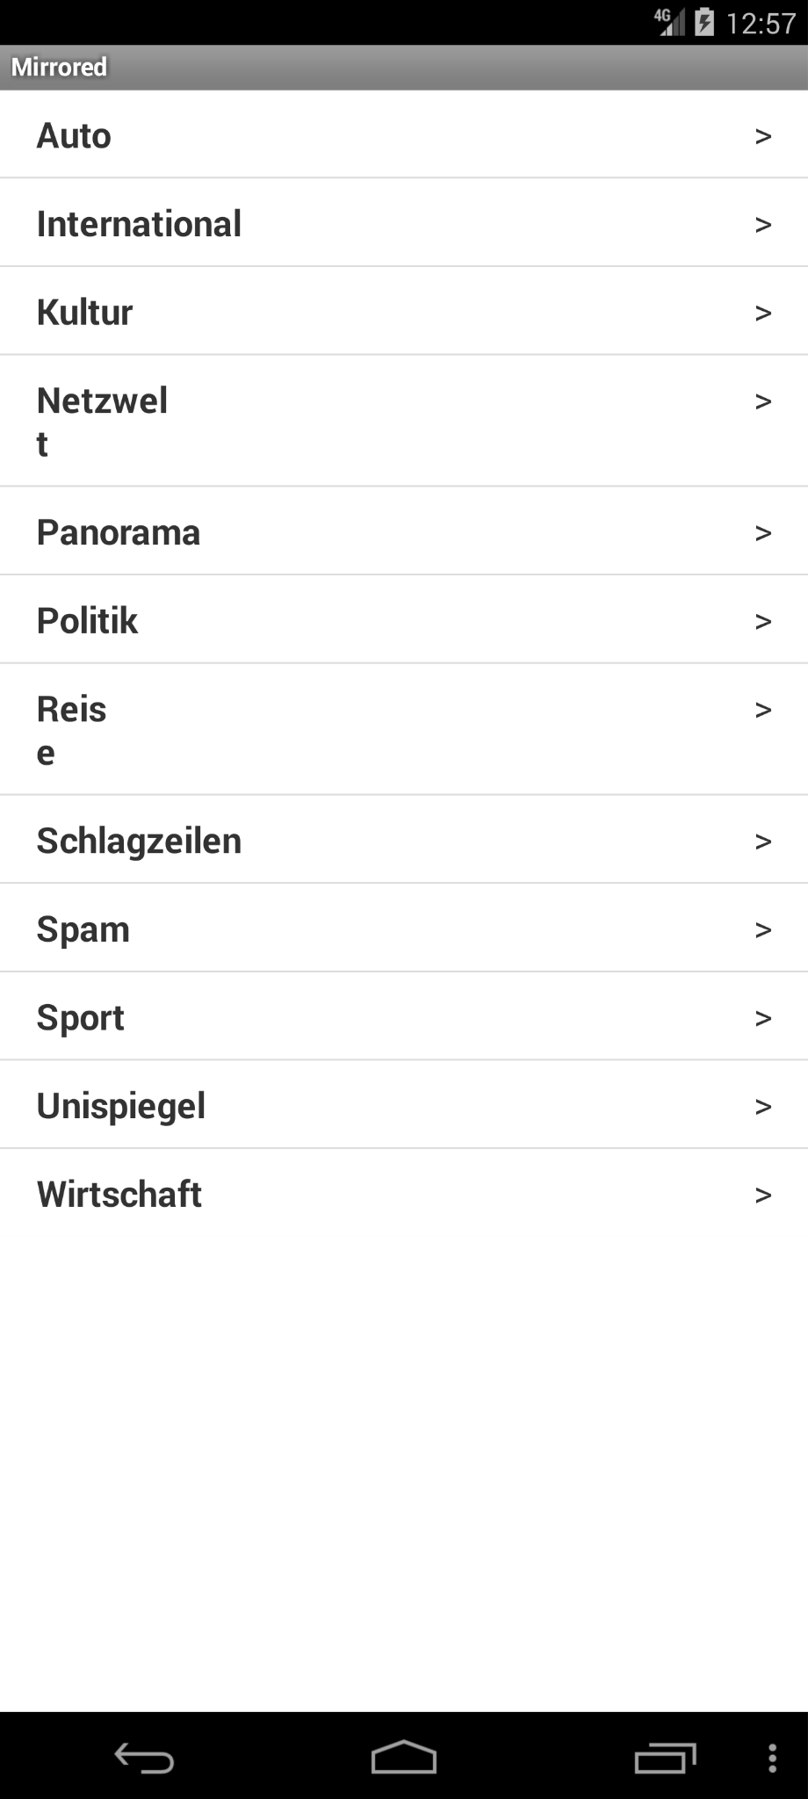

Click “menu” Click “Categories” Click “menu” Menu doesn’t show up and 2 words

are truncated into 2 lines.

23.Nectroid: ChatGPT4 response (com.kvance.Nectroid_11_src_oracle_0(12).mhtml)

Based on the provided app sequence and the screenshot, there is a UI error. The error message "Playlist update failed" appears at the bottom of the screenshot, which does not correspond to any text provided in the actions sequence. There is no mention of a failed update or any action that should result in such a message. Therefore, the presence of this error message is inconsistent with the expected output from the provided sequence of actions.

Final Decision: Yes, there is a UI error. The error message displayed does not correspond with the expected output from the action sequence provided.

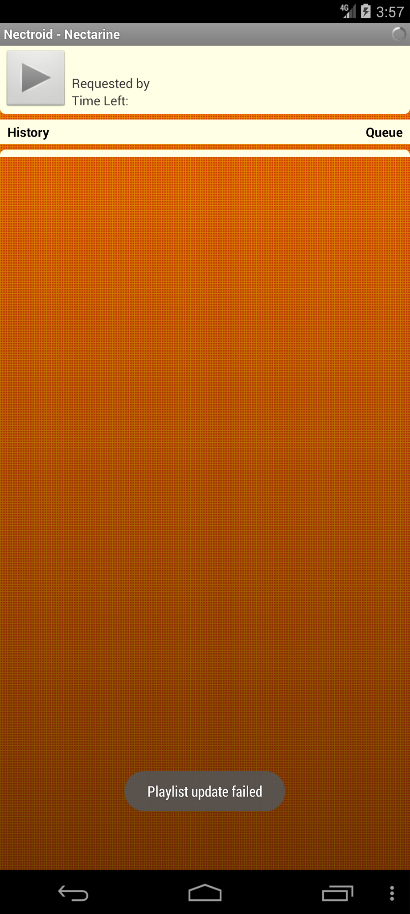 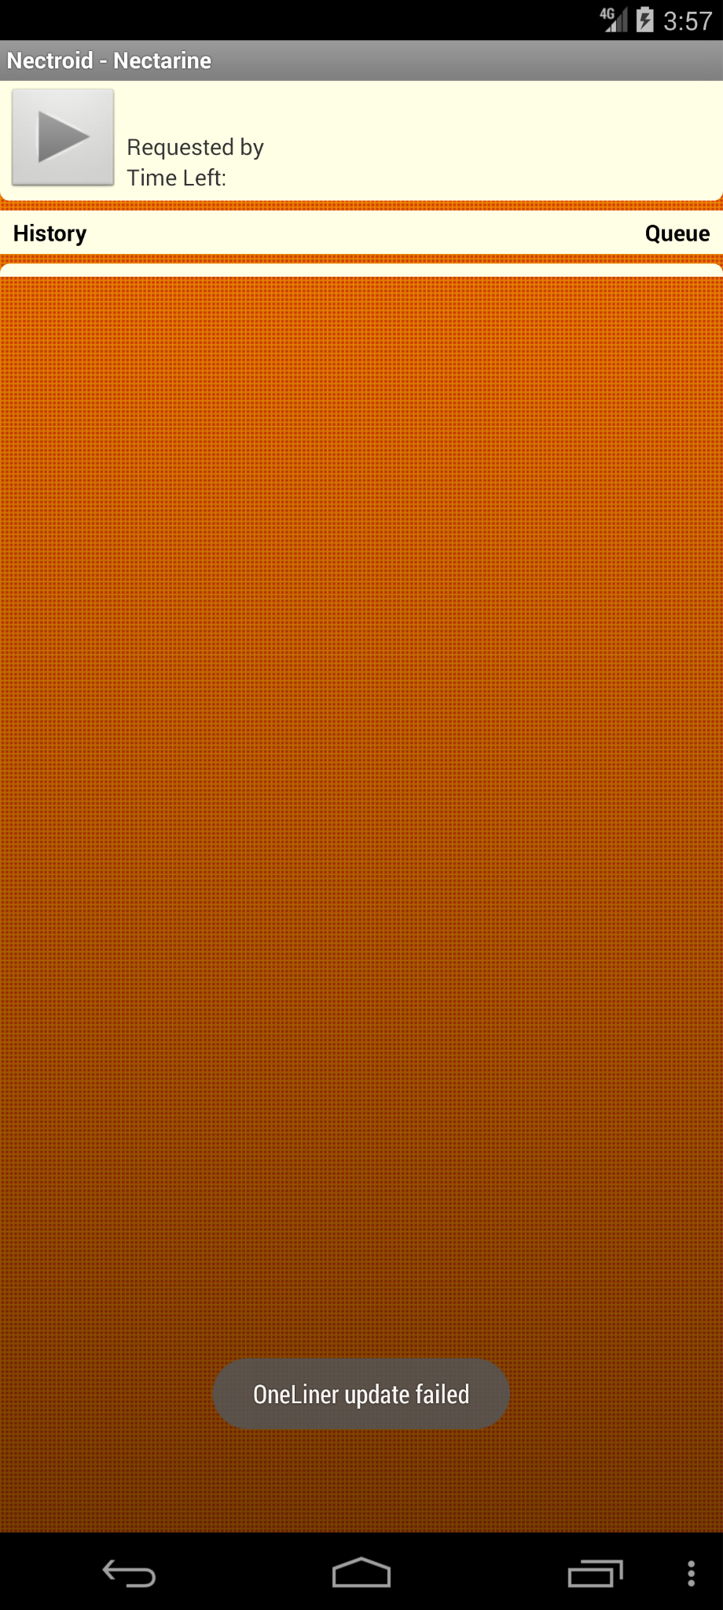

On start up the app, it pop up error messages.

24.RandomMusicPlayer: ChatGPT4 response (RandomMusicPlayer_oracle_0(76).mhtml )

Based on the sequence provided and the screenshot you uploaded, there is a UI error. The screenshot displays the message "No song to play :-(" which does not correspond to any expected output text as per the sequence you described. Throughout your described sequence, there is no mention of an error message or a condition leading to this state being displayed on the screen.

The actions described indicate manipulation of buttons for play, cancel, and menu interactions but not the display of an error message related to song playback, which suggests a discrepancy between expected behavior and the app's actual response in the screenshot.

Final Decision: Yes, there is a UI error in the screenshot, as the error message displayed does not match any given output in the sequence of actions.

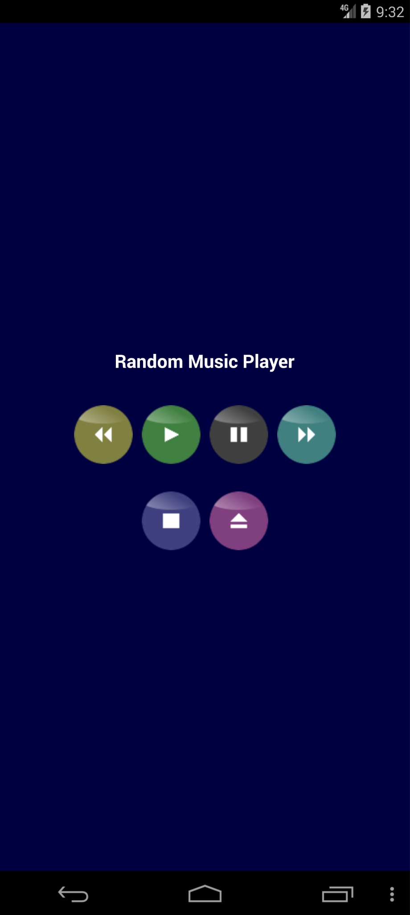 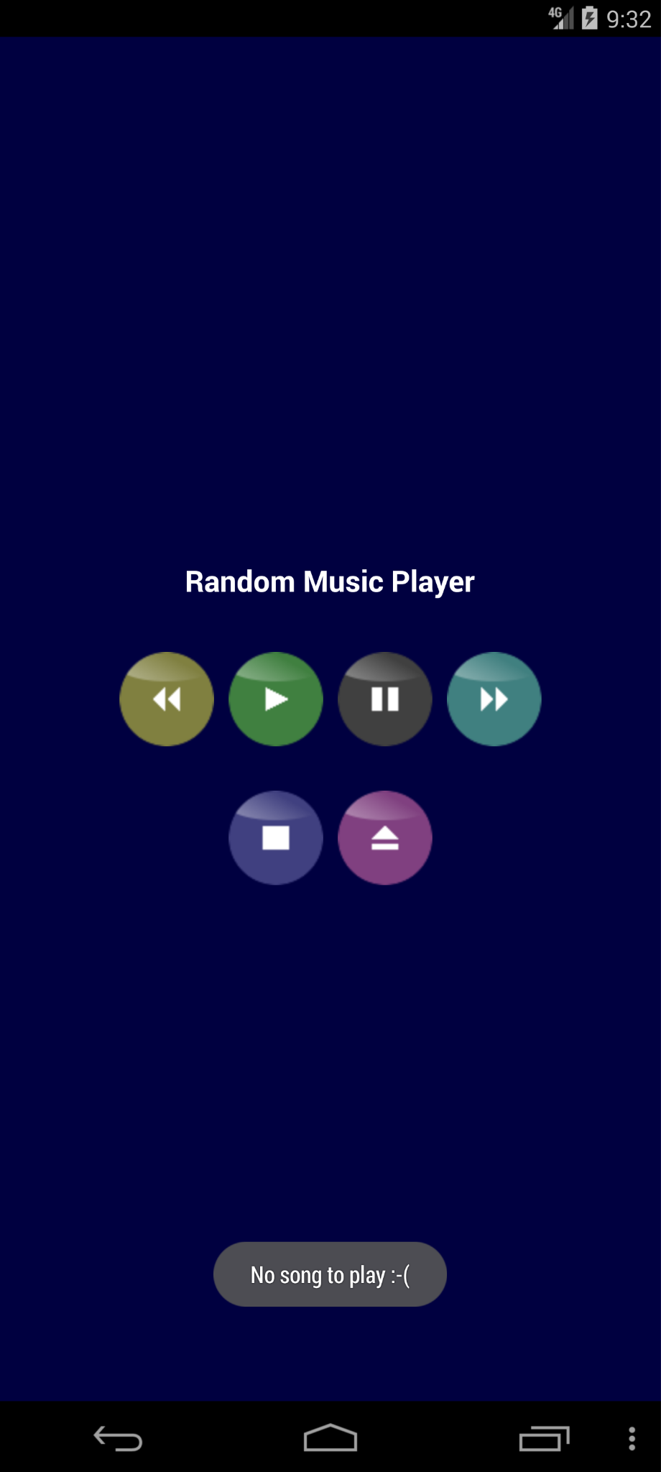 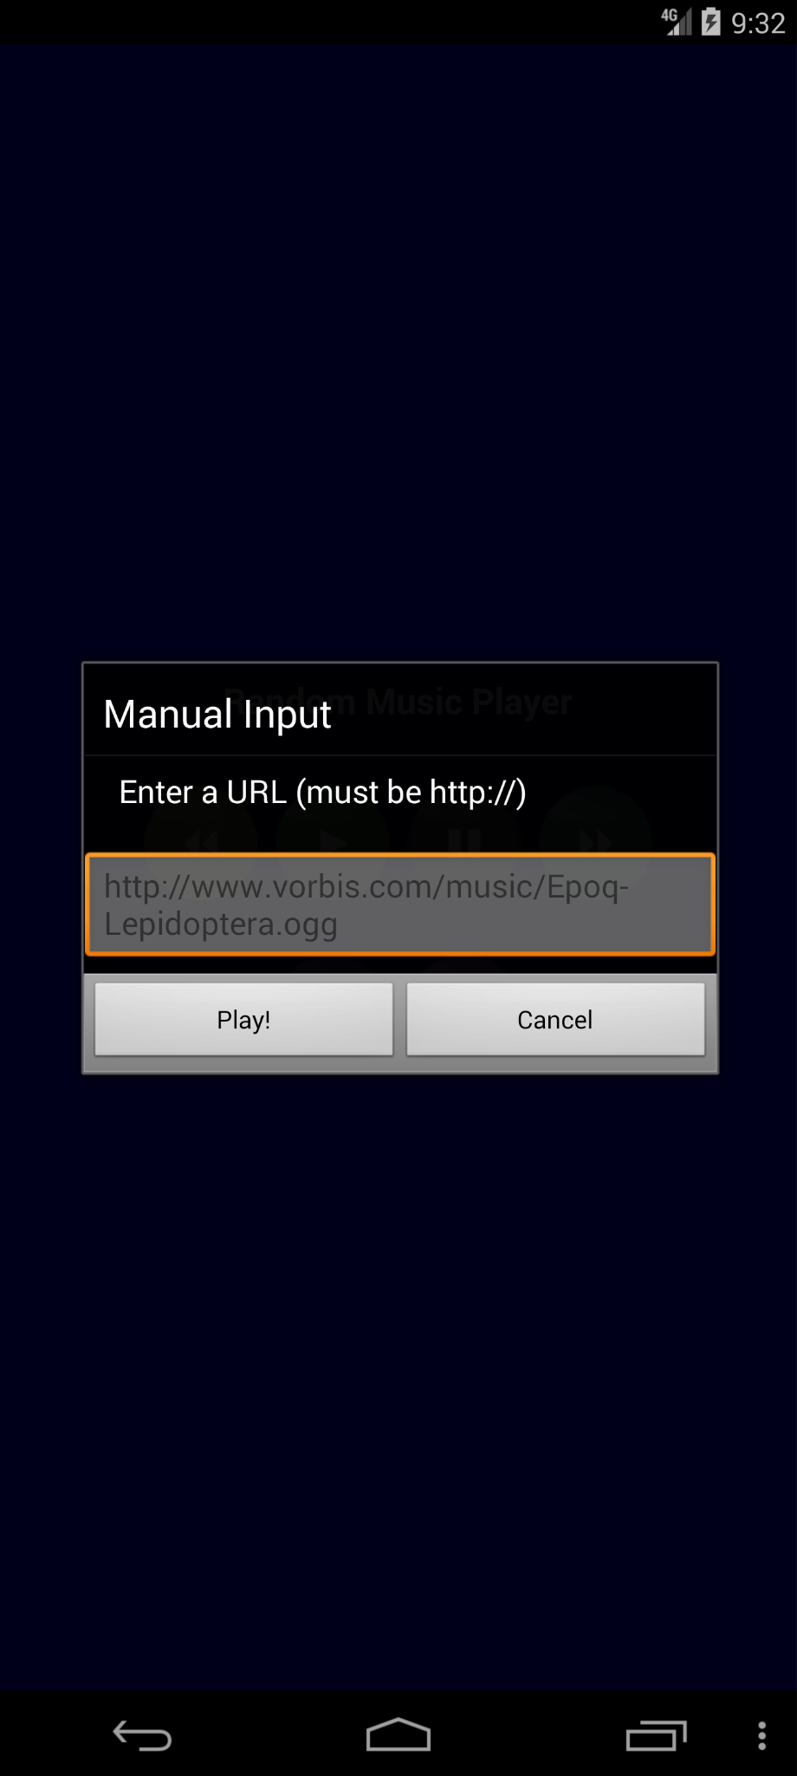

Click “▶️” It shows “no song to play” However the URL is valid music source.

25.SyncMyPix: ChatGPT4 response (SyncMyPix_oracle_0(25).mhtml )

Yes, there is a UI error in the screenshot. The text on the page states "For your account security, logging into Facebook from an embedded browser is disabled. To continue, download and log into the Facebook app on your device and try again." However, the page was expected to show an option for logging into Facebook based on the user's action sequence, which is not present. Instead, the user is blocked from logging in with an error message, indicating a potential discrepancy or error in the application flow related to account security settings.

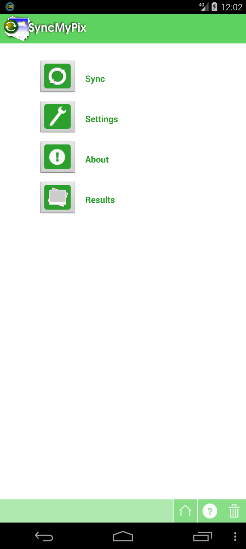 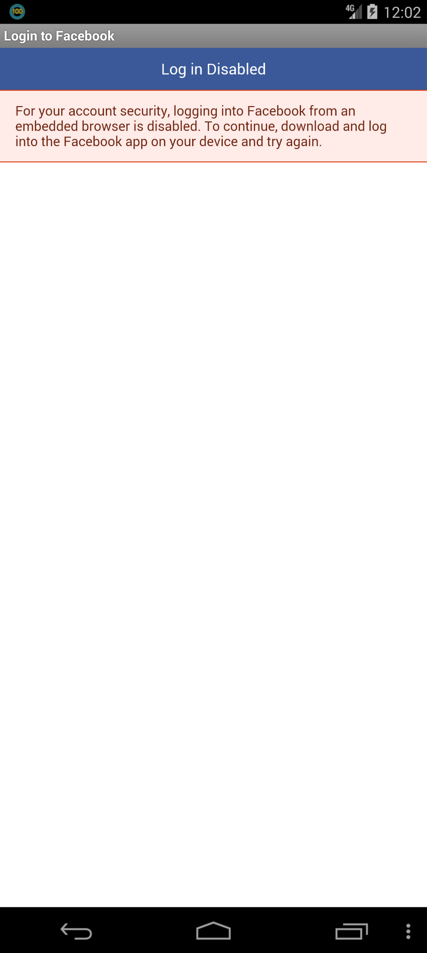

Click “Sync” icon Log in is Disabled in this app

26. Weight-chart: ChatGPT4 response (weight-chart_oracle_0(135).mhtml )

Yes, there is a UI error in the screenshot. The text "Goal Weight" and "You are over the weight!" are overlaid on the grid lines of the background, which makes them hard to read. This overlap can be considered a visual inconsistency, as it impacts the readability and clarity of the interface.

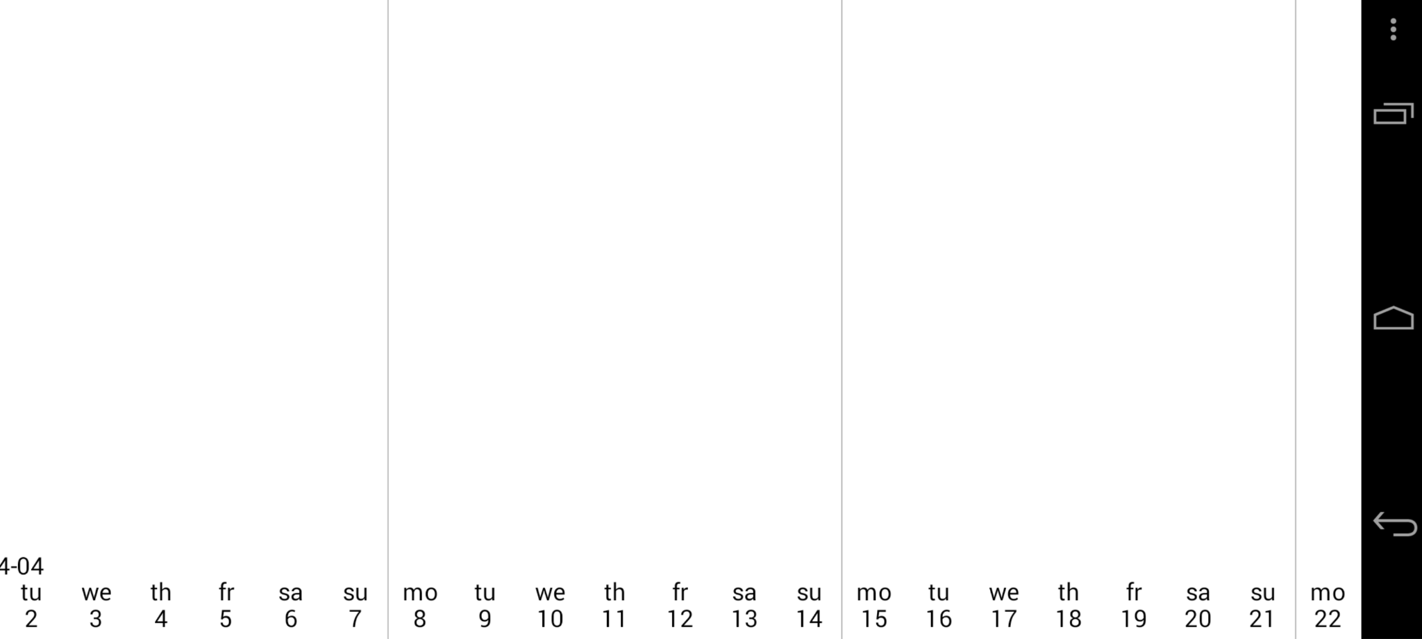 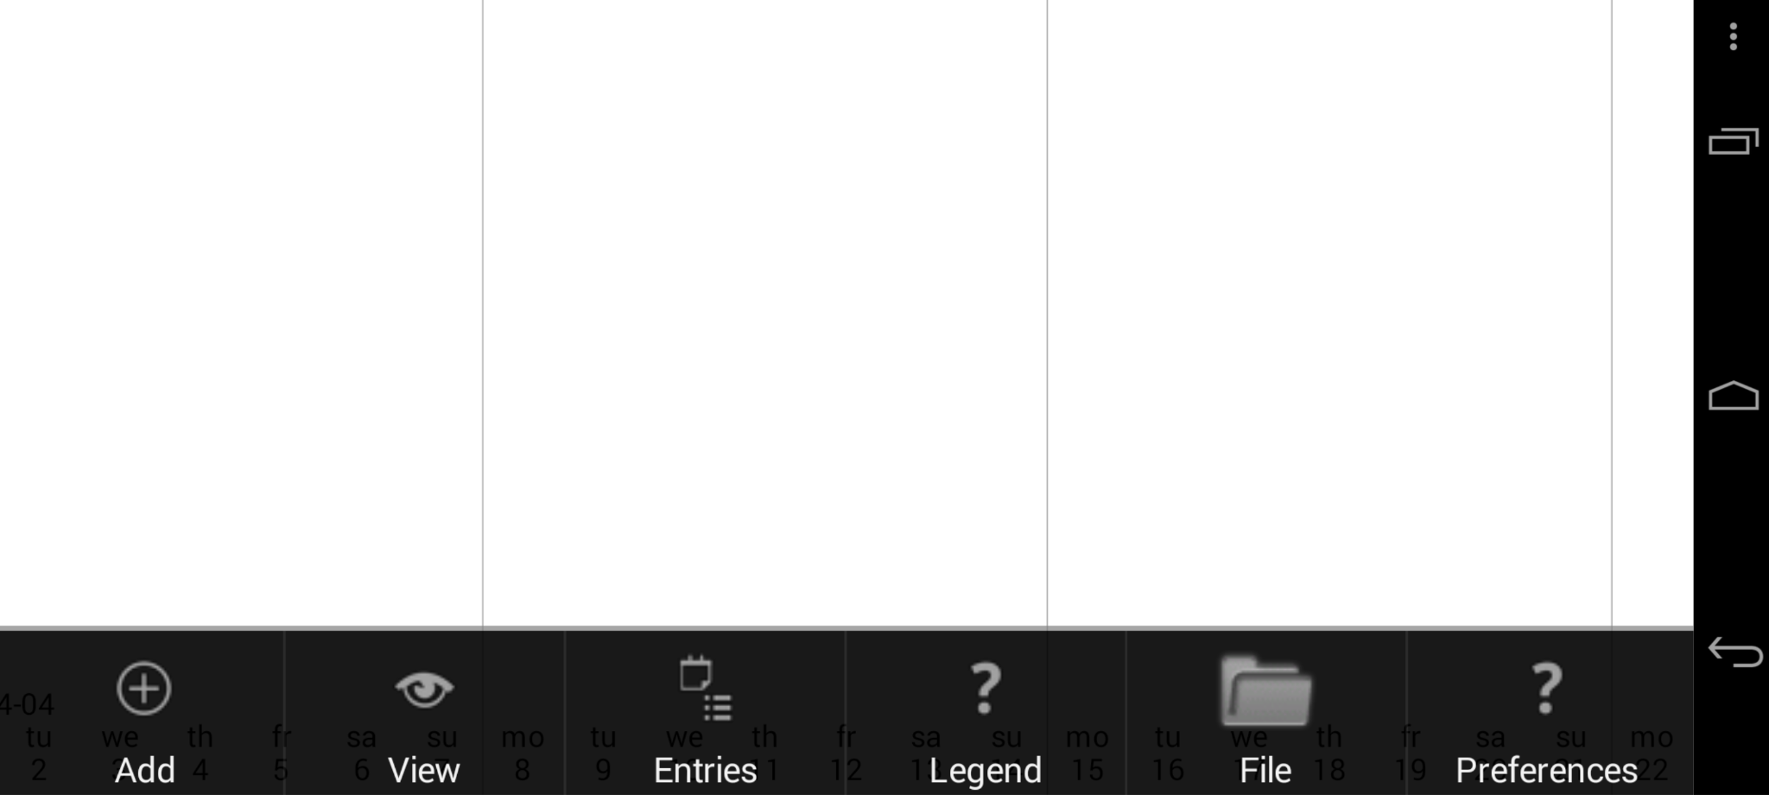

Click any place of the chart Click “Add”

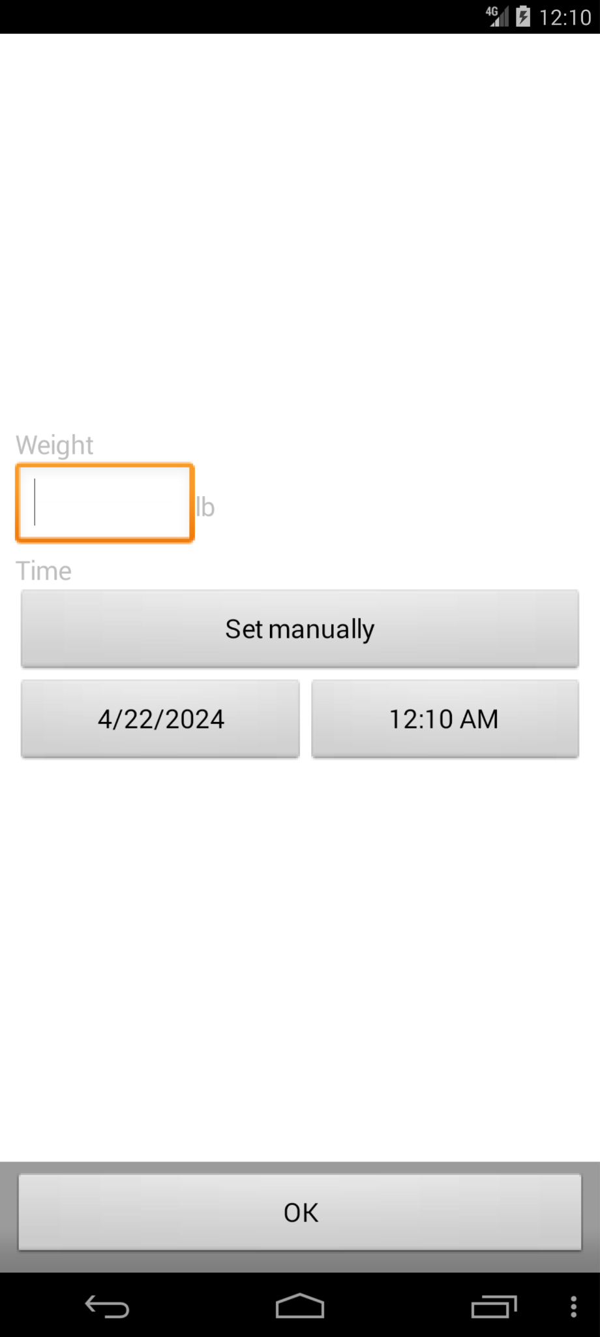 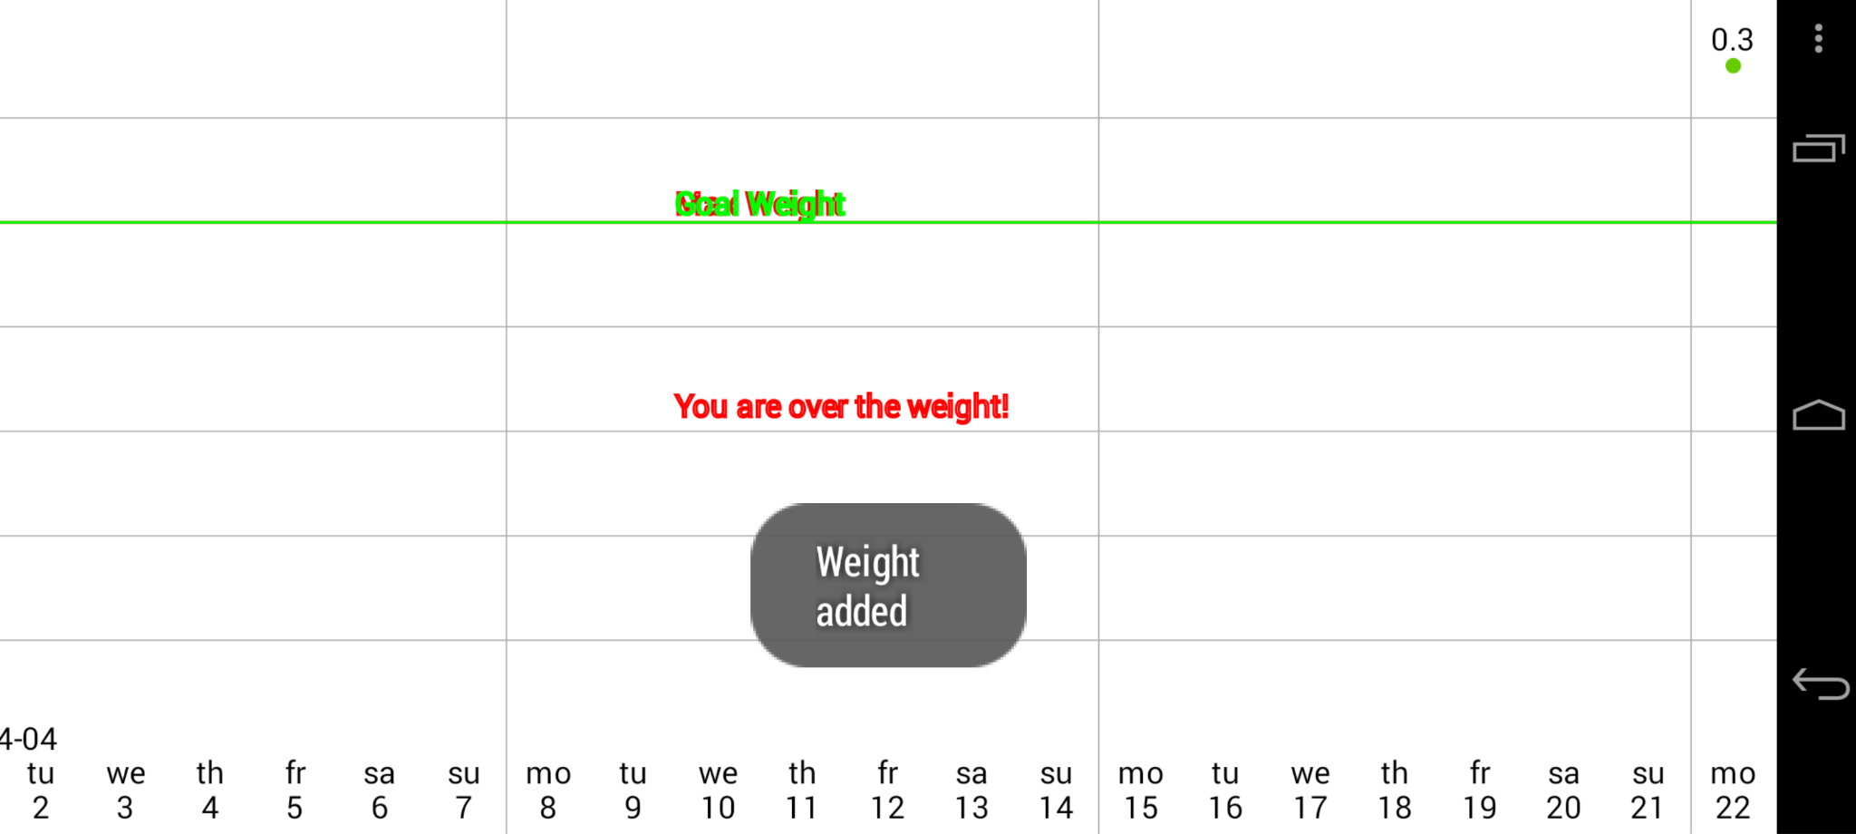

Input random text and Click “OK” Weight added but some texts are overlaid!

27.Yahtzee: ChatGPT4 response (com.tum.yahtzee_1_src_oracle_1(38).mhtml )

Yes, there is a UI error. The action sequence indicates that selecting a move labeled "Number 1" is possible (as indicated by the text "Possible: yes" and "Additional Points: 1"), but the screenshot displays an error message saying "The selected move isn't possible!" This contradiction between the action sequence text and the displayed error message is a discrepancy.

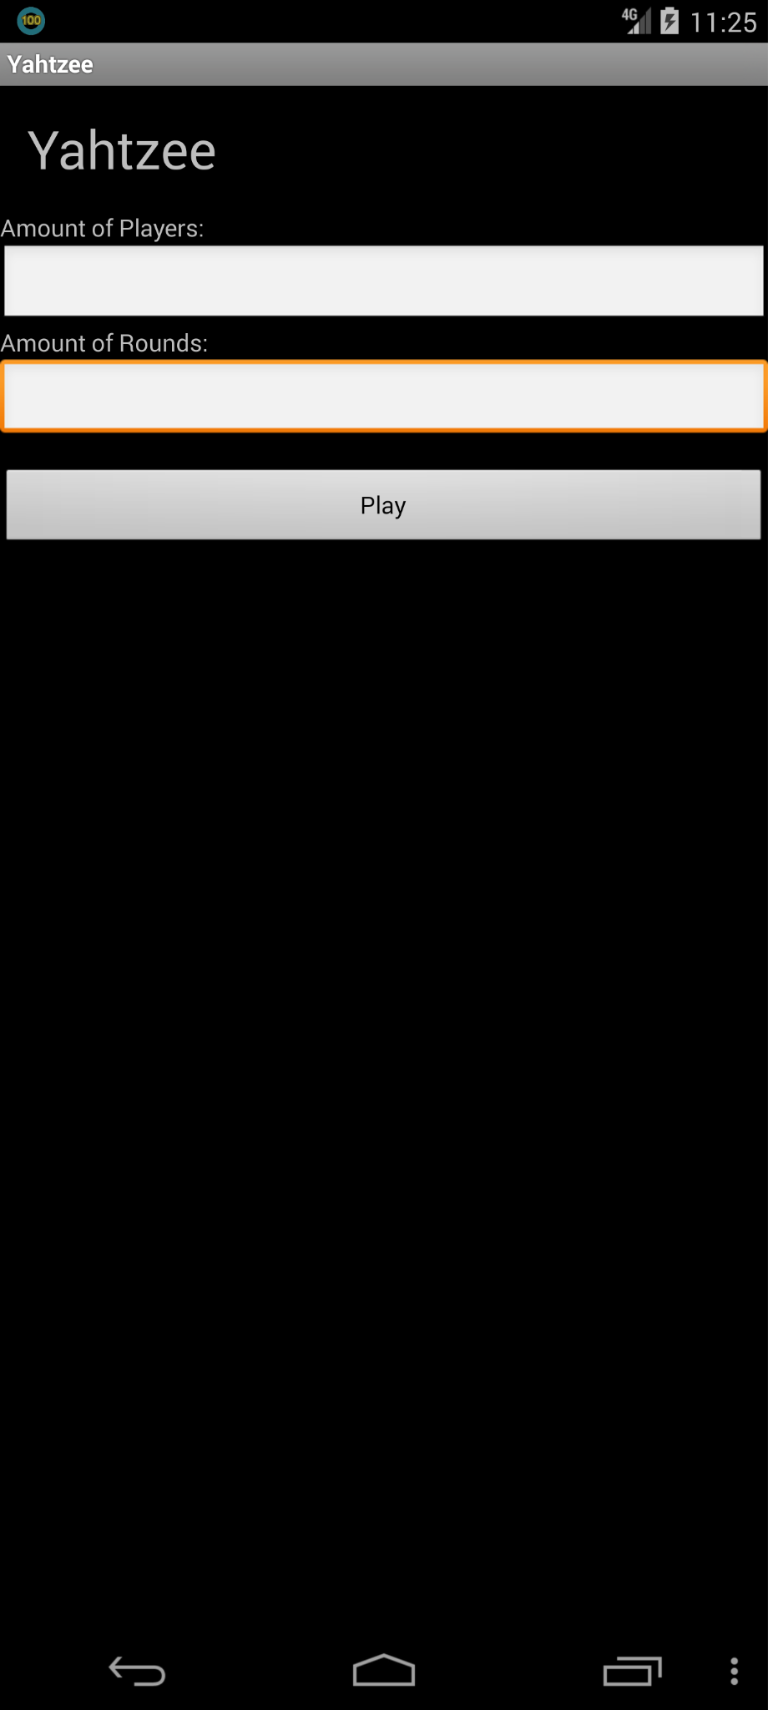 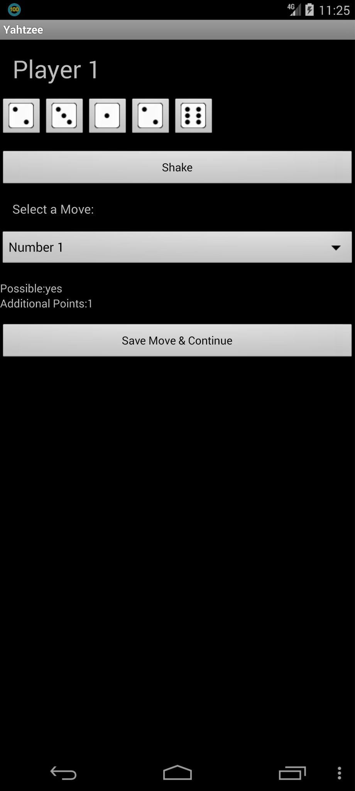 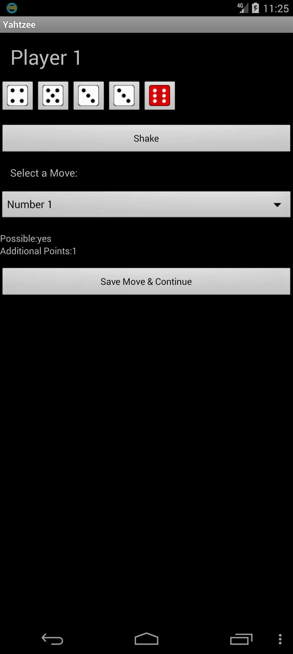 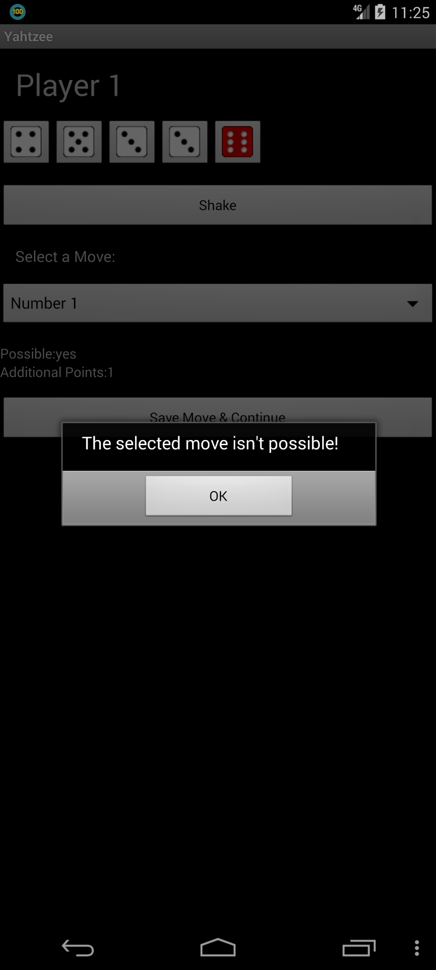

Input random numbers and Click “Shake” Click “Save Move & Continue” In the background, Possible is Yes,

Click “play” but the pop-up window say “isn’t possible!”

29. Zooborns: ChatGPT4 response (org.smerty.zooborns_14_src_oracle_0(14).mhtml )

Yes, there is a UI error. The screen is completely black and does not display any elements that should be present according to the provided action sequence. At the very least, there should be clickable buttons with 'content-desc: back button', 'content-desc: ZooBorns;', and other elements as described in the action sequence, but none of these are visible.

Final decision: UI error present.



On start up, it displayed nothin, rather than displaying any photo.